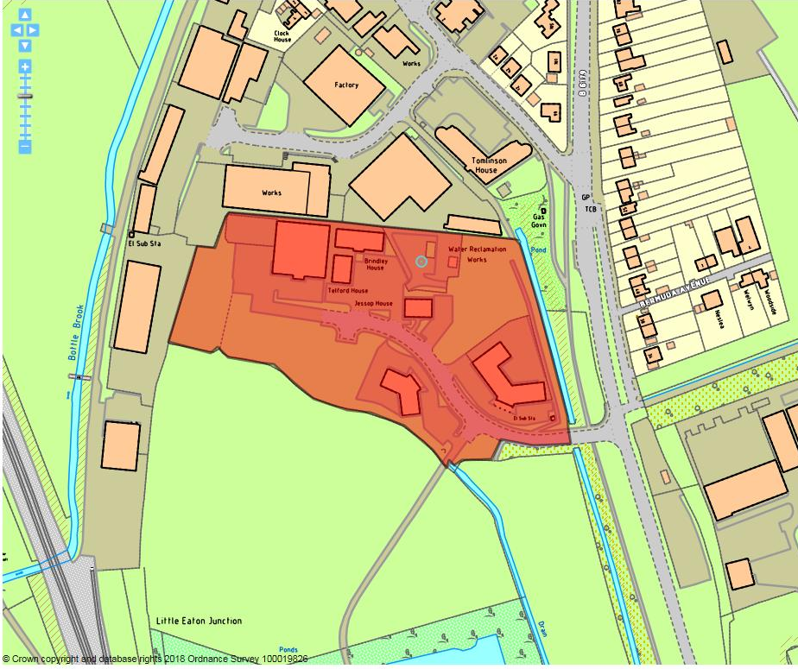

Site details:
Site reference (EELS) | EELS 001
Site name(s) | Outrams Wharf
Settlement | Little Eaton
Description | Modern Business Park on southern edge of Little Eaton
Occupiers | Various in professional services/High-tech Research and Development (R&D) sector
Current use classes present | B1(a) and B1(b)
Size (ha) | 2.2ha
Building age(s) | Premises/Business Park dates from early c21st
Building quality | Excellent
Site assessment:
Prox. to strategic road network | Site 900m from A38 8
Local prominence | Site accessed off B6179 Alfreton Road 3
Public transport | ‘Amber line’ and 7.1 bus services route along Alfreton Road immediately east of site 10
Relationship to workforce | Within Little Eaton settlement 10
Planning policy considerations | Within Flood Zone 3, likely low-level ground contamination from site’s previous use as sewerage works & group TPO zones around southern boundary 7 7 9
Environmental setting | Generally good however some areas of undeveloped hardstanding evident around the site 8
Flexibility of premises | Room to expand on parts of site, particularly in NE and SW 8
Demand/Commercial desirability | Fully occupied premises 8 8
Final score & status | (Out of 73) 62

Site commentary:
Site description:
A modern business park accommodating several commercially attractive premises positioned mainly north of a central access road (Outram’s Wharf). A single point of vehicular access and egress is taken from B6179 Alfreton Road, with the A38 and wider access to the strategic road network a short distance beyond. Formerly a sewage works, the site was redeveloped in the early-2000’s to provide excellent quality floorspace for professional services and R&D uses. Each of the buildings on-site enjoy generous areas providing for car parking, with each ‘House’ styled differently to create variety in the premises visual appearance. A small water reclamation facility is located in the north-east corner of Outram’s Wharf off the central road, and two notable plots on the site remain vacant awaiting development. North and west of Outram’s Wharf is an industrial estate accessed off Duffield Road (EELS 065), while south lays an area of historic landfill with several small ponds accessed via track from the main road through EELS 001.

Planning policy:
Given its close proximity to the River Derwent a few hundred yards west of Outram’s Wharf, modelling information from the EA show this site to be positioned within the extent of Flood Zone 3, placing limitations on the type and scale of new development permissible here. The site’s former use as a Sewage Works and the likely arising ground contamination from operations are also likely to constrain future (re)development opportunities. A series of group Tree Preservation Orders are in place around the site’s southern boundary, with a future development on a vacant parcel of land south of Outram’s Wharf needing to respect and maintain the settings of notable trees.

Site flexibility:
Modern office and HQ buildings provide the flexibility to accommodate a wide range of B1(a) and B1(b) uses. As previously described, two remaining development opportunities exist adjoining Outram’s Wharf allowing the site to accommodate additional employment premises.

Demand and commercial desirability:
With accommodation modern, it is unsurprising that all premises on-site are currently occupied. The site’s locational qualities are likely to ensure that facilities here will remain in commercial demand.

Final conclusion:
A somewhat limited example of a modern constructed business park in Erewash built to accommodate office/HQ facilities. Located close to the strategic network and accessed well by public transport, the Outram’s Wharf site is a popular location which currently enjoys full occupancy. With scope to add further office accommodation on-site, it is expected that Outram’s Wharf will continue to make a strong contribution to the local economy by offering excellent office and R&D space.

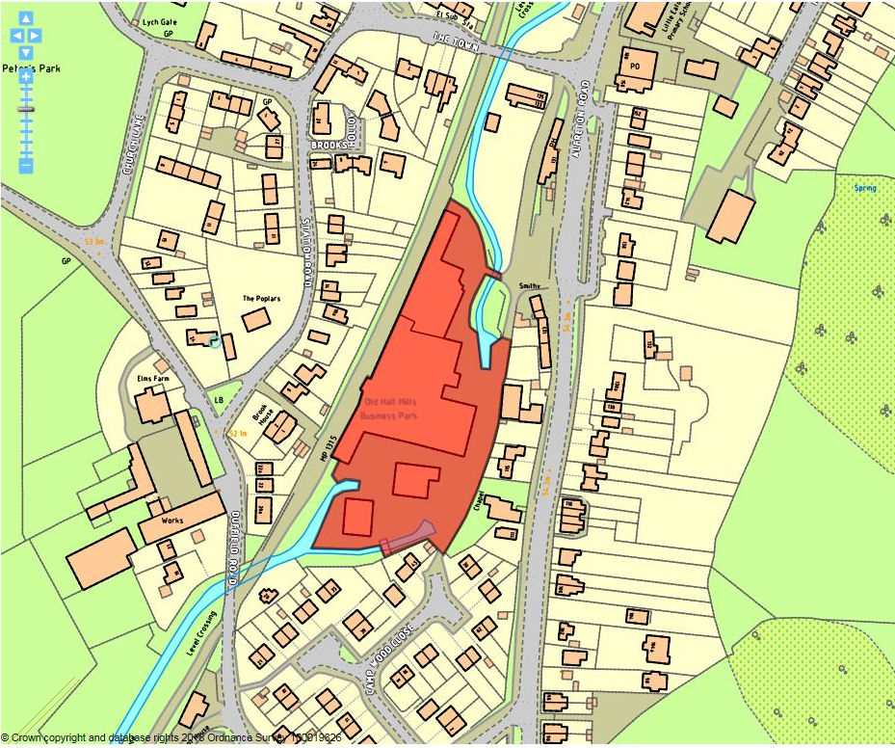

Site details:
Site reference (EELS) | EELS 002
Site name(s) | Old Hall Mills Business Park
Settlement | Little Eaton
Description | Small-scale mixed-use industrial estate located centrally within Little Eaton
Occupiers | Multiple largely independent/local businesses
Current use classes present | B2 uses including two microbreweries and various light industrial units. Small-scale B8 distribution, Car garage (Sui Generis) and Dance studio (D2)
Size (ha) | 1.0ha
Building age(s) | Mid-to-late c20th
Building quality | In acceptable condition to meet needs of current occupants but not up to modern requirements
Site assessment:
Prox. to strategic road network | Site 1.4km to A38 7
Local prominence | Site’s only vehicular access is taken from B6179 Alfreton Road 3
Public transport | ‘Amber line’ bus service routes along Alfreton Road immediately east of site 10
Relationship to workforce | Within Little Eaton settlement 10
Planning policy considerations | Site located within Flood Zone 3, proximity to neighbouring residential properties, limited vehicular access and a number of TPO designations in SE of site 6
Environmental setting | Limited soft landscaping evident. Predominantly hard standing across the site 4
Flexibility of premises | Little scope for expansion/alteration due to premises age 5
Demand/Commercial desirability | 100% occupancy of units on-site 8
Final score & status | (Out of 73) 53

Site commentary:
Site description:
Formerly Brook Mill which operated as a Paper Making factory for several decades, this much-amended facility now accommodates a number of small and independent local businesses. Largely obscured from view as a consequence of surrounding forms of development and its distance from the site’s only vehicular access point, this collection of standard stock industrial buildings in functional condition are located centrally within Little Eaton and sit within a relatively large site amongst a diverse range of neighbouring uses. Access into the Business Park is somewhat ambiguous, with visitors to the facility first passing through car parking abutting Alfreton Road before entering the yard space which provides much of the setting for the various premises. The yard sweeps around both to the north and the south of the buildings, although it is more spacious in the latter with provision made for car parking around the site’s boundary. The yard also allows trade vehicles to access loading bays set into the south and east-facing elevations of industrial buildings with a noticeably newer standalone unit in the south of site having much of its eastern frontage occupied by a loading bay door. Prominent screens of trees line the majority of the site’s boundary, again minimising inward and outward views, and this provides a visual break to residential development immediately east and south. West of the site sits a disused and now lifted railway line that once saw a spur access the Mill’s curtilage, while the Bottle Brook – a small watercourse tributary of the River Derwent continues to pass into the grounds of the Business Park today, although it is partly culverted beneath the yard before being uncovered as it flows north.

Planning policy:
Due to the presence of Bottle Brook through the site, the Business Park sits within Flood Zone 3 which limits new development (or redevelopment) opportunities. As described already, residential development now surrounds Old Hall Mills around most of its perimeter. The nature of some operations at the facilities here could result in some low-level disturbance to neighbouring households, particularly to those in gardens. Vehicular access to the site feels indirect, and given the nature of how the facilities are reached, it is thought that this limits the ability of larger HGVs to gain access to units. Finally, a number of TPO trees are sited at the southern end of the site, raising concerns about the quality of setting each protected tree currently receives given this is yard space.

Site flexibility:
A constrained site due to surrounding forms of development limiting expansion, any future development here would have to utilise the existing yard space surrounding the industrial premises. The aging nature of the facilities here will likely limit the flexibility of current stock as time passes, with modernisation possibly required.

Demand and commercial desirability:
Despite the concerns outlined under ‘site flexibility’, the units remain popular and provide floorspace for localised industrial uses. A lack of similar lower-quality facilities in the immediate area may demonstrate the facility’s continued popularity.

Final conclusion:
Positioned centrally within Little Eaton, these industrial Mill premises remain popular with local businesses. With the facilities showing signs of aging, and with unusual and indirect access arrangements for vehicles visiting the site, maintaining the current demand for floorspace into the future will be important to its long-term employment prospects; with investment and modernisation likely to be necessary.

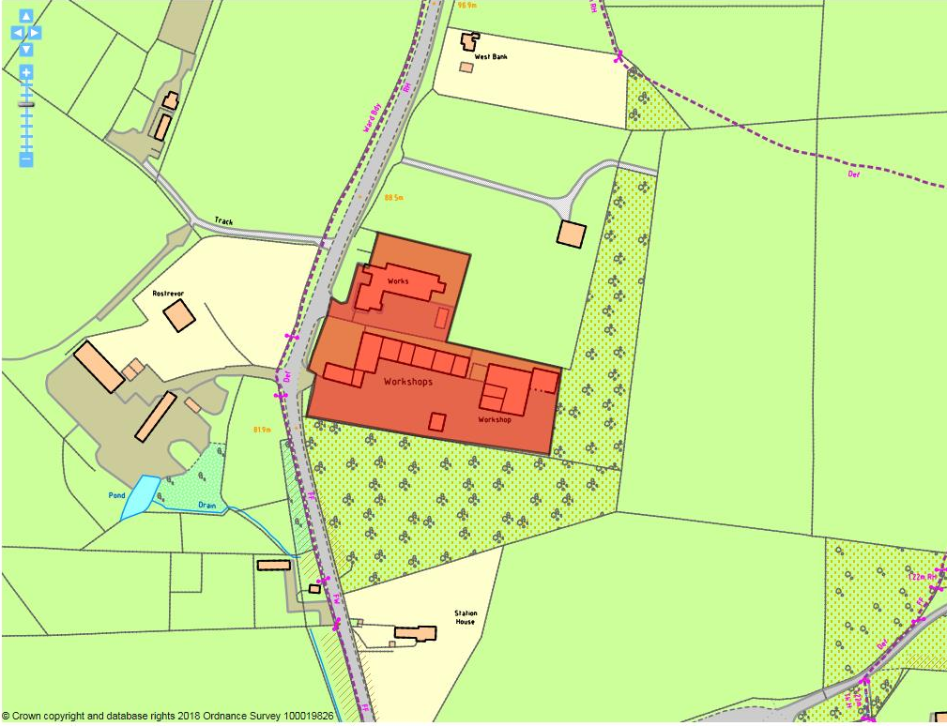

Site details:
Site reference (EELS) | EELS 003
Site name(s) | Workshops / The Old Pit Yard
Settlement | West Hallam
Description | Small complex of workshops and separate industrial premise situated south of West Hallam
Occupiers | P & H Fibreglass, JC Paints and S.M.C Automotive Services
Current use classes present | B2
Size (ha) | 0.9ha
Building age(s) | All fall within early-to-mid c20th
Building quality | Poor to average
Site assessment:
Prox. to strategic road network | Site 8.0km to A52 0
Local prominence | Site accessed from Station Road, an unclassified public highway 2
Public transport | Trent Barton ‘Black Cat’ service and no.11 bus routes along Station Road 10
Relationship to workforce | 250m from the edge of West Hallam settlement 7
Planning policy considerations | Green belt and probable contamination 8
Environmental setting | Surrounded by trees, but Old Pit Yard & separate industrial premise mainly buildings/hardstanding/service areas 5
Flexibility of premises | Workshops of aging appearance, making adaption unlikely and long-term occupants at P & H north of Old Pit Yard likely to have configured internal space for specialised needs. Also in Green Belt. 4
Demand/Commercial desirability | Some of the workshop units at Old Pit Yard vacant, but more than half appear in active use 6
Final score & status | (Out of 73) 42

Site commentary:
Site description:
A small area of somewhat isolated industrial uses situated just north of the former Stanley Colliery, these premises are split across two distinctively separate sections. The north of EELS 003 sees a functional building of rectangular design occupied by P & H Fibreglass that is set back from the roadside beyond a small grassed area and forecourt. The grounds of the premises are accessed by vehicle off Station Road, with a short stretch of road entering into a central yard area which accommodates limited car parking and a number of low-quality storage buildings that line its southern side. Further south, and separated by a line of mature and imposing trees are a row of workshops connected originally with Stanley Colliery. Accessed via a separate entry off Station Road, these buildings are positioned north of Old Pit Yard and run east-west in alignment, looking out over a sizeable area yard space. Further east, and beyond the end of the row of workshops, is a large double-bay industrial building of poor quality. This is served by a continuation of the communal yard that sweeps around the eastern side of the unit where a more recent annex has been added. A dense band of trees planted on the site of the former Colliery line the southern and eastern sides of EELS 003 helping to provide a clear sense of enclosure, while to the north an enclosed agricultural field adjoins the industrial site.

Planning policy:
Few planning policy issues are evident in relation to this site, although it is located within the Green Belt which places sizeable restrictions on the type and form of development which would be permissible. The site is also likely to be subject to some forms of contamination owing to being situated within the immediate vicinity of the former Stanley Colliery, and the Old Pit Yard buildings appear to have been associated with the Coal Mine, potentially to store linked equipment, that heighten the probability of some ground contamination.

Site flexibility:
The facilities on the site, particular workshop accommodation around the Old Pit Yard, are aged making it likely that their ability to adapt and be modified for more modern industrial uses would prove difficult to achieve. With the site located within the Green Belt, this adds another aspect of complexity in reconfiguration of the current facilities, or the consideration of a new development use.

Demand and commercial desirability:
The industrial premise in the north of the site is filled by a single occupant, although it was difficult to ascertain which of the many units sited within the Old Pit Yard part of EELS 003 was occupied, although it appeared some of the businesses present were operating from multiple units. Some of the units gave a strong impression that they were unoccupied (or at the very least, underutilised) at the time of visit.

Final conclusion:
An isolated employment site between West Hallam and Stanley Village, this facility accommodates several industrial uses which benefit from distance away from residential areas. As such, the site offers businesses wishing to carry out noisy operations which sometimes spill out from built units into adjacent yard areas and given its Green Belt designation, it is unlikely that new development (or a material addition to the on-site facilities) would be easily achievable.

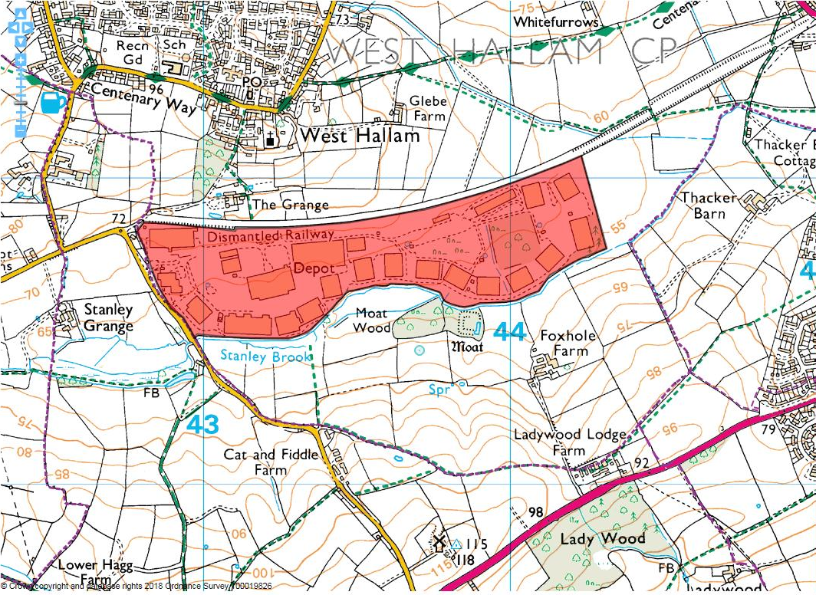

Site details:
Site reference (EELS) | EELS 004
Site name(s) | West Hallam Storage Depot
Settlement | West Hallam
Description | Former military ordnance depot, now predominantly a large-scale storage facility accommodating a number of small industrial businesses in ancillary units
Occupiers | Various
Current use classes present | B2, B8, Sui Generis
Size (ha) | Approx. 47ha
Building age(s) | Romney huts constructed in 1940’s, with larger warehousing buildings built during 1960’s-onwards
Building quality | Warehousing premises modernised, but Romney huts aged and in deteriorating condition
Site assessment:
Prox. to strategic road network | Site 7.8km to A52 0
Local prominence | Site accessed off the unclassified Cat & Fiddle Lane 2
Public transport | Around 0.8kms from bus services which route through Stanley Village 5
Relationship to workforce | 250m from the edge of West Hallam settlement 7
Planning policy considerations | Scheduled Ancient Monuments, area of historic landfill adjoining site, ground contamination, group/individual TPO’s across the site & potential local wildlife sites neighbouring site 6
Environmental setting | Mixed quality across site – sizeable areas of green landscaping (including trees), but vast areas of hardstanding also evident 6
Flexibility of premises | Limitations on warehousing and distribution operations and activities due to planning conditions. Romney huts difficult to adapt to serve other functions 4
Demand/Commercial desirability | Vast areas of open storage filled with cars, caravans and road-related infrastructure – warehousing units appeared in good level of occupancy, but Romney Huts mixed 8
Final score & status | (Out of 73) 38

Site commentary:
Site description:
A vast site located south of West Hallam, the facility was originally constructed as a military ordnance depot in 1940 taking advantage of its proximity to the now removed Great Northern Railway Line which ran alongside the site’s northern boundary, before the site’s decommission occurred in 1959 and its subsequent operation as a storage and distribution centre since. With a single vehicular access from its western boundary along Cat and Fiddle Lane, and beyond security barriers and building, an internal network of roads run broadly around the site’s edges, some of these operating on a ‘one-way’ basis to ensure site safety. The facility is able to be zoned into different areas. Large-scale and modernised warehousing buildings are generally positioned over within the site’s west close to its vehicular entry/exit. Throughout the centre, considerable parts of land are given over to open storage B8 uses – with large volumes of cars, caravans and road-related infrastructure (signage, gantries) sited in-between buildings, and also greater in visibility throughout the open areas of the site where new vehicles are neatly configured. Around the edge of the site, moving towards its east, are large quantities of Romney Huts. These have generally been constructed in arrangements of 6-10 connected units and mainly serve as areas of covered storage, although some small-scale business operations are currently based within them. Also located centrally within the eastern side of the site is Newdigates New Covert, a densely wooded plantation which predates the ordnance depot and is now faced on its north and south sides by Romney Huts with an area of open storage immediately east.

Planning policy:
The site’s long-term use as an ordnance depot is likely to have resulted in ground contamination. This is not currently a concern as present uses are able to co-exist on such conditions, although future redevelopment to a non-employment use would require remediation works. Additionally, Council records show a sizeable area of historic landfill on adjoining land between the Storage Depot and Foxhill Farm to its south. Playing a key role in greening the site, numerous trees enjoy designation through individual and group TPO’s are to be found across it, offering an ongoing challenge in ensuring the continued protection of notable trees amongst active employment uses. Immediately surrounding the site are aspects of varying statutory interest. These include two Scheduled Ancient Monuments; 141: Moated site with two fishponds and 29983: Mediaeval iron working remains at Stanley monastic grange. Finally, two candidate local wildlife sites adjoin the site – the first at Moat Wood along the southern boundary, and the former route of the adjoining railway line – both with potential to be added to the Borough’s list of non-statutory wildlife sites.

Site flexibility:
The warehousing/distribution elements of the site are subject to restrictive conditions to control the hours in which HGVs are able to access it, limiting scope to provide additional logistics development facilities here. Also, aging Romney Huts will become increasingly difficult to maintain in time as their conditions deteriorate.

Demand and commercial desirability:
Current planning conditions restrict overnight access to the site, diminishing the facility’s attractiveness to logistics-based companies who require round-the-clock operations. The usage of open storage space here shows the popularity of the site for this purpose.

Final conclusion:
The West Hallam Storage Depot site has provided for warehousing and distribution uses for a number of decades making a notable contribution to the local economy. However, restrictions on warehousing operations and the deteriorating quality of the Romney Huts raises concern over the ability of the site to retain employment uses across the long-term.

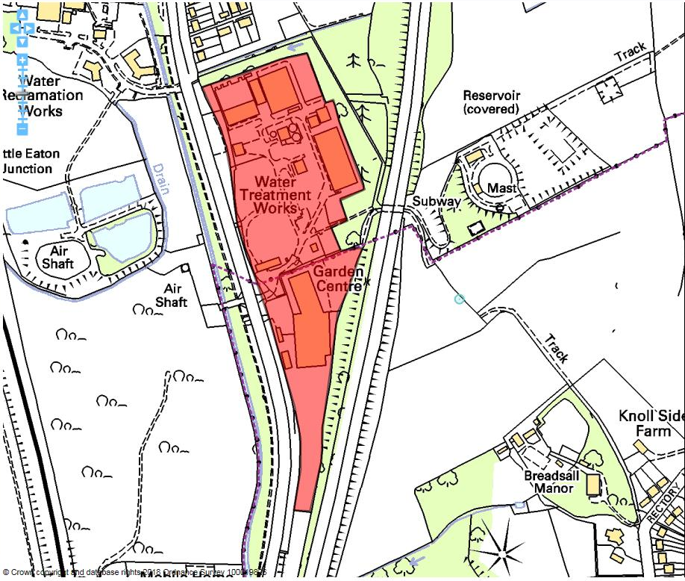

Site details:
Site reference (EELS) | EELS 005
Site name(s) | Little Eaton Southern Triangle
Settlement | Little Eaton
Description | Mixed-use site comprising Garden Centre and essential infrastructure (Water Treatment Plant)
Occupiers | Blue Derby Garden Centre/NMC Nomenca (Water Works)
Current use classes present | Approx. 50% A1 & 50% Sui Generis
Size (ha) | 6.2ha
Building age(s) | Mixed C19th-20th (Water treatment works) C20th (garden centre)
Building quality | Good
Site assessment:
Prox. to strategic road network | Site 0.7km to A38 8
Local prominence | Site accessed from B6179 Alfreton Road – site adj. to A38, but obscured from view due to dense wooded area 3
Public transport | ‘Amber line’ and 7.1 bus services route along Alfreton Road immediately east of site 10
Relationship to workforce | 500m from the edge of Little Eaton settlement 7
Planning policy considerations | Located within Flood Zone 3. Site in Green Belt. Water treatment works would have ground contamination issues 7
Environmental setting | High degree of mature planting 8
Flexibility of premises | Room to expand within curtilage of Water Works estate, however not known how much of unbuilt up area is required for current operations 5
Demand/Commercial desirability | All premises occupied 8
Final score & status | (Out of 73) 56

Site commentary:
Site description:
An area of land south of Little Eaton village and positioned in-between the B6179 and A38, this site accommodates two operations; the first, a Water Treatment Works (WTW) which covers the majority of EELS 005, while a Garden Centre occupies a narrowing piece of land situated between the two aforementioned roads. Water infrastructure has been present on this site, albeit covering a smaller area, since the late-c19th when the Derby Water Corporation occupied land and premises west of Alfreton Road. The current facility spreads over a much wider footprint, extending north and eastwards, and sees a number of buildings of varying type, construction and size positioned mainly around the edge of a largely greened site. Adjoining to the south is a recent Garden Centre built during the 1990’s with loading/service area positioned at the north of the site, whilst a sizeable area of visitor car parking is situated south of the premises. These areas are each accessed separately off Alfreton Road with their entrances around 100m apart. The commencement of residential properties occurs just to the north of the WTW beyond a dense line of mature and imposing trees providing a strong visual screening. Roads help to enclose the site on its east and western sides, while a thin band of open ground sits south of EELS 005 that serves to separate the A38 and B6179.

Planning policy:
With its proximity to the River Derwent, the western part of the site sits within the extent of Flood Zone 3 bringing greater restrictions on new development or redevelopment opportunities. Also acting as a constraint on future site development/redevelopment is EELS 005’s location within designated Green Belt, placing limitations on the type and scale of development allowed. Finally, with having over a century’s history of treating waste water, some ground contamination is thought highly probable to exist across parts of the site.

Site flexibility:
The Garden Centre component of the site appears to have utilised almost all aspects of its curtilage for various uses, restricting its ability for further growth. The WTW covers a sizeable area of land across EELS 005, and whilst large parts appear to be vacant it is unclear how much of this space is operationally required. Even if some land within the WTW facility was underutilised and surplus to requirements, new employments uses may not be compatible with such a neighbouring operation.

Demand and commercial desirability:
All parts of this site are presently occupied. The WTW is a bespoke infrastructure facility and would not be suited to other uses.

Final conclusion:
The site contains an important utilities-based infrastructure, accommodating facilities which are of local significance. It is expected that this will remain vital to local water-based infrastructure needs for the foreseeable future. The Garden Centre is a successful facility which contributes positively to the local economy in this part of the Borough.

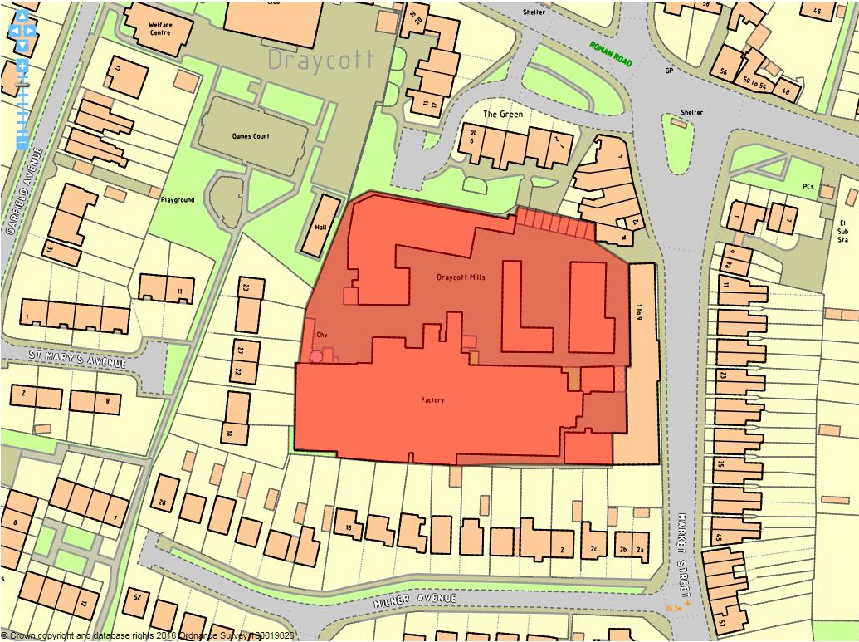

Site details:
Site reference (EELS) | EELS 006
Site name(s) | Draycott Mills
Settlement | Draycott
Description | Former cotton warehouse in centre of Draycott, now Listed and accommodating a diverse range of uses
Occupiers | Incite Interiors & Upholstery, Pumpkinz Coffee Shop, Frox Dresses, Woodworks Derby, The Emporium, D J. Bennett Joinery. MATtest Laboratories and Avado Boutique
Current use classes present | A1, A3, B1(b) & B1(c) and B2
Size (ha) | 0.72ha
Building age(s) | Main Warehouse and connected buildings date from mid-c19th with later workshop added mid-c20th
Building quality | Average
Site assessment:
Prox. to strategic road network | Site 3.8km from A52 2
Local prominence | Site visible from A6005 Derby Road 4
Public transport | Indigo, Y5 and 12 bus services all route along Derby Road 10
Relationship to workforce | Within settlement of Draycott 10
Planning policy considerations | Listed Buildings, within Draycott Conservation Area and adjacent to residential properties 7
Environmental setting | Whilst no landscaping on site, a number of heritage assets create a good quality built environment 6
Flexibility of premises | Limitations on reconfiguration of Listed premises or new development in the setting of these 4
Demand/Commercial desirability | Most space within the Mill complex appeared to be fully occupied during a recent site visit 8
Final score & status | (Out of 73) 51

Site commentary:
Site description:
Historically a Cotton warehouse (with ancillary workshop facilities) upon its construction in the mid-c19th, the Mills complex now accommodates a diverse range of business uses within buildings across the site. With the Mills Grade II Listed eastern two-storey frontage now converted into residential properties (and hence now outside the extent of EELS 006), buildings positioned further back into the site remain of interest to the EELS. Vehicular access into the site is taken off Market Street immediately north of the now residential part of the Mills building, with a large irregularly-shaped yard servicing all buildings positioned back into the site. Extending westwards, the largest employment building sees a number of service bays positioned across its north-facing elevation. More Listed buildings, albeit much smaller in size, are located both within the yard itself and also along its northern boundary. At its western-most point, a notable brick chimney rises from the industrial premises at their western-most point, a structure which is visible from a number of locations around Draycott. Residential development from different eras now surrounds all four sides of EELS 006.

Planning policy:
As mentioned, the majority of structures on the site benefit from Grade II Listing. Six separate listings are in place to cover the Cotton warehouse and chimney (HE Asset No. 1250121), Cotton storage and processing buildings (1329376), Leavers machine shed (1250092), Cotton doubling mill (1140154), Cotton spinning mill & office block (1250046) and Cartshed/stable (1140155). The presence of these listings will inevitably have an impact on current and future developments taking place at the Draycott Mills complex. Unsurprisingly, the site also forms part of Draycott Conservation Area, and this designation also provides protection for buildings within this part of the Village. The site description refers to the neighbouring residential development which adjoins on all sides. This is likely to have scope to generate some noise through the nature of operations which could create low-level disturbance for adjoining properties.

Site flexibility:
With multiple listings in place for buildings across the site and it also situated within a Conservation Area, the flexibility to reconfigure EELS 006 is much reduced. The local and national heritage-based policies collectively create a strong framework against which any development proposal would be considered against, although a strong presumption of retaining current structures at Draycott Mill continues to exist.

Demand and commercial desirability:
From a recent site visit, premises and workspace at the Mill complex appeared to be in a good level of occupancy showing demand for floorspace here to be reasonably strong. The eclectic range of uses currently trading from Draycott Mill demonstrates the facility’s importance to the local area, with a number of small businesses able to co-exist from the various buildings. Whilst heritage-based policies could be viewed as reducing the site’s flexibility, the status of the buildings here could also help by providing a unique selling point as a high quality built environment.

Final conclusion:
The Mills continue to support a range of business operations, some of which are industrial in nature. Such operations have been able to show they are able to co-exist with retail and food-based enterprises, collectively creating an important local source of employment floorspace and jobs within Draycott.

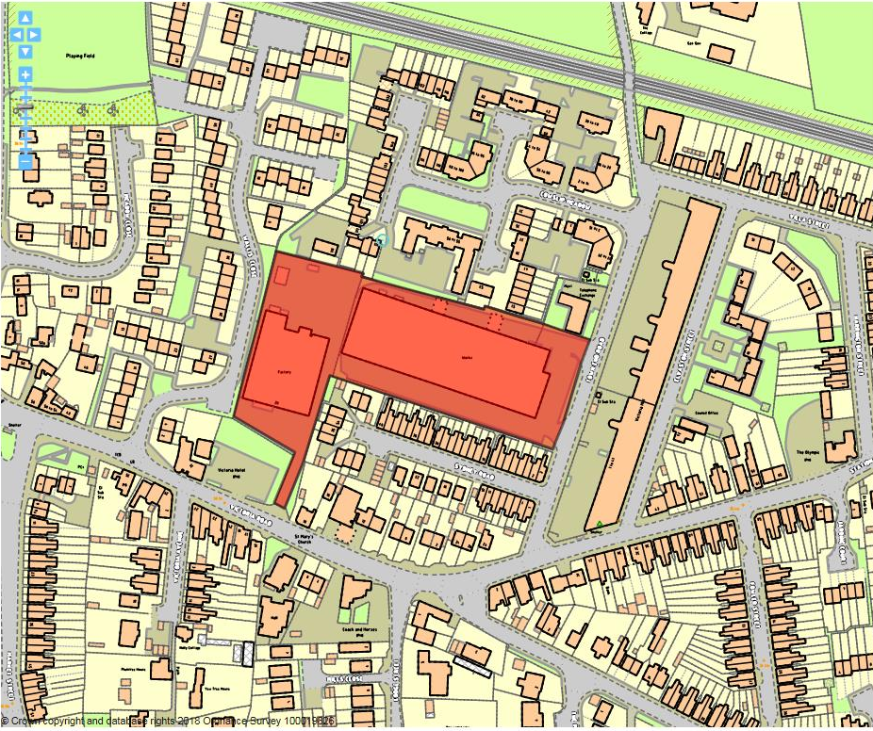

Site details:
Site reference (EELS) | EELS 007
Site name(s) | Works at Victoria Rd & Town End Street
Settlement | Draycott
Description | A pair of adjacent factories located close to Draycott Village Centre
Occupiers | Parry Catering Equipment Ltd & EPM: Technology Group
Current use classes present | B2 with ancillary B1(a).
Size (ha) | 1.2ha
Building age(s) | Victoria Rd factory in 1970’s & Town End Road factory in 1990’s.
Building quality | Average
Site assessment:
Prox. to strategic road network | Site 3.9km to A52 2
Local prominence | Western factory takes access off the A6005 Victoria Road 4
Public transport | Several bus services route along Victoria Road 10
Relationship to workforce | Site within Draycott settlement 10
Planning policy considerations | Proximity to nearby residential properties, within setting of Grade II Listed Building 8
Environmental setting | Very little soft landscaping on site, mainly consisting of car parking and service yard/loading space 6
Flexibility of premises | Some space around periphery of both sites for car parking, but this is needed to maintain highway safety on surrounding residential roads 5
Demand/Commercial desirability | Both premises currently occupied 8
Final score & status | (Out of 73) 53

Site commentary:
Site description:
This site is home to two separate factories, which while their curtilages physically adjoin, are accessed from different roads within Draycott. The first factory, accessed off Victoria Road but positioned some way from the highway (ensuring views of the factory are somewhat distant), has a small two-storey administrative block spanning its entire frontage with manufacturing premises situated behind and spreading throughout the rest of the building. A small staff and visitor car park provides the setting from this elevation. At the rear is a sizeable yard area which borders at its northern-most end relatively recent residential properties located along Cowslip Meadow. Whilst Wallis Close spans nearly the entirety of the factory along its western side, this elevation is blank with no access or interaction between the two. The second factory, more recently constructed and generally modern in appearance, fronts onto Town End Road with the imposing Victoria Mill on the opposite site of the highway. Two access points meet at the front of the building which is partially obscured behind a row of bushes, although this generally is a dead frontage except for a row of windows positioned high up on the elevation. An area of car parking sweeps around the building along its southern side, whilst a service area for loading/unloading flanks the northern elevation of the factory. Adjoining the site on its southern side are properties along the neighbouring Sydney Road whilst newer properties on a recently-constructed housing estate (Cowslip Meadow) are positioned immediately north, closest to the loading bays on the factory.

Planning policy:
Opposite the factory occupied by Parrys is the Grade II Listed Victoria Mill building which is now fully-restored and home to a large number of flats and apartments. The functional appearance of the factory premise is somewhat incongruous with such a notable, locally historic building and given the proximity between the two, the factory is thought to impact slightly on the setting of Victoria Mill. Also of note is the relationship between the factory and the neighbouring homes along Cowslip Meadow. Being adjacent to the factory’s servicing area, it is likely that some low-level disturbance is encountered by residents impacting on their amenity when trade vehicles are accessing the loading/unloading bays.

Site flexibility:
Little site flexibility insofar as the scope for physical expansion is thought possible from a recent site visit. As explained previously, both factories make adequate provision for on-site car parking and this offsets the impact of trips to the premises which without such space would see parking on narrow residential local roads causing a much greater level of amenity harm to homes in this part of Draycott.

Demand and commercial desirability:
Both premises are currently occupied demonstrating demand in these employment facilities away from the Borough’s larger industrial areas.

Final conclusion:
This site, increasingly surrounded by additional residential development with new housing to the north and the conversion of Victoria Mill now complete, provides the two largest single industrial premises remaining in Draycott. As such, both are of importance to the local economy by providing a reasonably large number of jobs. However, with residential development increasing characterising the immediate surroundings, the long term future of this site as employment is uncertain given the loss of other industrial premises between here and the Nottingham-Derby railway line several hundred metres north.

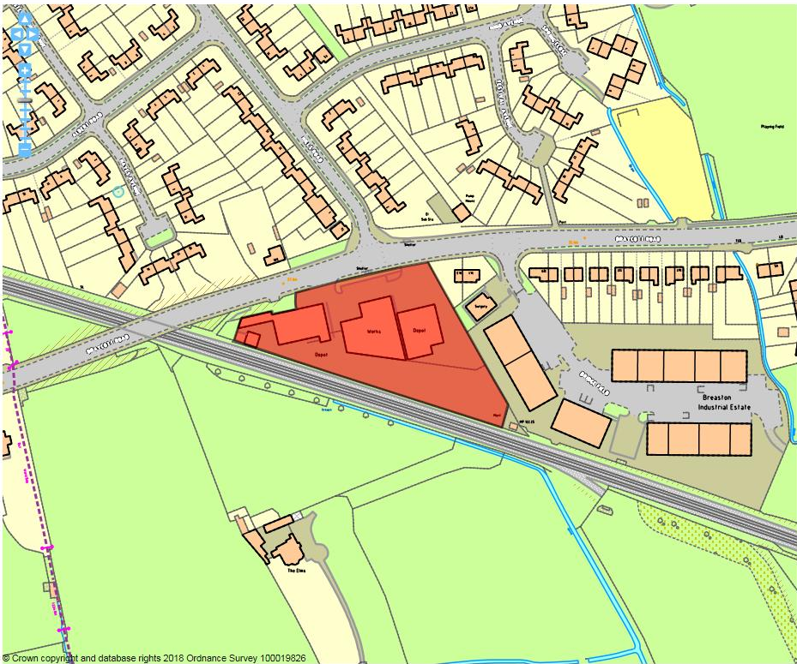

Site details:
Site reference (EELS) | EELS 008
Site name(s) | Works/Depot adj. to Bridgefield Industrial Estate
Settlement | Breaston
Description | Grouping of industrial buildings between A6005 and the Nottingham-Derby railway line
Occupiers | T&H Ford Hauliers, Coes of Derby and Harry Steer Engineering
Current use classes present | B2
Size (ha) | 0.8ha
Building age(s) | Premises constructed circa 1960/70’s
Building quality | Average
Site assessment:
Prox. to strategic road network | Site 3.8km to J25 (M1(A52) 2
Local prominence | Site fronts onto the A6005 Draycott Road 4
Public transport | Several bus routes serve Draycott Road 10
Relationship to workforce | Site within Breaston settlement 10
Planning policy considerations | Group TPO running along site’s eastern boundary 9
Environmental setting | Some informal, unkempt landscaping along site’s frontage but little evident elsewhere 6
Flexibility of premises | Permission granted in 2016 for a new steel-framed industrial unit in south-eastern corner of site. Limited scope for expansion of existing units 6
Demand/Commercial desirability | All units on site are occupied 8
Final score & status | (Out of 73) 55

Site commentary:
Site description:
On land which formerly adjoined the now-demolished Breaston Railway Station, a group of low-quality employment premises have been constructed around the 1970’s which house a number of industrial processes. The three separate buildings, each recessed some way back from Draycott Road to help form a sizeable hardstanding forecourt containing space for vehicles to park, are each different in design and appearance. All are functional in style, with the unit furthest east displaying several high bay openings across its frontage, perhaps explaining the amount of space which exists between the building and the highway to allow for loading operations. The remainder of buildings moving west across the site are typical examples of utilitarian industrial units with factory space located under mono-pitched roofs, but with block brick annexes where ancillary office and/or reception space have been created. Two vehicular access points into the site exist, one of which in the north eastern-most corner allows for access to the side of Fords. A second access point which appears more prominent in its width and use than the other sits further west along Draycott Road. Not only does this allow access to the site’s forecourt, but also passes between buildings, sweeping around the rear of the industrial premises into a narrow but long yard which, beyond a row of overgrown shrubs, adjoins the adjacent railway line.

Planning policy:
The general lack of surrounding residential properties directly adjoining the employment site ensures that the operations taking place do not impinge upon householder amenity. However, a group TPO designation protects a line of approx. 30 trees along the eastern boundary, separating this site from the adjacent Bridgefield Industrial Estate (EELS 009). The low quality space immediately adjoining the protected trees to the east of the Fords premise raises doubts about what manufactured objects or vehicles may potentially be positioned alongside trees with protected status.

Site flexibility:
A recent permission was granted to construct a steel-framed industrial unit with an open B-use guiding what operations can take place. This intensifies the built development on the site, leaving little space other than that required for car parking in which further extensions could occur, or separate new buildings could be constructed.

Demand and commercial desirability:
With all premises on site occupied, and the construction of a consented B-use employment unit, this demonstrates that the site is popular and provides space for uses which would be largely non-conforming if sited within the confines of a residential neighbourhood.

Final conclusion:
The current full occupancy of the site shows it serves an important use in one of Erewash’s village settlements, and given the site’s location aside an established industrial estate (Bridgefield) and an operational railway (with open countryside stretching beyond), it is ideally situated to continue providing accommodation to industrial uses which require some separation from more densely populated residential areas.

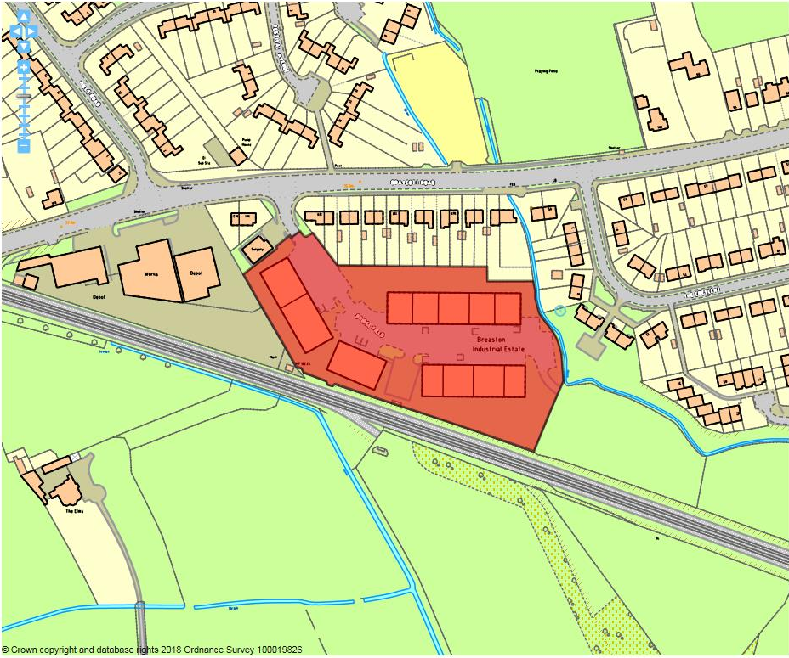

Site details:
Site reference (EELS) | EELS 009
Site name(s) | Bridgefield Industrial Estate
Settlement | Breaston
Description | Modern industrial estate located on the edge of Breaston
Occupiers | Melbourne House Furnishings, Aerosol Solutions, The Bike Shop, London & General Packaging, Interwood, Newliv Engineering, Alpha Maintenance, Dawn Engineering, Red Wood Upholstery & Intrim UK.
Current use classes present | B1(c) & B8
Size (ha) | 1.4ha
Building age(s) | Estate constructed during late-c20th
Building quality | Good
Site assessment:
Prox. to strategic road network | Site 3.7km to J25 (M1/A52) 2
Local prominence | Site accessed from A6005 Draycott Road 4
Public transport | Indigo, Y5 and 12 bus routes serve Draycott Rd 10
Relationship to workforce | Site within Breaston settlement 10
Planning policy considerations | None evident 10
Environmental setting | Grassed areas around estate, with trees positioned around the site contributing to good env. setting 7
Flexibility of premises | Each unit relatively small-scale limiting opportunities to adapt internally. Limited space with the site generally to incorporate further units or extend current ones 5
Demand/Commercial desirability | All units occupied at the time of visit 8
Final score & status | (Out of 73) 56

Site commentary:
Site description:
Located at the western-end of Breaston Village, this modern industrial estate managed by Derbyshire County Council accommodates a number of small, functional business units in a relatively pleasant setting. A single vehicular access into Bridgefield Ind. Est. is taken from the A6005 Draycott Rd, a main road linking the site to Nottingham, Derby and the nearby strategic road network. The units, positioned on each side of a curving central spine access road are modern, well-presented and are examples of portal steel frame buildings with half-height block work. Full-height roller doors are evident on the front of each. The site has ample parking, with three notable areas for visitors and employees located throughout the estate. A number of trees surround these areas helping to reduce the visual dominance of hardstanding and the basic nature of the on-site units. Immediately south of the Bridgefield Industrial Estate is the Nottingham-Derby railway line, whilst residential properties are to be found adjacent to the north and east. West of the site is EELS 008; a depot, factory and outdoor works area.

Planning policy:
Few policy conflicts are evident from the site visit and desktop mapping exercise. Whilst the units adjoin the curtilages of residential properties on two sides of the Estate, units are restricted to light industrial uses (B1(c)) and B8), both of which are compatible with preserving the residential amenity of adjacent householders.

Site flexibility:
With units on-site broadly of the same size and shape, the ability to alter aspects of these (other than cosmetic, elevational details) are somewhat limited. The units are small and functional, and such are designed to be flexible in what uses take place inside of them. Little space exists on-site, so the construction of further units is not thought to be possible, nor indeed would the reconfiguration of units to merge and create greater internal floorspace.

Demand and commercial desirability:
The Industrial Estate has traditionally maintained good levels of occupancy, and a recent site visit confirmed all units on site are currently in-use.

Final conclusion:
Examples of traditionally designed industrial estates such as Bridgefield in areas away from the Borough’s two main towns are very few in quantity. The traditional popularity of premises on the Estate demonstrates a high level of interest in trading from the facilities, with its functional yet modern units able to accommodate a number of light industrial operations.

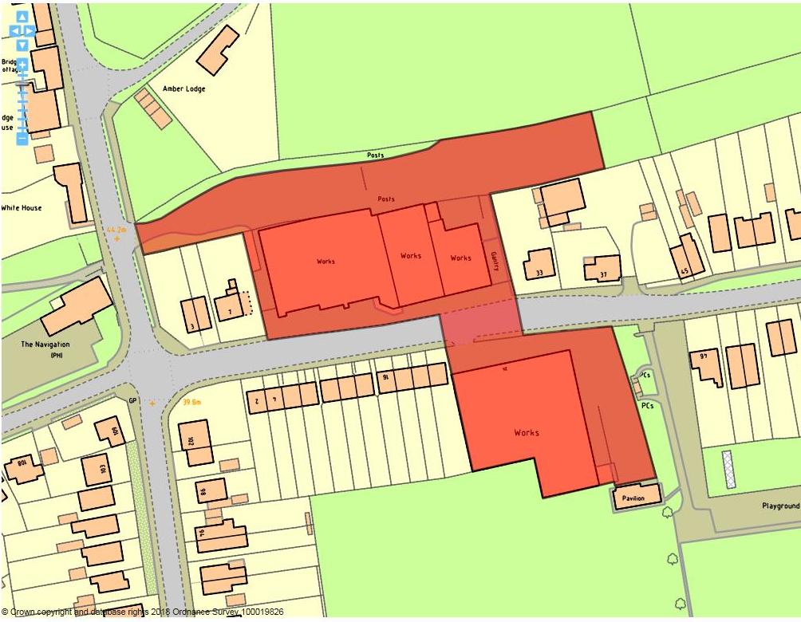

Site details:
Site reference (EELS) | EELS 010
Site name(s) | Works north and south of Longmoor Lane
Settlement | Breaston
Description | Collection of industrial buildings in a predominantly residential area of Breaston Village
Occupiers | South of Longmoor Lane – Cavagna Ltd, north – Breaston Garage, Long Eaton Rewinds, Stone Leisure Ltd, Litho Supplies PLC and DRG Building.
Current use classes present | B1(c) & B2
Size (ha) | 0.8ha
Building age(s) | South of Longmoor Lane – 1950’s to 60’s, north – redeveloped buildings date from the mid-c20th.
Building quality | Average
Site assessment:
Prox. to strategic road network | Site 2.2km to J25 (M1/A52) 5
Local prominence | Site positioned on both sides of a local residential road away from nearby main highways 2
Public transport | Nearest buses over a 1km away routing along A6005 5
Relationship to workforce | Site within Breaston settlement 10
Planning policy considerations | Site within residential surroundings 9
Environmental setting | Some greenery at frontage of Cavagna premises, but none around or on buildings north of Longmoor Ln. 6
Flexibility of premises | Units north of Longmoor Ln. have accommodated various manufacturing uses, but little space on site for new buildings or extensions to existing premises 5
Demand/Commercial desirability | All units appear to be occupied from site visit 8
Final score & status | (Out of 73) 50

Site commentary:
Site description:
A mixed area of industry in a predominantly residential part of Breaston Village. On the north side of Longmoor Lane, a long row of brick industrial units front the highway with no uniformity in appearance. Mainly two-storey in height, the buildings rise to three-storey centrally as a result of a later addition looking to accommodate administrative space. South of Longmoor Lane is premises which appear to have been much altered since the original building’s construction as a traditional industrial premise with saw-tooth roof pitches. The frontage of the building is a more recent addition extending it closer to the highway, with two rows of modern windows, the upper row recessed into a steeply-pitched roof. An area of staff and visitor car parking exists immediately east of the premises. A recreational ground can be found to the rear (south) of the premises and residential properties front onto Longmoor Lane immediately west.

Planning policy:
Some of the industrial operations occurring at the premises north and south of Longmoor Lane may contribute to a low-level of disturbance to the residential amenities of neighbourhood properties. Trade deliveries to and from the premises may also have an adverse effect of local highway safety given the largely residential character of the area. Immediately north of the premises north of Longmoor Lane, the course of the now disused and filled-in Derby and Sandiacre Canal exists. Whilst this does not affect the operational businesses trading from the premises, long-term plans to reinstate a Canal may be of relevance to this part of EELS 010.

Site flexibility:
The premises north of Longmoor Lane are split into a number of units demonstrating that the buildings are capable of internal reconfiguration. Permission was granted to change the use of part of the Cavagna building to accommodate a leisure-based fitness operation, but it is unclear as to whether this has been implemented. Little space, other than the car park serving Cavagna, exists within the site for further new-build or extensions to occur.

Demand and commercial desirability:
All units appeared to be occupied from a recent site visit.

Final conclusion:
The premises, slightly incongruous in their location in this part of Breaston, are established works which provide economic uses in one of Erewash’s village settlements adding to the diversity of development. With all units occupied, floorspace at the facilities appear to be in-demand.

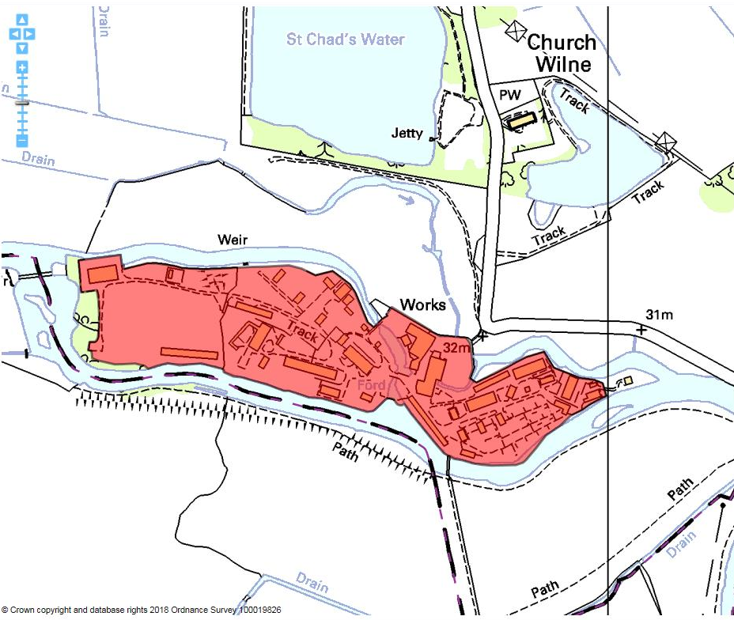

Site details:
Site reference (EELS) | EELS 011
Site name(s) | Land around the former Wilne Mills buildings
Settlement | Church Wilne
Description | Sizeable campus site accommodating a number of buildings in which specialist defence and pyrotechnic products are manufactured and tested
Occupiers | Chemring Defence UK Ltd
Current use classes present | All B-uses (B1, B2 (a-c) and B8)
Size (ha) | 8.1ha
Building age(s) | Former (and remaining) Wilne Mills’ buildings date from mid-c19th, but most campus structures added throughout 1970’s, 80’s and 90’s as development of site intensified.
Building quality | Average – newer buildings built for operational needs
Site assessment:
Prox. to strategic road network | Site isolated, being 5.4km away from the A50 0
Local prominence | Site enjoys secluded setting, distant from nearby road network 2
Public transport | Site more than 1km from nearest bus route/stop 0
Relationship to workforce | Site >0.5km from nearest settlement (Sawley) 5
Planning policy considerations | Site falls wholly within Green Belt and majority of site sits inside Flood Zone 3b 8
Environmental setting | Premises set largely within green surrounds with some landscaping within the confines of the site. 8
Flexibility of premises | Despite a number of premises located across the site, a large amount of remaining space exists in which specialist facilities could be sited dependant on needs 8
Demand/Commercial desirability | The entire site and its many buildings and structures are occupied by Chemring 8
Final score & status | (Out of 73) 39

Site commentary:
Site description:
The site is located equidistantly between the villages of Sawley and Draycott in the south-western corner of Erewash Borough, close to the hamlet of Church Wilne. At its centre are buildings once connected with Wilne Mills; a location closely associated with cotton production during the late c19th and early c20th. The River Derwent flows immediately south of the site, forming the entirety of its southern boundary. A by-pass channel once flowed around the north of the site, although this has now been lost and replaced over time by a screen of mature trees which forms the vast majority of its northern boundary and heavily restricts views in and out. A wide variety of smaller structures are dispersed across Chemring’s campus, although it is noticeably more open at its western end where an outdoor drill and exercise area is located. Despite this, the site is extensively landscaped with basic grassed areas in-between the assortment of buildings and on-site infrastructure which, together with trees around the boundary help minimise the visual intrusion of the site when viewed in the wider open area.

Planning policy:
Green belt spans the entirety of the site, demonstrating its remoteness to nearby settlements. This would obviously be a significant constraint should there be future plans to locate large-scale buildings and structures here, but it is important to recognise the need for a facility of this nature to enjoy a remote location and minimise the amenity impacts on the nearby resident population. Also of note is the severity of flood risk which the site is subject to. This should not be surprising given its setting alongside the River Derwent, but would heavily restrict any alternative uses for the campus with most of the site falling inside Flood Zone 3b (the functional floodplain). A Grade I Listed church (St. Chad’s) is located around 300m from the site entrance, but is not thought to have its setting or character adversely impacted by the nearby industrial operations at Chemring. Similarly, a Local Nature Reserve at St. Chad’s Water approx. 130m north is a successful site for ecology and co-exists without concern.

Site flexibility:
As mentioned in the site description, there are spacious areas across the facility free from buildings or structures where, depending on operational requirements, new additions could be constructed. These would need to be modest in scale and size however given the site’s location within the Nottingham-Derby Green Belt. The buildings present are extremely varied in size, condition and purpose, with the older facilities stretching out from the centre of the site thought to be replaceable.

Demand and commercial desirability:
Since its former use as a Fireworks production facility, Chemring have gradually shaped and intensified the site for their specific commercial business needs. The nature of business (pyrotechnics) means that an isolated location is essential so that omitted noise does not harm residential amenity. As the sole occupants of a highly bespoke site, its level of commercial desirability for other employment uses is not thought overly relevant.

Final conclusion:
With its remote location, the site is ideal for its current operations which could not be realistically sited any closer to urban environs. With a need for a large campus and advanced facilities, the site adds to the diversity of the local economy and whilst scoring low on accessibility criterion (affecting its overall score), should not be viewed as being a low quality employment site given its exceptional locational requirements.

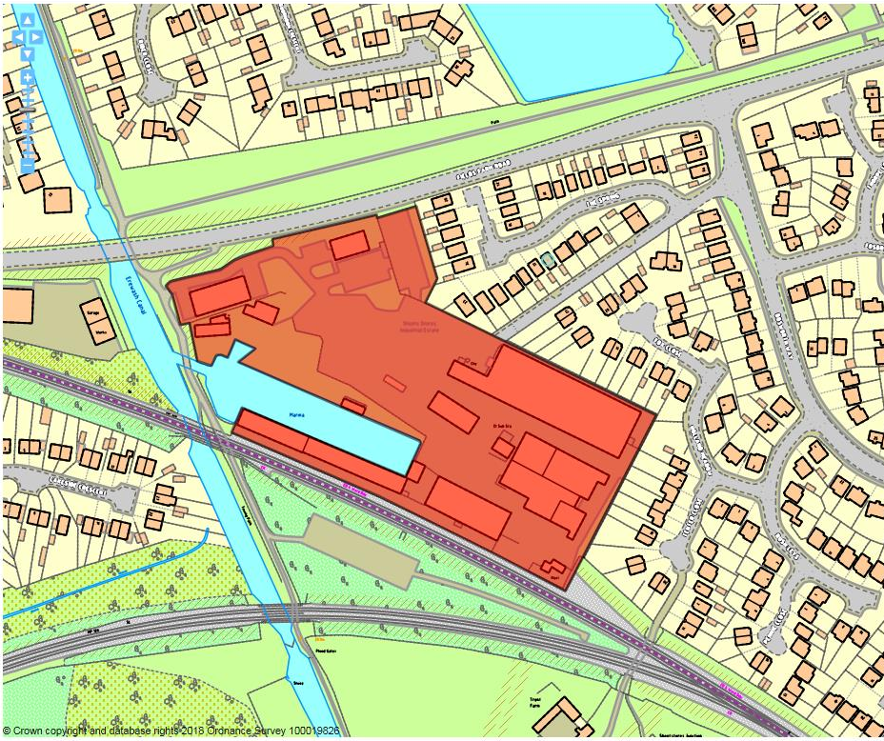

Site details:
Site reference (EELS) | EELS 012
Site name(s) | Sheetstores Industrial Estate
Settlement | Long Eaton
Description | Historic Industrial Estate linked with Canal-era still in active use with predominantly B2 operations. Good quality of public realm
Occupiers | Multiple small-medium scale manufacturing/storage units. Some connection with furniture sector e.g. Celtheath
Current use classes present | Predominantly small – med scale B2/B8 sector (80%) remainder B1a office/B8/Sui Generis (e.g. car parts)
Size (ha) | 2.3ha
Building age(s) | Predominantly c19th with some late-c20th additions
Building quality | Generally well maintained and have historic appeal due to Conservation Area
Site assessment:
Prox. to strategic road network | Site 3.9km to J25 (M1/A52) 2
Local prominence | Only vehicular access is from Bosworth Way/Fields Farm Road – both unclassified local roads 2
Public transport | Site within 500m of local bus service 27 on Wyvern Avenue 10
Relationship to workforce | Site within Long Eaton settlement 10
Planning policy considerations | Conservation Area, adjacent to residential properties and internal access unconducive to HGVs, local list buildings 6
Environmental setting | Canal basin & historic buildings create a good aesthetic, however minimal planting throughout the site 7
Flexibility of premises | Space to expand but may be constrained by restrictions posed by Conservation Area & Local List Buildings 6
Demand/Commercial desirability | Site appeared to be at full occupancy from recent visit 8
Final score & status | (Out of 73) 51

Site commentary:
Site description:
Land now occupied by Sheetstores Industrial Estate was originally developed in 1840 with the construction of a large depot to facilitate the transfer of coke between the adjacent Erewash Canal and railway line. Further buildings on the site were added in the latter half of the c19th and associated with its sheet dressing operations. Since the site became a private industrial estate during the mid-1960’s further buildings have been added, although some more recent industrial accommodation is slightly out of character with the style of the older stock which range between a single and three-storey in height. Sheetstores has been laid out in a linear manner reflecting the site’s rectangular shape, although the position of buildings is skewed more towards its east with a large area of hardstanding serving as car parking sat centrally within the site. The aforementioned depot building is located between the current railway line and a long, active canal basin accessed from the adjacent Erewash Canal which runs to its west. Whilst the site retains a degree of openness across it, recent additions (a two-storey office building facing out onto Fields Farm Road and a portal framed industrial unit at the eastern-end) have served to add further employment floorspace to the Estate. Despite Sheetstores physically adjoining Fields Farm Road, a single point of vehicular access is instead taken via a long, narrow road off Bosworth Way which eventually enters the central car park. A 1990’s housing estate adjoins the site to its east/north east, while Fields Farm Road provides most of the Ind. Est’s northern boundary. The remainder of the site’s surrounds are defined by the adjoining Canal and railway line.

Planning policy:
The site is almost exclusively located within the Sheetstores Conservation Area, a recent c21st designation, to reflect its historic merit. No new additions to the employment facilities have been added since the designation, with all future buildings expected to make a greater contribution to the character of the area than recent additions. The presence of two buildings on the Council’s local list register (Manager’s House and former Coke Depot) also will have some influence on further building additions adjacent to their location on the site). The presence of housing east of the site may result in some minor levels of disturbance being experienced by householders, particularly if within outdoor parts of domestic curtilage. Finally, the irregular arrangement of industrial premises at the eastern end of the Estate and limited space between buildings could pose problems for HGV’s trying to access particular units.

Site flexibility:
Sheetstores designation as a Conservation Area places some restrictions on the type and scale of new development proposed here. While a potentially excessive amount of car parking exists centrally within the site, the use of any part of this to accommodate further premises would result in a stronger design and building specification than recent additions.

Demand and commercial desirability:
All premises appeared to be fully occupied from a recent site visit.

Final conclusion:
This is a popular industrial estate located in the south of Long Eaton. With historic associations to the movement of coking materials between rail and canal, the continued existence of the site in an industrial use provides a diverse range of accommodation to local businesses. Sheetstores Conservation Area status also provides the site with desirability and commercial appeal, setting it aside from modern nearby industrial estates.

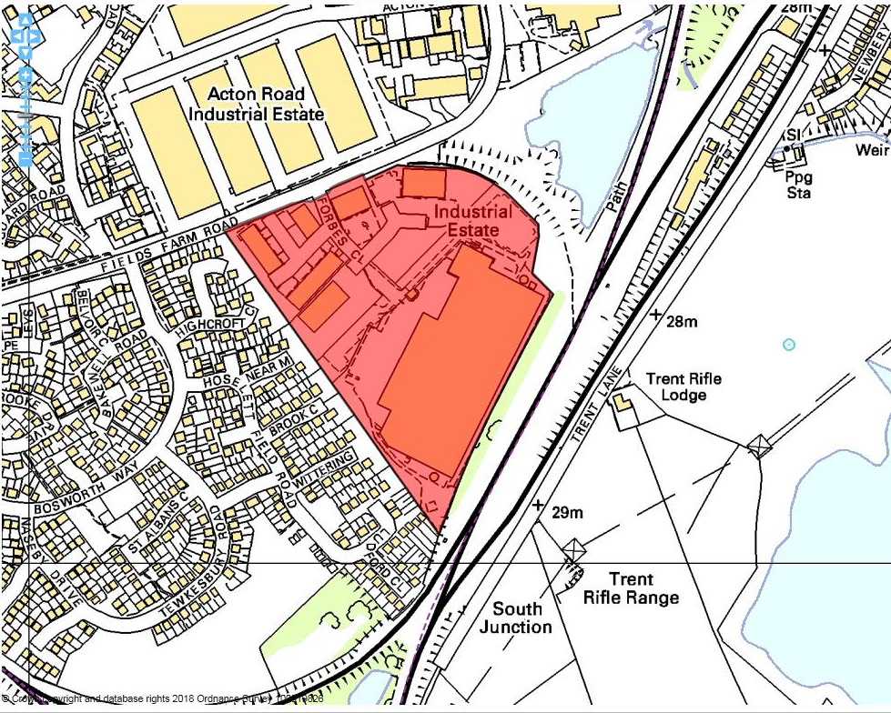

Site details:
Site reference (EELS) | EELS 013
Site name(s) | Forbes Close Industrial Estate
Settlement | Long Eaton
Description | Recent industrial estate located on fringe of Long Eaton
Occupiers | Largest occupants include DHL, Censol, Travis Perkins, DFS (Sofas) & Impact Fork Trucks – a number of others are based in units at Gainsborough Business Park
Current use classes present | B1(c), B2, B8, A1 and Sui Generis
Size (ha) | 7.7ha
Building age(s) | Site developed in early-1990’s, with some more recent additions to premises.
Building quality | Generally good
Site assessment:
Prox. to strategic road network | Site 4.4km to A52 1
Local prominence | Despite fronting Fields Farm Road, a busy local road, this highway is unclassified 2
Public transport | Nearest bus service is over a 1km away from site 0
Relationship to workforce | Site within Long Eaton settlement 10
Planning policy considerations | Site neighbours Local Nature Reserve (Forbes Hole) and group TPO on trees between DHL and the adjacent railway line 8
Environmental setting | Minimal soft landscaping throughout the site, with largely hardstanding for car parking and service areas 6
Flexibility of premises | New premise (for Censol) recently built, but little remaining space for new builds or extensions to premises 5
Demand/Commercial desirability | Only two vacant units (on the Gainsborough Business Park side of site) evident from site visit 8
Final score & status | (Out of 73) 40

Site commentary:
Site description:
An industrial estate located off Fields Farm Road in the south-east of Long Eaton, this area of employment can be further divided into two areas with larger premises within its east and south, whilst a number of small units are situated in the west of the site in Gainsborough Business Park. Set out for employment use at the same time as the construction of Fields Farm Road in the 1990’s, the largest premise on the site is clearly DHL distribution; the curtilage of which occupies around half the total size of EELS 013. Despite its size, its position at the rear of the employment site behind other premises obscures clear views of the vast logistics facility. In the site’s east and north are larger employment premises, mainly with single occupants although one building accommodates both The Plumbing Centre and Howdens Joinery. Another sizeable area of the site is taken by Travis Perkins, understandably with a large outdoor storage area in which building supplies are kept before loading. In the west of the site is Gainsborough Business Park, with three rows of units incorporating a diverse range of uses. Whilst most appear to have ancillary office accommodation at the frontage, several have reconfigured these to incorporate a vehicular access bay into the elevations. A notable area of car parking can be found at the frontage of all three rows of units.

Planning policy:
The business park is generally compliant with planning policies, although there could be concerns about the site’s operations at its north-eastern edge conflicting with a sensitive area of environmental importance at Forbes Hole Local Nature Reserve. Additionally to this, a line of predominantly Beech trees are positioned in-between the rear of the DHL distribution facility and the adjacent railway line. While this area appears to be private and inaccessible to DHL, the presence of a group TPO in such close proximity to employment premises does give rise to issues regarding the maintenance of trees as part of the designation.

Site flexibility:
With the recent addition of a new unit accommodating Censol, no further obvious plots now remain on the site in which new premises could be constructed. Whilst there is space surrounding some of the occupants on the estate, a site visit showed this space to largely be needed for operational purposes or to accommodate car parking to avoid the need for cars to park on the estate’s internal roads.

Demand and commercial desirability:
A recent site visit showed only minimal vacancies existed in the units on site. This, together with the presence of some well-known businesses, demonstrates that the estate is a popular area in which to trade.

Final conclusion:
As mentioned above under ‘demand’, a relatively-modern industrial area on the edge of Long Eaton remains a thriving area of business which contains a good diversity of business space and occupants. The site is considered to make a strong contribution to the local economy, with DHL in particular providing a large number of jobs to the local workforce.

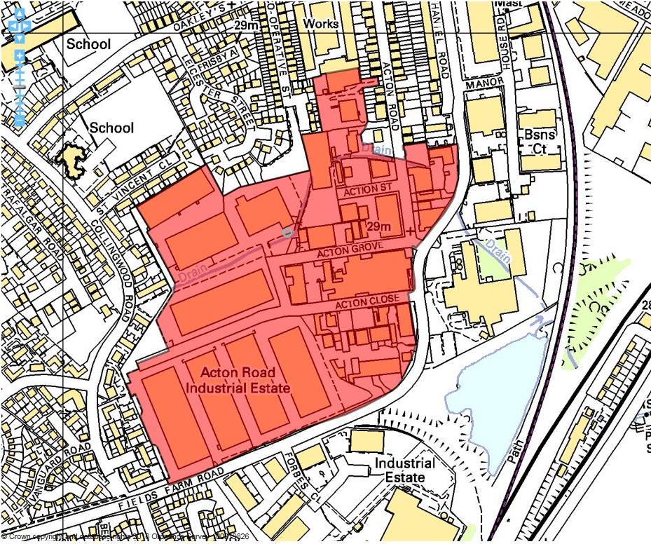

Site details:
Site reference (EELS) | EELS 014
Site name(s) | Acton Road Industrial Estate
Settlement | Long Eaton
Description | Vast area of industrial facilities accessed off Fields Farm Road south of Long Eaton Town Centre.
Occupiers | Various
Current use classes present | Mainly B2 & B8
Size (ha) | 15.7ha
Building age(s) | Mixed
Building quality | Average
Site assessment:
Prox. to strategic road network | Site 4.2km to A52 1
Local prominence | Site accessed off Fields Farm Road, an unclassified highway 2
Public transport | Site within 500m of nearest bus stop on local 29 bus service 10
Relationship to workforce | Site within Long Eaton settlement 10
Planning policy considerations | Adjacent to residential development & presence of tree preservation orders on site 8
Environmental setting | Lack of landscaping or green aspects across the site in general with some isolated exceptions 5
Flexibility of premises | Good diversity of premises across the site in general 7
Demand/Commercial desirability | Vast majority of units and industrial premises across the site currently occupied – only a handful of premises currently vacant and being commercially marketed 8
Final score & status | (Out of 73) 51

Site commentary:
Site description:
A notably-sized area of industry in Long Eaton with clear east-west divide evident between age and size of employment stock. The older eastern section of EELS 014 was constructed throughout the 1960’s and sees a wide mixture of industrial buildings of varying sizes and appearance, but mainly of average quality. The layout of premises is random, with buildings positioned in different ways within their plots. An absence of soft landscaping in this part of the site creates a notably low-quality environment which is heavily dominated by the private car and trade vehicles with several buildings positioned to the rear of large forecourts given over to serve parking requirements. Access to these premises is taken from Acton Road, which in turn serves Acton Avenue, Street, Close and Grove; all no-through road highways, although the last two provide an alternative point of access into the western section of the site. The west of EELS 014 is a newer area of industrial development constructed during the mid-1970s. With several direct accesses off Fields Farm Road, eight sizeable multi-bay portal frame industrial units which collectively total 462,000 sq. ft. of gross internal floorspace are arranged to allow front and rear access to high service bay doors. Ample hardstanding exists between each of the eight individual buildings allowing ample space for employer and visitor parking. A drain runs through the centre of this part of the site in an east-west alignment with grassed areas flanking to create a softer area of landscaping within an otherwise visually bland industrial estate. Residential development has encroached to the western and northern boundaries of the site, although general areas of industry remain to the south and east.

Planning policy:
Few planning policies are of note which would adversely impact upon this site’s ability to continue operating as an industrial site. Given the size of the employment area, it is inevitable that it comes into closer contact with residential area at points around its perimeter, which is the case at its northern and western boundaries. The operations taking place are could result in some minor noise disturbance, particular within domestic curtilages. Two small groupings of TPO designated trees are located close to the junction of Acton Road and Acton Street which would require protection in the event of nearby redevelopment of industrial facilities.

Site flexibility:
The large-scale site results in a wide variety of premises being present providing a good range of choice to the market. Some signs are evident of newer small industrial buildings being constructed within the eastern section of EELS 014, although space in which further development(s) can be accommodated without more extensive estate reconfiguration now appears to be limited. The larger multi-bay premises in the west of the site offer the opportunity to be internally partitioned.

Demand and commercial desirability:
Occupancy levels are excellent around the site, with only limited units being commercially marketed during a recent visit.

Final conclusion:
A thriving area of industry off Fields Farm Road, Acton Road Industrial Estate is the largest employment area in Long Eaton. Housing a wide range of industrial operations within a diverse building stock, the Estate’s popularity demonstrates strong mark appeal as a business location. Some premises in the eastern section of the site are now beginning to look dated, but any future development should retain the employment uses Acton Road currently enjoys.

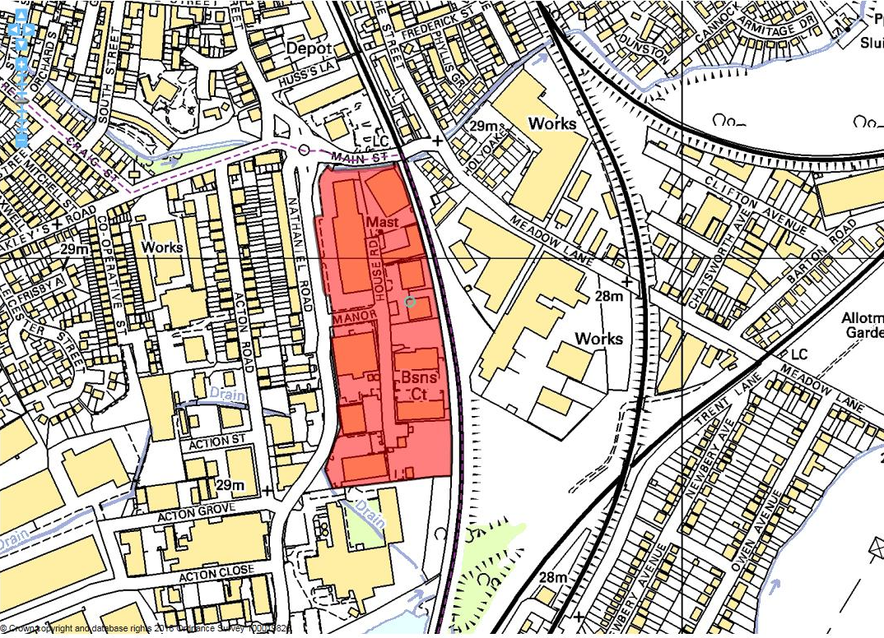

Site details:
Site reference (EELS) | EELS 015
Site name(s) | Fields Farm Industrial Estate
Settlement | Long Eaton
Description | Industrial Estate consisting of larger single factories and smaller unit premises in a court arrangement
Occupiers | GB Flints, Rise & Recline, CPT, Albert Pochin, Plus Art, Douglas Gill International, Acclaim Upholsterers, LF Intimates Ltd, Transworld Trophies, Civa Logistics, MCA Enterprises & Actavo
Current use classes present | Predominantly B2 and B8 with ancillary office uses in some premises
Size (ha) | 5.0ha
Building age(s) | Northern half of site constructed during 1980’s with southern half built during 1990’s and early 2000’s
Building quality | Generally good
Site assessment:
Prox. to strategic road network | Site 3.9km to A52 2
Local prominence | Despite fronting Fields Farm Road, a busy local road, this highway is unclassified 2
Public transport | Site is located more than 1km away from nearest bus route 0
Relationship to workforce | Site within Long Eaton settlement 10
Planning policy considerations | Site adjoins confirmed HS2 route 9
Environmental setting | Some soft landscaping evident at road verges with limited shrubbery around some of the units on site 6
Flexibility of premises | Most premises thought able to expand into wider curtilages and single plot remains to build new premise 7
Demand/Commercial desirability | All units and premises appeared occupied at time of visit 8
Final score & status | (Out of 73) 44

Site commentary:
Site description:
An Industrial Estate accessed off Fields Farm Road, located south-east of Long Eaton town centre. Formerly railway sidings serving the adjacent line, the Estate was constructed around the same time as Fields Farm Road, and occurred over two phases. The northern half of the Estate was constructed first, followed later by premises further south ensuring the expansion of the site to the now shared boundary of EELS 016. Given the age of premises, all are relatively modest in design, albeit there are notable differences in each’s appearance given some visual interest. In the north of the site, the largest building sits between Fields Farm Road and Manor House Road with its primary frontage facing westwards onto the former (where vehicular access is taken from) with a notable area of car parking in foreground. To the east of this building, a telecommunications mast of minor height is sited at the end of Manor House Road. A more recent addition is units at Palmer Business Court located on the eastern side of Manor House Rd, with a secured curtilage situated behind palisade security fencing. Away from the Business Court’s units, a number of industrial premises across the site display a broadly similar style, with exposed brick elevations at ground level being obscured by sheet metal facades at higher levels. Most have access bays to allow for internalised loading/unloading to occur. Ancillary office space is also evident and is set within the buildings; some restricted to one-storey, whilst occasionally the office space spans both storeys of the premises. There are varied surrounds to the site, with a mix of residential properties fronting Nathaniel Road (a parallel road to Fields Farm Rd) and additional industrial premises situated further south. East of the site, beyond the railway line, is further industrial land accessed off Meadow Lane.

Planning policy:
Few issues exist which demonstrate conflict with the policies of the Borough’s Local Plan. Whilst not directly impacting upon the site, the published and confirmed route of HS2 immediately east is likely to cause disturbance during the construction of the line.

Site flexibility:
With most premises on the site large in size and positioned within fairly spacious plots, there is potential to make adaptations should operational requirements occur. There is also a vacant parcel of land, immediately north of Palmer Business Court, with vehicular access already established from Manor House Road to serve future unit(s).

Demand and commercial desirability:
A recent site visit showed no evident vacant units across the entirety of the site demonstrating the Estate’s popularity. Whilst further units could be delivered just north of Palmer Business Court, there were no commercial marketing details evident in which to direct enquiries towards.

Final conclusion:
Another Industrial Estate situated close to Long Eaton Town Centre with excellent occupancy rates. The majority of those operating from units at the Estate have been present for a considerable period of time, demonstrating the importance of the site in supporting local enterprises. The nearby presence of HS2 could be of concern to some firms here, but with the line only adjoining rather than requiring any land on the Estate, it is expected that this area of industry will continue to make a strong contribution to the local economy for a considerable amount of time.

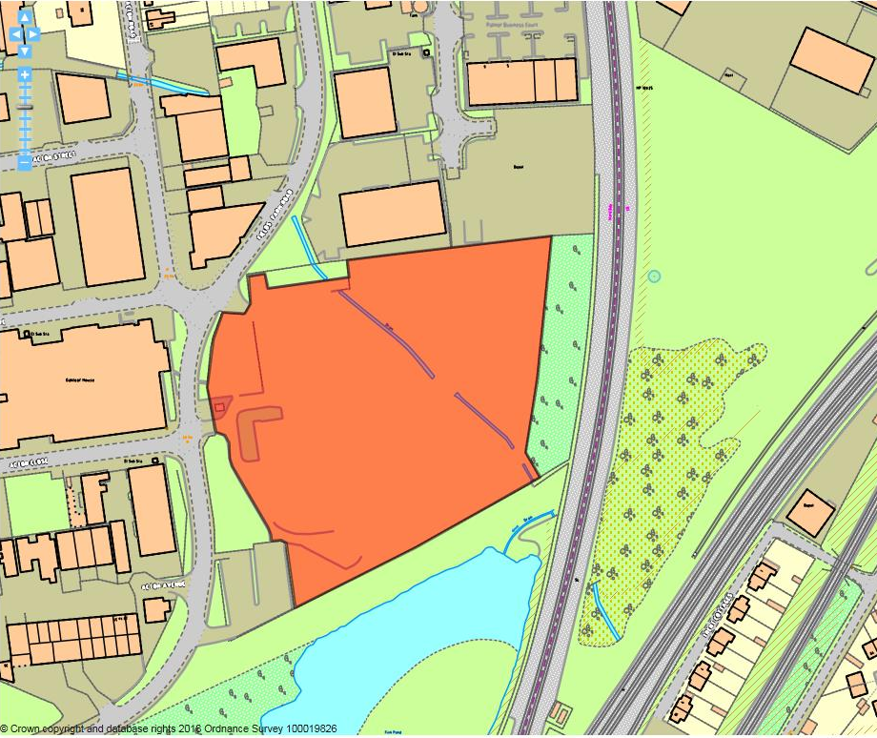

Site details:
Site reference (EELS) | EELS 016
Site name(s) | Former Nylatex factory site
Settlement | Long Eaton
Description | Now cleared site of former Nylatex factory premises
Occupiers | N/A
Current use classes present | None, but formerly B2
Size (ha) | 2.4ha
Building age(s) | N/A
Building quality | N/A
Site assessment:
Prox. to strategic road network | Site 4.2km to A52 1
Local prominence | Despite fronting Fields Farm Road, a busy local road, this highway is unclassified 2
Public transport | Nearest bus services are accessed around 850m west at Tamworth Road 5
Relationship to workforce | Site within Long Eaton settlement 10
Planning policy considerations | Adjacent to Forbes Hole Local Nature Reserve, presence of Group TPO listing bordering the site and exposed drain running across site 7
Environmental setting | Notable number of mature, tall trees line the site’s boundaries providing a green surrounding, although the cleared site reveals a large area of hardstanding 7
Flexibility of premises | Flexible in sense that site is currently vacant, although Planning Policy aspects provide some limitations and restrictions 7
Demand/Commercial desirability | Site currently being commercially marketed by FHP as ‘Forbes Park’, but has been vacant for some while 0
Final score & status | (Out of 73) 39

Site commentary:
Site description:
The site of the former Nylatex factory, this area of land currently stands vacant after the demolition of all previous buildings and structures around three years. It is on the eastern edge of a notable area of wider industrial uses in the south-east of Long Eaton. Two main vehicular accesses are taken off Fields Farm Road, the northern-most almost level with at its junction with Acton Road on its western side. Notable areas of hardstanding remain closest to its site frontage, with areas of site car parking largely untouched. Despite its former industrial use, the site does have a strong green environment with it enclosed on south and eastern sides with fairly dense screenings of trees, whilst some self-seeded shrubs have begun to colonise the land in the time since the site was cleared of its industrial premises. A small exposed drain runs across the land here, although this is partially hidden by a dense grouping of trees positioned centrally within the site.

Planning policy:
Initially, early alignments of the eastern leg of HS2 showed a possible impact on this site with the route passing very close to its eastern boundary. However, the Government’s preferred route now sees the line pass comfortably away from the boundary to not raise concerns about sterilising the redevelopment potential of the Forbes Park site. Policy issues of concern are a neighbouring Local Nature Reserve (Forbes Hole) immediately south of the site, a grouping of Tree Preservation Order trees between the edge of the site and Fields Farm Road and also an open drain which flows broadly along an east-west axis through the site giving rise to some concerns over the site being the source of localised flooding, despite this part of Long Eaton sitting only inside Flood Zone 2.

Site flexibility:
The site has flexibility in the sense that it is vacant, has established points of vehicular access and egress and is currently being commercially marketed for new employment uses. The issues identified within Planning Policy above, whilst are relevant concerns, are not thought prohibitive enough to sterilise the redevelopment potential of Forbes Park, but matters such as the drainage arrangements will give cause for careful design of new buildings.

Demand and commercial desirability:
The site is currently being marketed by Fisher Hargreaves Proctor (FHP), with a keenness sought for a design and built option upwards of 30,000 sq.ft. However, given the recent uncertainty caused from the route HS2 was to take, it is understandable why the site has not been acquired so far.

Final conclusion:
This is an excellent opportunity to deliver new employment premises within Long Eaton. With land for new-build generally short in supply, such locations should be encouraged to provide new industrial space in a manner which respects the neighbouring Local Nature Reserve. With a number of industrial premises likely to be lost to accommodate a new HS2 route through Long Eaton, this site may well play an important future role in absorbing displaced businesses who have to vacant current premises which are earmarked for demolition in accordance with the Government’s preferred HS2 line north of Birmingham.

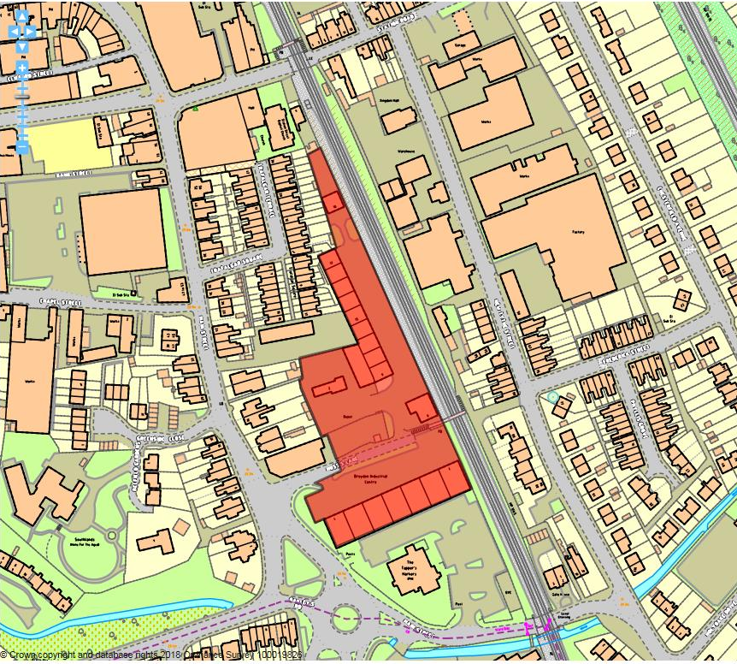

Site details:
Site reference (EELS) | EELS 017
Site name(s) | Breydon Industrial Centre
Settlement | Long Eaton
Description | Modern, functional industrial centre on SE fringe of Long Eaton town centre
Occupiers | Whitt Bros Contractors, Robert Binding Engineers, Dave Wallis Motor Repairs, Reem Machine, Long Eaton Koi Carp, Moobarb, Jackdaw Express, Crowns Surveillance, Smarts Tops, Nottm Garage Doors Ltd, A1 Imports, Elm Training, Midland Building Plastics, MD Computers, Halfords Autos, Screwfix and East Mids Wholesalers.
Current use classes present | A1, B1(c), B2, B8 & Sui Generis
Size (ha) | 1.1ha
Building age(s) | Ind. Centre built during 1990’s with modern units added
Building quality | Good to excellent
Site assessment:
Prox. to strategic road network | Site 3.7km to A52 2
Local prominence | Site accessed off unclassified Main St/Huss’s Lane 2
Public transport | Site within 500m of nearest bus service (no.29) which routes to corner of Main St. and Oakley’s Rd 10
Relationship to workforce | Site within Long Eaton settlement 10
Planning policy considerations | Adjacent residential development, presence of Local Building of Interest & adjoins HS2 Safeguarding Zone 7
Environmental setting | Some isolated trees throughout site, but mainly buildings, road, service areas and car parking – limited greenery 6
Flexibility of premises | Modern premises able to be adapted, while new business units built just north of entrance on Huss’s Lane 8
Demand/Commercial desirability | All premises currently occupied – although new business units remain under construction 8
Final score & status | (Out of 73) 55

Site commentary:
Site description:
Breydon Industrial Centre is a relatively recent employment area featuring around 20 good quality and functional units within close walking distance of Long Eaton town centre. Constructed during the 1990’s, the Centre consists predominantly of two rows of units; the first to the right upon entrance into Huss’s Lane enjoy spacious forecourts which provide off-street car parking and loading areas serving high roller shutter loading bay doors interspersed between limited doors and windows along the north-facing elevation. Turning left before reaching a pedestrian footbridge providing access over the adjacent railway line, road access running parallel with the railway continues northwards. Lining this along its left is the second row of industrial units, again each containing loading bay doors providing internal service access for vehicles. A narrow area of car parking faces the industrial units on the opposite side of the service road, which eventually reaches an isolated, single unit marking the northern-most point of EELS 017. To the rear of these units, and lining a small yard is Centra House; a c17th farmhouse extended in early-c20th. Prominent as a result of its white render, this building, which now incorporates an office use, sits within a much-altered environment characterised yet further with the construction of five close-to-finished light industrial units immediately opposite that adjoin Huss’s Lane on their southern side.

Planning policy:
The eastern boundary of the site is also the outer extent of the HS2 Safeguarding Zone. Beyond this, the construction of the HS2 line is expected to occur. Whilst EELS 017 does not sit within the Zone, the adjacent engineering operation is likely to create significant disturbance during the line’s construction. At the northern tip of this site, industrial units back directly onto residential properties along terraced properties on the eastern side of Trafalgar Terrace and Square raising the likelihood that operations at the neighbouring units could generate minor noise disturbance to those within their domestic curtilage. Finally, the presence of a Building of Local Interest at 2 Huss’s Lane (described above) is of interest. Surrounded by various forms of employment, ensuring the building’s continued presence through future (re)development will be important to protect a local heritage asset.

Site flexibility:
The site has demonstrated its flexibility recently through the construction of new light industrial units on the northern side of Huss’s Lane. With units at Breydon Industrial Centre relatively modern, and each with basic facilities (service/loading bay), their internal usage is thought to be adaptable. However, with space constraints limiting the physical extension of existing units, there remains little room across EELS 017 for units to grow or to accommodate any further employment floorspace.

Demand and commercial desirability:
Occupancy across the site appeared to be at 100% from a recent site visit. Industrial units under construction to the north of Huss’s Lane are not yet ready to occupy, but are expected to be commercially available soon.

Final conclusion:
A good example of modern light and general industrial units in a highly accessible location. Units here appear to be popular to small local enterprises, as well as national names (Halfords, Screwfix). The addition of new units to Breydon demonstrates a strong level of commercial interest in EELS 017, although the future construction of an elevated HS2 line immediately east of the site could impact the desirability of facilities here.

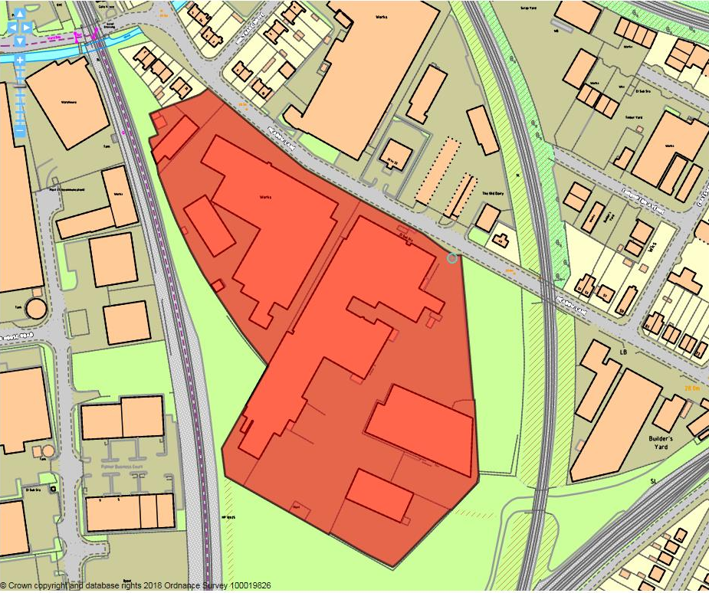

Site details:
Site reference (EELS) | EELS 018
Site name(s) | Meadow Brooks Business Park
Settlement | Long Eaton
Description | Large complex of factories south-east of Long Eaton town centre
Occupiers | Andrew Paul Furniture, Glynwed Leisure, Leisure Furnishings Ltd and Webro Cable & Connectors
Current use classes present | B2
Size (ha) | 3.8ha
Building age(s) | Original section (formerly Meadow Mills) of site dates from early c20th, with additions between 1960 and 1990.
Building quality | Mixed
Site assessment:
Prox. to strategic road network | Site 3.8km to A52 2
Local prominence | Site accessed from Meadow Lane, an unclassified road linking site to town centre and A6005 2
Public transport | Site within 500m of nearest bus service (no.29) which routes to corner of Main St. and Oakley’s Rd 10
Relationship to workforce | Site within Long Eaton settlement 10
Planning policy considerations | Proposed HS2 line passes through site and adjoins local wildlife site (ER133: Meadow Lane Carr) 8
Environmental setting | No green landscaping evident on site. Consists largely of buildings and areas of hardstanding 5
Flexibility of premises | Site densely covered in industrial stock (more so in west of site), leaving little scope for building extensions or new units. HS2 route will reduce size of site on SW side 4
Demand/Commercial desirability | Premises appeared to be fully occupied from recent visit although given depth of buildings, difficult to ascertain usage towards back of site 8
Final score & status | (Out of 73) 49

Site commentary:
Site description:
Meadow Brooks Business Park is an established area of industry south-east of Long Eaton town centre providing large-scale factory space to a number of companies. The Business Park is sectioned internally into two distinct parts, with the western half of the site containing multi-bay fronted industrial units positioned back from the public highway to incorporate small areas of car parking. Good levels of circulation space all around the premises are noticeable allowing HGVs access to the side and rear elevations, and two points of vehicular access exist to this part of the site, with wide entry points positioned immediately east and west of the largest block of buildings, allowing vehicles to navigate around the entire exterior of this section. The eastern section of the site sees more industrial buildings project even further south back into the site. At the site’s frontage with Meadow Lane, the former Meadow Mill is noticeable in appearance with its largely brick construction setting it aside from other stock of more functional appearance on-site. The Mill premises have been modified over decades with rear and side additions, although a number of newer larger industrial properties have been constructed further back into the site displaying no fixed layout. Access to this part of the site is taken towards the north-eastern corner, and passes east of the Mill premises before opening up into various areas serving each of the individual buildings. Towards the rear of the site, large areas of yard are noticeable which allow good access to the service/loading bays of premises. South of the site is land considered by EELS 019, whilst both to the east and west railway lines are present, the former carried by embankment.

Planning policy:
The Business Park is located within a general area of wider industry in this part of Long Eaton, so few issues are raised concerning the use of the site and its association with neighbouring residential areas – although it does adjoins local wildlife site (ER133: Meadow Lane Carr), situated immediately south-east of EELS 018. An immediate industrial environment is likely to not afford the LWS with the quality of setting that a sensitive area of biodiversity would expect to enjoy. Of significance to the site’s future as a Business Park is the proposed construction of the HS2 line which in the Government’s published route shows it passing through the south of the site. The current alignment would see land in which buildings currently stand upon at the very rear of the site required to allow the route’s construction.

Site flexibility:
Whilst some flexibility for reconfiguration of buildings on-site exists, this is limited due to the layout of EELS 018. New buildings are thought to be unlikely for the same reason, and whilst a large area of yard is situated towards the south of the site, the removal of some of this would create operational difficulties in serving buildings sited towards the rear. The future HS2 line passing through the site also limits any aspirations to provide additional industrial stock at the site, with more detail on aspects of the line’s construction likely required before site reconfiguration can occur.

Demand and commercial desirability:
All premises on-site are currently occupied. Leisure Furnishings Ltd have recently utilised 25,000sq.ft of vacated industrial space created with the departure of Hypnos to further expand their manufacturing operations demonstrating the site’s practical desirability.

Final conclusion:
The Business Park remains an important area for industrial uses in a relatively self-contained part of Long Eaton. Whilst stock is largely average in quality, this currently suits those present with established businesses making important contributions to the local economy. HS2’s presence across a corner of the site may require some reconfiguration of premises.

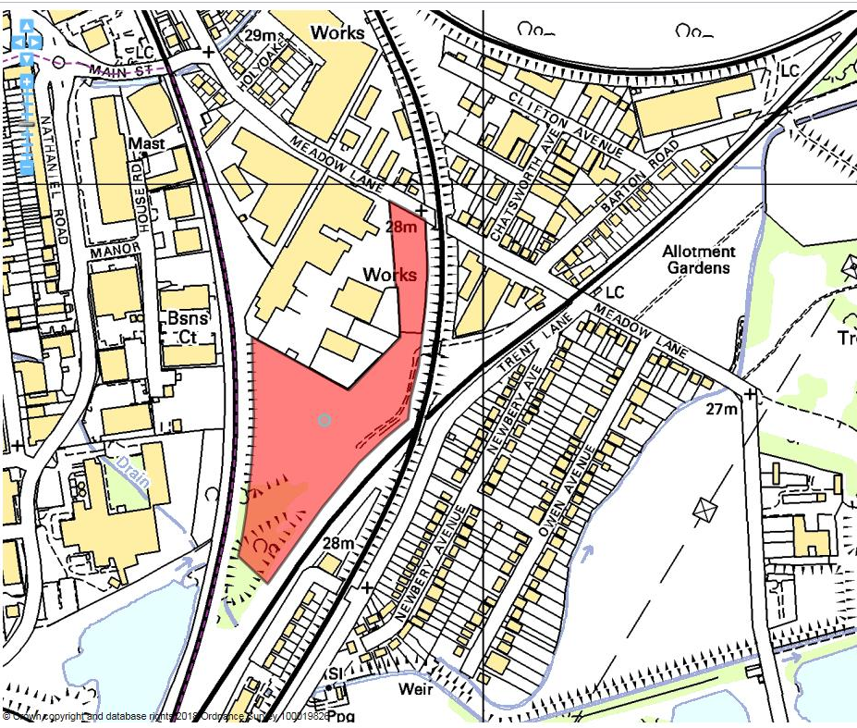

Site details:
Site reference (EELS) | EELS 019
Site name(s) | Former Meadow Lane industrial site allocation
Settlement | Long Eaton
Description | Former area of railway land positioned between operational rail lines
Occupiers | N/A
Current use classes present | N/A
Size (ha) | 3.6ha
Building age(s) | N/A
Building quality | N/A
Site assessment:
Prox. to strategic road network | Site 3.9km to A52 2
Local prominence | Access to site off Meadow Lane, a local road serving a number of industrial premises and residential area further south-east 2
Public transport | Site more than 1km from nearest bus service 0
Relationship to workforce | Site within Long Eaton settlement 10
Planning policy considerations | HS2 route, designated local wildlife site & likely contamination from former railway line through site 7
Environmental setting | Surrounded on three sides by railway lines, with parts of EELS 019 designated as local wildlife sites 4
Flexibility of premises | With HS2 route scheduled to pass through site, this further restricts the flexibility of site to accommodate new employment uses 2
Demand/Commercial desirability | Site was formerly allocated for new industrial uses for a number of years without being developed 3
Final score & status | (Out of 73) 30

Site commentary:
Site description:
This site, situated between three separate railway lines, is accessed off Meadow Lane at the southern end of a wider industrial area in the south-east of Long Eaton. Until the 1970’s, a railway line ran across this site, forming another approach to Trent Junction, where several local railway lines met close to the now closed Trent Station. Since the lifting of the line, the site had been identified by the Borough Council as land thought able to accommodate new industrial development, although the site’s constrained nature and poor scope for vehicular access from Meadow Lane (any access would have to cross privately-owned Network Rail land) led to its recent de-allocation. Nowadays, the area is noticeable for its wooded coverage, with a number of self-seeding trees and shrubs having colonised the site giving it enhanced ecological importance.

Planning policy:
The site’s employment potential is notably jeopardised by the published route of the eastern leg of the HS2 route running directly through the site in a broad north-south alignment. In addition to this, a Local Wildlife Site has been designated (ER133 - Meadow Lane Carr) which is separated into two parts, positioned on either side of the proposed route of the HS2 line. Lastly, with the railway line routed across this site until the 1970’s, it is expected that contamination consistent with the omission of oil and other pollutants into the ground from passing trains will have left ground conditions requiring an element of remediation before any new employment use could be approved.

Site flexibility:
The above planning policy factors, coupled with the highly-constrained nature of how to form vehicular access onto the site ensures that its flexibility to accommodate employment uses is severely reduced.

Demand and commercial desirability:
The site was allocated as one which industrial development was welcomed, with the allocation forming part of the Council’s Local Plan for a number of years. However, and likely as a result of some of the constraints mentioned above, no formal interest was ever expressed in bringing the site forward for development.

Final conclusion:
A heavily-constrained site which now sees published plans for the HS2 line cross it ensures that this site will not likely be able to accommodate any employment-based development upon it in the future.

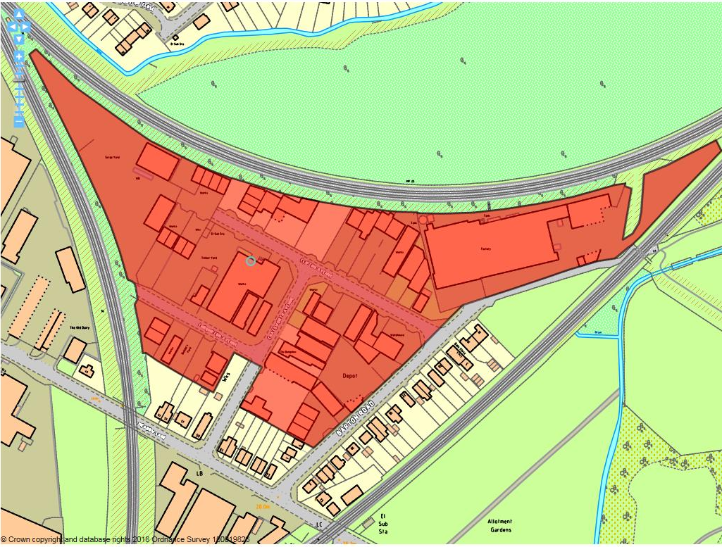

Site details:
Site reference (EELS) | EELS 020
Site name(s) | Clifton Avenue Industrial Area
Settlement | Long Eaton
Description | Area of generally low-quality yard-based employment uses located off Meadow Lane on the edge of Long Eaton
Occupiers | Various businesses based out of motor & timber yards, garages, scrap dealers with small factories involved in fabrications and upholstery
Current use classes present | B2, B8 & Sui Generis
Size (ha) | 4.4ha
Building age(s) | Industrial area established from the 1960’s onwards
Building quality | Largely poor
Site assessment:
Prox. to strategic road network | Site 4.1km to A52 1
Local prominence | Roads leading to and those within the site are all unclassified highways 2
Public transport | Site more than 1km from nearest bus route 0
Relationship to workforce | Site within Long Eaton settlement 10
Planning policy considerations | Neighbouring residential uses 9
Environmental setting | Very poor. Area characterised by scrap yard operations and noisy industrial uses. Little soft landscaping evident throughout the site 3
Flexibility of premises | Most plots positioned throughout the area are small, offering little scope for expansion with premises generally poor in quality which provides difficulties in adaptation 4
Demand/Commercial desirability | Whilst environment is low in standard, plots are popular with excellent levels of occupancy 8
Final score & status | (Out of 73) 37

Site commentary:
Site description:
This Industrial Area located on the very eastern edge of Long Eaton provides accommodation and space for a number of low-quality and non-conforming industrial operations. Accessed off Meadow Lane, a number of smaller yards, depots and factory premises are located at Clifton Avenue, Thrumpton Avenue, Chatsworth Avenue and Barton Road. The area’s relative degree of separation from the rest of Long Eaton is emphasised by railway lines which form the site’s western and northern boundaries, while a further line exists just south beyond Barton Road. With the physical separation this provides, the area has evolved into one supporting numerous yard-based operations which cumulatively creating a generally poor built environment. Some larger factory and works premises are present, with such buildings north of the junction of Chatsworth and Thrumpton Avenue’s, whilst the largest single building across the site is positioned at the end of Barton Road (Barton House) and sees a significant warehouse facility with spacious service and loading areas to its frontage positioned between converging railway lines at the eastern-most tip of EELS 020 – whilst originally constructed as a B2/B8 facility, it now accommodates a local motor sales company. Throughout the remainder of the site, a number of smaller, low-quality buildings can be found positioned at the rear of yards, whilst a notable area of hardstanding storage space supporting a motor-based operation exists at the end of Clifton Area on land which narrows on approach to the junction of two railway lines. Adjoining commercial businesses at the southern end of the site are residential properties situated on the northern side of Meadow Lane, whilst further houses are located along the southern side of Barton Road and these face directly across to several yards and small industrial buildings.

Planning policy:
With the Industrial Area for the most part isolated away from residential areas, few planning policies have been assessed as being of relevance to EELS 020. However, as the site description mentions, residential properties do directly adjoin the curtilages of homes on Meadow Lane, whilst properties on Barton Lane are also in very close proximity to industrial operations. At both locations, the close distance between industry and residential development is likely to create amenity issues for the latter with noise of most concern given the number of nearby active scrap and motor yards, but also the number of vehicular movements connected with all businesses in the wider area.

Site flexibility:
As already mentioned, the layout of the area sees a number of smaller yard spaces positioned around the several highways which pass throughout EELS 020. This reduces the flexibility of the site to either support the modification of a network of minor buildings or more extensive works to provide new employment floorspace. Regarding the latter, little space around the industrial area is evident which could accommodate a new standalone building.

Demand and commercial desirability:
Despite the poor general environment throughout the area, the vast majority of premises are currently occupied. Whilst facilities are not of good quality, there is nevertheless a commercial requirement for such space in parts of urban areas that are generally remote from residential areas to reduce amenity impacts.

Final conclusion:
Whilst scoring low against the assessment criterion, this area of low-quality industrial space and premises should still be recognised for the important contribution made towards the local economy by providing an opportunity for such non-conforming uses to be removed from Long Eaton’s residential areas.

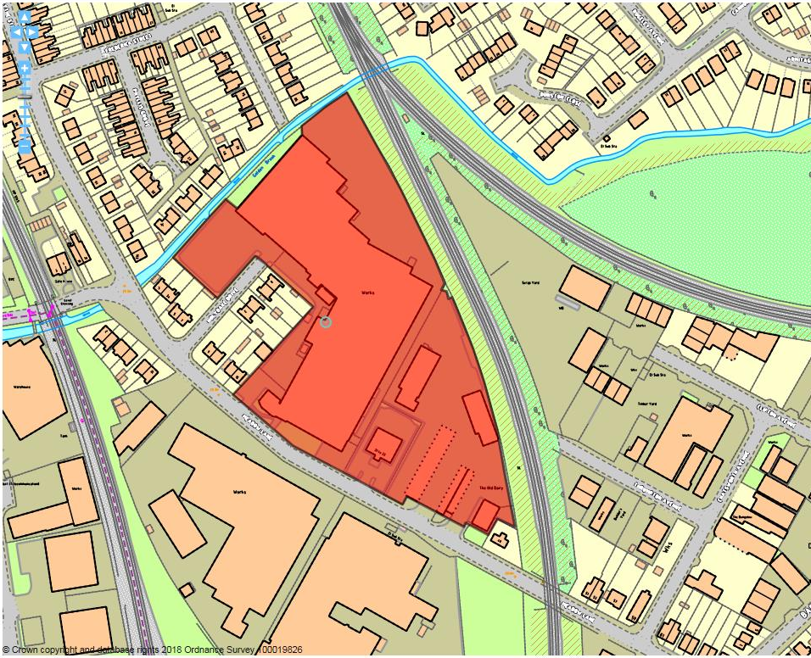

Site details:
Site reference (EELS) | EELS 021
Site name(s) | Works at Holyoake Drive / Meadow Lane
Settlement | Long Eaton
Description | Mix of variously-sized industrial premises located north of Meadow Lane
Occupiers | AGA Rangemaster, Michael Key Automobile Workshop, Aspey Trucks, Bridgecraft Upholstery, Auto Direct Cars, Practical Car & Van Rental and Alan Bexon Ltd.
Current use classes present | B2 and Sui Generis
Size (ha) | 2.5ha
Building age(s) | Rangemaster premises from 1970’s, some older buildings connected to The Old Diary from early-mid c20th.
Building quality | Average
Site assessment:
Prox. to strategic road network | Site 3.8km to A52 2
Local prominence | Site accessed off Meadow Lane, an unclassified local highway 2
Public transport | Site within 500m of nearest bus service (no.29) which routes to corner of Main St. and Oakley’s Rd 10
Relationship to workforce | Site within Long Eaton settlement 10
Planning policy considerations | Adjacent to residential properties 9
Environmental setting | Some trees evident around site boundary, particularly at western end separating Rangemaster from homes on Holyoake Drive. Little landscaping evident elsewhere 5
Flexibility of premises | Rangemaster factory adapted/extended over time, while permission was granted for demolition of units and rebuild, although this was not implemented 7
Demand/Commercial desirability | Vast majority of premises occupied around the site 8
Final score & status | (Out of 73) 53

Site commentary:
Site description:
This site, located within a wider industrial area in the south-east of Long Eaton, is dominated visually by the vast AGA Rangemaster production facility which occupies most of the western half of EELS 021. The building’s elevation with Meadow Lane sees a fairly modern looking three-storey ancillary office floorspace fronting the highway, with a more recent two-storey addition constructed to its side. Beyond the office accommodation, a sizeable production facility of significant depth and staggered height runs back in the site, almost towards its boundary with an adjacent rail line. Towards its rear, further facilities run at right angle projecting towards the site’s western boundary. Given the building’s size, three separate vehicular accesses serve different parts. The end of Holyoake Drive accesses staff car parking and a loading area beyond, a small private and gated access enters the site just west of the office buildings with a limited area of parking at its end, and a final access runs the length of the premises fronting Meadow Lane, before turning westwards and entering yard space and the rear of the building’s western wing. The eastern section of the site, an old dairy facility, now provides smaller units of industrial space as well as a detached office premise (no. 31-33) which, facing out over a parking forecourt towards Meadow Lane, is situated between Rangemaster and older former outbuildings on the Old Dairy site. The latter is served by a separate dual access off Meadow Lane, with vehicular entrances passing between palisade fencing either side of a small gatehouse which immediately north continues as low-quality sheltered parking. Further back into a narrowing site, a pair of contrasting industrial units faces each other across a central yard space. The eastern row of units is more modern, whilst the western row were formerly garages since converted to workspace. Neighbouring the site on its east and sweeping around to its north is a densely vegetated railway embankment, whilst to the west are properties on Holyoake Drive, the Golden Brook (a tributary of the River Erewash) and beyond that, homes on Phyllis Grove and Chesterfield Avenue.

Planning policy:
Few specific planning policies affect or impact upon the site, although operations from the Rangemaster premises and loading/unloading of products at the rear of the western wing of the building may generate some noise and disturbance for those in the curtilages of properties at the southern end of Chesterfield Avenue.

Site flexibility:
The Rangemaster factory and premises have been modified and extended in recent decades to meet operational needs and requirements, although further expansion now looks unlikely given the footprint that buildings cover and their proximity to the boundaries of this part of EELS 021. Further south, evidence of the site’s flexibility to accommodate additional industrial space was demonstrated through the granting of permission (ERE/0804/0066) to reconfigure the Old Dairy site and provide fourteen additional units and modernisation of three existing buildings. Whilst this was not implemented, it is unlikely the Borough Council would refuse a similar scheme.

Demand and commercial desirability:
Good occupancy levels exist across both elements of the site, with the facilities here proving popular for smaller local businesses.

Final conclusion:
A well-performing employment site, the presence of Rangemaster in Long Eaton is vital for the town’s economy with a large number of employees drawn from the local area. Whilst the facilities at the Old Dairy are currently popular, the potential for redevelopment of this part of EELS 021 could help to safeguard employment at the site in the long-term.

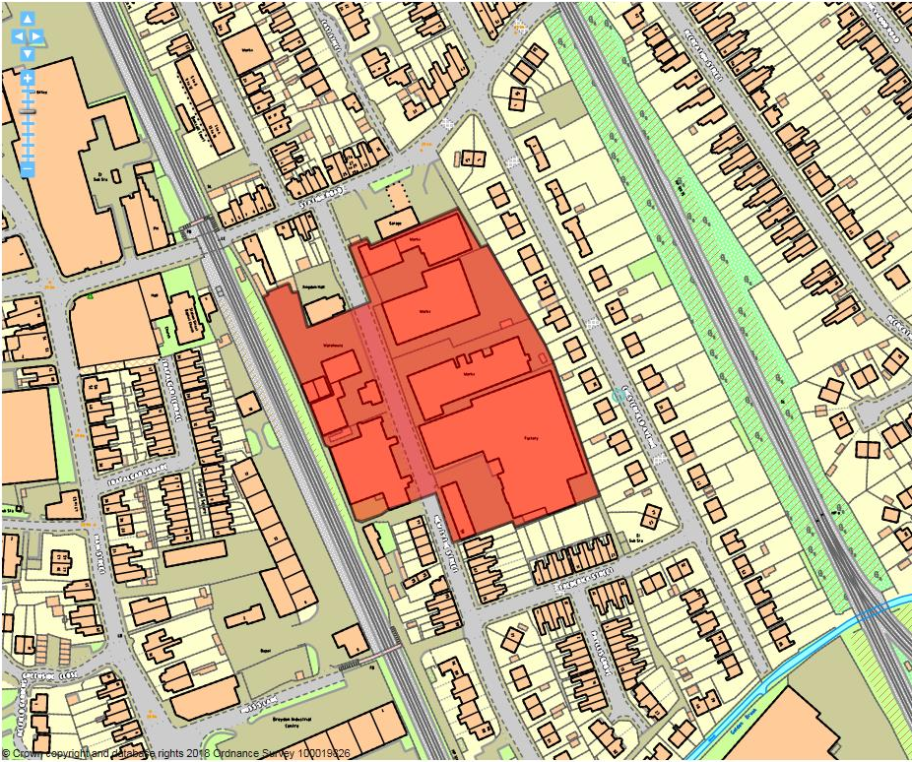

Site details:
Site reference (EELS) | EELS 022
Site name(s) | New Tythe Street Industrial Area
Settlement | Long Eaton
Description | Industrial area consisting of several large factory premises located east of Long Eaton town centre
Occupiers | Kaylee Transfers, Occupants of the New Media Centre, Erewash Valley Gymnastics, Nexus Exhibitions, Air Cat Ltd, Everso Catering, Arbon Joinery, Censol Industrial Products & Crowdpullers Ltd.
Current use classes present | Mix of B1(c) and B2, with B1(a) & A1/A2 in New Media Centre and D2 (Gym Club)
Size (ha) | 1.7ha
Building age(s) | Industrial buildings on-site from early-c20th, with inter, and post-war (WWII) additions
Building quality | Mixed
Site assessment:
Prox. to strategic road network | Site 3.4km to A52 3
Local prominence | Site accessed from New Tythe Street, an unclassified local road 2
Public transport | Site within 500m of nearest bus service (no.29) which routes to corner of Main St. and Oakley’s Rd 10
Relationship to workforce | Site within Long Eaton settlement 10
Planning policy considerations | Proposed HS2 route and safeguarding area spans entirety of area west of New Tythe Street, surrounding residential development and Local Building of Interest on the site 7
Environmental setting | Very little soft landscaping throughout the site, with buildings, parking space and servicing yards prevalent 5
Flexibility of premises | Loss of western part of site to HS2, aging premises 4
Demand/Commercial desirability | Single-storey office building at southern end of site vacant at time of visit – occupancy good elsewhere in site 8
Final score & status | (Out of 73) 49

Site commentary:
Site description:
An industrial area of Long Eaton located just east of the town centre, but which is largely surrounded to its north, south and east by residential areas. The central road, New Tythe Street, provides vehicular access to all employment premises throughout the area, with a number of entry and exit points located between the various buildings which either line the highway, or are situated to the rears of buildings which front New Tythe Street. In general, buildings found around EELS 022 are typical of industrial buildings of the c20th, with little visual interest or architectural merit. Most are functional in their appearance, although a former Mill building abuts the road to the east, whilst the frontage of Nexus is styled in a way consistent with the appearance of a Chapel. Adjoining this on its southern side is a single-storey office building which is included on the Council’s Buildings of Local Interest List. This building, designed by Gorman & Ross, extends back from New Tythe Street and eventually adjoins, through modern additions, a large factory originally constructed as Lace Mills and which displays a traditional saw-tooth roof arrangement. Of note on the west side of New Tythe Street is a prominent, rectangular two-storey building with fabricated sheet metal cladding. Now a Media Centre with a diverse range of uses within it, the building is highly visible due to its unusual finish.

Planning policy:
Of greatest significance for the site are the published plans from Government to route its eastern leg of the HS2 line through land west of New Tythe Street. Should this occur, all land sited west of the road would be required to help facilitate the line’s path through the town leading to the loss of all current industrial premises. Other issues of note is the proximity of residential properties to the wider site, but particularly properties along the western side of Chesterfield Avenue which back directly onto EELS 022. This is likely to give rise to some minor levels of disturbance for households, particularly within domestic curtilage. Finally, acknowledgement of the presence of a Local List Building on the site (Part of New Tythe Mills) which would be relevant in the event of proposals to modify or replace the asset.

Site flexibility:
The likely loss of the west of EELS 022 reduces much of the flexibility which exists to redevelop or reconfigure, serving to reduce the premises on the site but also presents issues to those businesses who will be directly facing an area of engineering throughout the construction of the HS2 line along an elevated section. Surviving buildings on the east of New Tythe Street are ageing, reducing further the degree of flexibility available at this location.

Demand and commercial desirability:
Good occupancy remains across the site, although the impacts of HS2’s planned route through its western side will likely see businesses starting to leave should the project progress and land is acquired to facilitate construction of the line. Opposite this, a single office building, formally occupied by part of the Nexus business, has recently been vacant but has now been removed from commercial marketing with a new occupant found.

Final conclusion:
A generally low-quality industrial area within walking distance of Long Eaton town centre, part of the site faces an uncertain future with HS2 likely to result in the demolition of industrial premises here. What remains east of New Tythe Street is largely average in its quality, and whilst currently enjoying strong levels of occupancy, this may alter when HS2 construction begins with the resulting disturbance created to adjoining areas.

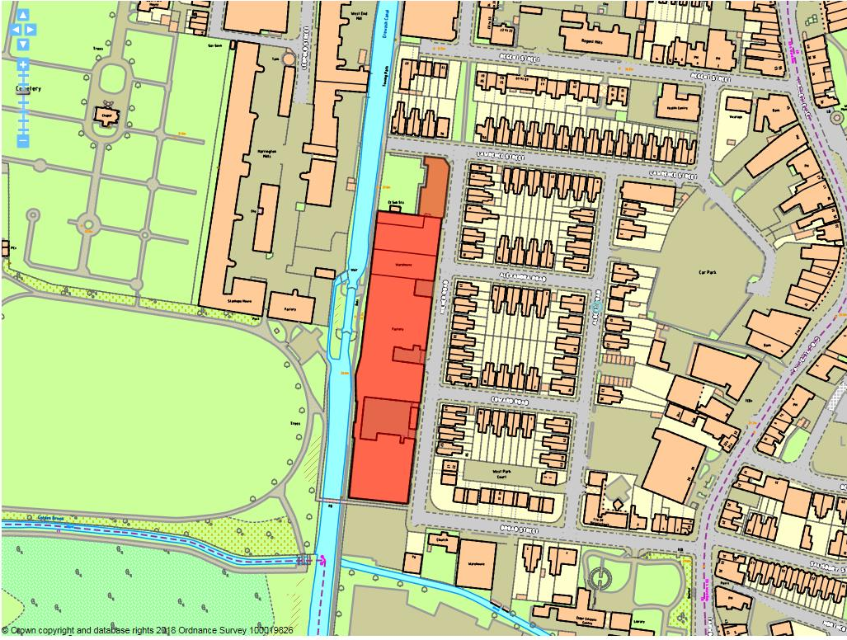

Site details:
Site reference (EELS) | EELS 023
Site name(s) | Meadowmeads, Milner Road
Settlement | Long Eaton
Description | A row of low-rise Mill buildings/electricity generating station between Milner Rd & the Erewash Canal.
Occupiers | Western Power Distribution, Sankey Upholstery & Barton Bespoke.
Current use classes present | B1(c), B2 & Sui Generis
Size (ha) | 0.7ha
Building age(s) | Mills & Electricity Station built between 1905-08, with more recent addition to the southern-end of the complex.
Building quality | Mixed – facades of some buildings require aspects of sympathetic modernisation.
Site assessment:
Prox. to strategic road network | Site 3.6km to J25 (M1/A52) 2
Local prominence | Site fronts onto Milner Rd, a local residential road 2
Public transport | Close to the Y5 and Indigo services along Derby Rd 10
Relationship to workforce | Site within Long Eaton settlement 10
Planning policy considerations | Within Long Eaton Lace Factories Con. Area, majority of buildings on Local Interest List and residential amenity concerns 7
Environmental setting | Limited setting to front where premises front directly onto adj. highways or back onto the Erewash Canal. The Canalside environment provides a pleasant setting 6
Flexibility of premises | Constrained by surrounding roads, Canal and presence inside Conservation Area 4
Demand/Commercial desirability | All units/workshops appeared occupied at time of visit 8
Final score & status | (Out of 73) 49

Site commentary:
Site description:
The site, long and rectangular in shape, consists of three Mill properties (named Alexandra, Edward and Victoria) dating from the turn of the c20th, all of which originally constructed to house lace manufacturing. Across the course of their histories, construction work, both at the rear and front of the buildings has served to largely amalgamate all Mill premises to create a near-continuous structure evident along their front (east) and rear (west) elevations. Bookending the Mill premises at its northern end is a red-brick Power Station which shows two-storeys on the Milner Rd. frontage with irregular fenestration and a dual pitched roof with elevated façade. At the southern end is Meadowmead House, a more modern two-storey building (1950’s) with some art-deco features evident from its frontage and a decorative stone staircase leading up to a centrally-positioned main entrance slightly elevated above ground level. Behind the façade is a rather incongruous structure with its southern and western elevation divided into sectional panelling. Further south, an area of off-road private car parking for staff and visitors enables vehicles to be kept off local residential roads. A small service yard for deliveries and dispatch which also accommodates some additional car parking space can be accessed just to the north of Meadowmead House.

Planning policy:
A number of local planning policies impact upon this employment site. Firstly the site sits within the Long Eaton Lace Factories Conservation Area (LFCA). Whilst most of the buildings serve to make a positive contribution to the character of the LFCA, some of the inter-joining modern annexes added in the second half of c20th do detract from the collective historic character. With four of the buildings on the site contained on the Borough Council’s List of Local Buildings of Interest, it is also noticeable how each of these have modern building aspects annexed which serve to somewhat dilutes their setting. The buildings also directly adjoin the Erewash Canal, a designated local wildlife site across the entirety of its length (ER215). However, despite the adjacent presence of industry to a sensitive habitat, the lack of direct physical interaction between the Canal and employment through access points and footpaths means it is unlikely that industrial operations are having a detrimental effect on the area of wildlife importance. Finally, the relationship between surrounding residential properties and the employment site is worthy of comment.

Site flexibility:
As previously stated, with limiting physical factors surrounding the site, its expansion to take in adjacent land to expand operations is not possible. Also, the policy implications which come from the site’s location within the LFCA, the directly adjoining Grade II listed Long Eaton Lock and a number of buildings being on the Local List are thought to realistically constrain any significant alterations to EELS 023.

Demand and commercial desirability:
Three businesses are present across the various units and buildings across the site, occupying all available space within the premises and demonstrating a strong demand for such units located in close proximity to Long Eaton town centre.

Final conclusion:
These units, whilst materially altered since their original construction as Lace Mills, continue to support businesses which make important contributions to Long Eaton’s status as the UK’s centre of upholstery excellence. Whilst the employment site sits inside the LFCA, the buildings uses remain relevant to the character of this part of Long Eaton.

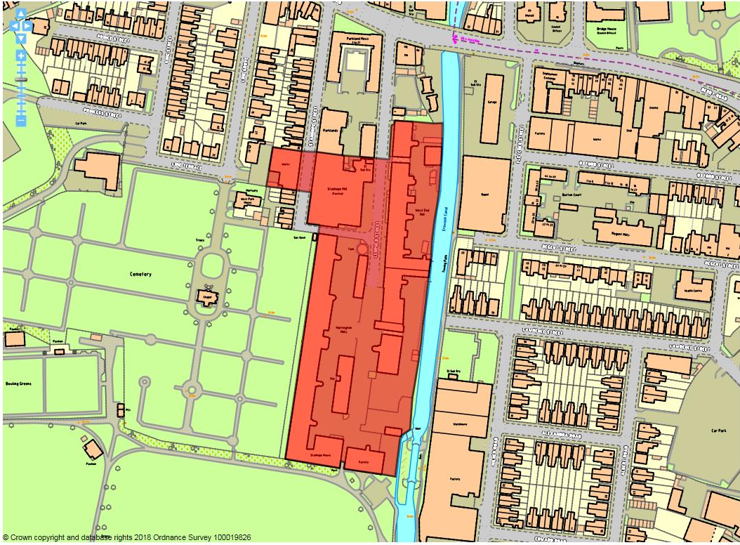

Site details:
Site reference (EELS) | EELS 024
Site name(s) | Mills and Factories at Leopold Street
Settlement | Long Eaton
Description | Historic area of former Lace Mills and associated factory premises located alongside the Erewash Canal which now house a range of business uses
Occupiers | Various
Current use classes present | B1(a), B1(c), B2 & B8
Size (ha) | 2.1ha
Building age(s) | West End Mill (1882), Harrington Mill (1887) with early-to-mid c20th additions (Stanhope Mill & other ancillary buildings).
Building quality | Some modernisation of Mills although ground floor frontage of West – other premises average
Site assessment:
Prox. to strategic road network | Site 3.2km to J25 (M1/A52) 3
Local prominence | Site visible from A6005 Derby Road 4
Public transport | Numerous bus services route along Derby Road just north of site 10
Relationship to workforce | Site within Long Eaton settlement 10
Planning policy considerations | Conservation Area and Several premises on List of Buildings of Local Interest, adjacent Listed Building and local wildlife site (ER215) 6
Environmental setting | Little soft landscaping within the site, but surroundings include Erewash Canal and West Park and Cemetery 7
Flexibility of premises | Mills internally reconfigured to diversify business uses 6
Demand/Commercial desirability | Good rates of occupancy for industrial workspace in Mills, although a number of units vacant for B1(a) uses 8
Final score & status | (Out of 73) 54

Site commentary:
Site description:
A prominent area of Long Eaton adjoining the town centre and heavily characterised by two large-scale former Lace Mill buildings lining the east and west site boundaries. Over time West End and Harrington Mills have seen internal sub-divisions to create a range of business premises over several floors including industrial workspaces, serviced office areas and creative spaces. Accessed via Leopold Street and Stanhope Street, a number of premises abut these roads, helping to retain a historic industrial landscape. Both Mills are served by sizeable yard areas which provide a significant number of parking spaces and also allow for the buildings to be serviced at street level. Projecting out into these yards are stair turrets constructed at regular intervals which offer further visual interest to the exteriors of each Mill. South of West End Mill is Whiteley’s Factory which fronts onto Leopold Street; another locally important three-storey industrial premise constructed at the end of the c19th. More recent additions are notable around the site and often functional in their appearance. These buildings appear to accommodate lower-quality ancillary offices serving industrial premises. Directly facing West End Mill across Leopold Street is the much smaller Stanhope Mill. The original double-bay Mill building has been extended during the mid-c20th seeing a flat-roofed structure annexed to its eastern side somewhat at odds with the architectural style prevalent throughout EELS 024. The Erewash Canal forms the site’s eastern boundary, whilst West Park and West Park Cemetery provide EELS 024’s setting around its southern and western edges. Immediately north are residential properties extending along Stanhope and Leopold Street before commercial properties fronting onto Derby Road are reached.

Planning policy:
With four separate Buildings of Local Interest situated across this site, this demonstrates the important heritage character displayed by much of the stock within EELS 024. Recognising this, the Long Eaton Lace Factories Conservation Area incorporates the entirety of the employment site, providing policy protection for the area’s special and sensitive heritage. Adjoining the site at its SE-most point is the Grade II Listed Long Eaton Lock, with its setting partially comprised by the development and use of land within this site. Finally, the adjacent Erewash Canal is a designated local wildlife site and stretches along the site’s eastern boundary. Despite the historic link between the products manufactured on-site and their transportation by Canal, the sensitivity of the wildlife asset may be put at slight risk with adjoining industrial uses.

Site flexibility:
The two largest Mills on site accommodate flexible areas of workspace, with offices, shop or industrial workshop space able to be internally configured to meet client needs. Other premises within the area are more constrained due to neighbouring forms of development which restrict scope for physical outward growth.

Demand and commercial desirability:
Numerous units now exist in the two largest Mill buildings, making a detailed accommodation audit difficult. Online commercial details however allude to the availability of some vacant floorspace in both Mills, mainly for office-type uses with workshop areas remaining popular.

Final conclusion:
The area and the business premises within it continue to make an important economic and heritage contribution to Long Eaton. With an eclectic range of operations occurring within the Mill buildings, their ongoing ability to accommodate employment uses will be determined by ensuring the premises remain at an acceptable level of quality. Timely investment and maintenance will be vital if buildings are to continue to be desirable for local enterprises.

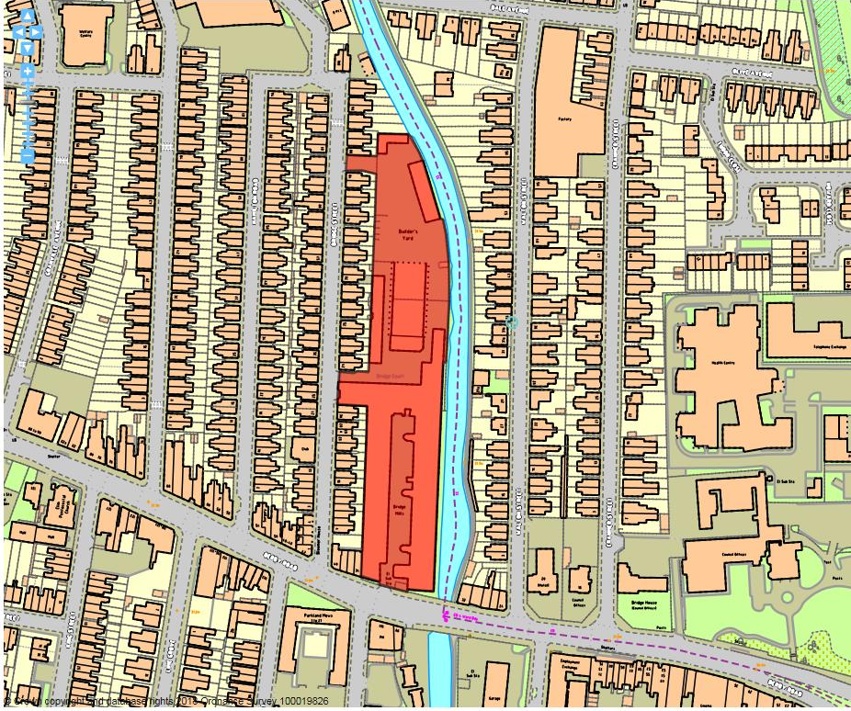

Site details:
Site reference (EELS) | EELS 025
Site name(s) | Bridge Mills, Bridge Court and adjoining Builders supplies yard
Settlement | Long Eaton
Description | Prominent three-storey Mill and associated sheds alongside Erewash with builders merchants occupying land immediately north
Occupiers | Bridge Mills - various and Jewson (building supplies yard)
Current use classes present | Bridge Mills & Bridge Court - fairly even mix of light industrial B1(c) uses, professional services B1(b), with some B1(a) office space present. Builder’s merchant – Sui Generis.
Size (ha) | 1.0ha
Building age(s) | Bridge Mills & Court built 1902, with adjoining northern site developed early-to-mid c20th.
Building quality | Average
Site assessment:
Prox. to strategic road network | Site 3.2km to J25 (M1/A52) 3
Local prominence | Southern end of Mills adjoin A6005 Derby Road 4
Public transport | Numerous services route along Derby Road 10
Relationship to workforce | Site within Long Eaton settlement 10
Planning policy considerations | Partly within Conservation Area, building of local interest, adjacent to local wildlife site (ER215: Erewash Canal), vehicular access arrangements in/out of yard and proximity to residential development 5
Environmental setting | Bridge Mills a prominent local Mill building contributing to urban landscape of Long Eaton – builders yard in north of site contributes little to surrounding environment 6
Flexibility of premises | Bridge Mill reconfigured internally to create different sized units and workspaces 6
Demand/Commercial desirability | Good level of occupancy (upwards of 75%) evident from recent site visit and commercial property search 8
Final score & status | (Out of 73) 52

Site commentary:
Site description:
Originally built as premises for lace making in 1902, the mainly three-storey Bridge Mills facility lining the Erewash Canal continues to provide a sizeable area of floorspace for a range of industrial and employment operations on the edge of Long Eaton town centre. Its height and prominent brick chimney, positioned at the Mills southern-most point, ensures the building remains highly visible with it elevated comfortably above surrounding forms of development. Vehicular access is taken from Derby Road through a narrow entry point which looks unsuitable to allow for HGV access. Inside, a long central yard separates the three storey Mills premises on the right from a facing single-storey row of workshops located opposite. North of the Mills, and accessed off Bridge Street, are the remaining areas of EELS 025. Associated with Bridge Mills, but with separate vehicular access arrangements south of 42 Bridge Street, is Bridge Court. Along the Court’s southern and western edge (the latter adjoining the northern elevations of Bridge Mills) are one and two-storey buildings respectively, and these accommodate diverse uses ranging from car sales showroom to accountants. Positioned centrally within the employment site is a large-scale depot building of limited quality. Single-storey at its southern end, this houses a building company, whilst rising to a much higher height at its northern end where it provides indoor storage for Jewsons. A final section of site can be found at the northern-most end of EELS 025. Accessed between nos. 84 & 88 Bridge Street, an entry road leads into a yard occupied by Jewsons. Around this, a number of low-quality buildings provide sheltered storage for building materials. At its southern end is the northern part of the large-scale depot building referred to earlier with a pair of high-span loading doors positioned on north-facing elevation allowing access for trade vehicles. The site sits within a predominantly residential area north-west of the town centre. Housing along Bridge Street adjoins to the west, while immediately beyond the Erewash Canal further homes are located along Walter Street.

Planning policy:
A number of planning policy matters impact upon this employment site. The southern section containing Bridge Mill forms part of the Long Eaton Lace Factories Conservation Area, and the Mill itself is on the Local List for Buildings of Interest. Both aspects require consideration ahead of any future works on this part of EELS 025. The entirety of the site’s eastern boundary adjoins the Erewash Canal, a designated local wildlife site. At the northern end of EELS 025 where the Canal adjoins the builders merchants, the latter’s environment isn’t believed to provide a positive setting for an area of biodiversity. Residential amenity and vehicular access arrangements are also of relevance. With the close proximity between homes and some ‘noisy’ industrial activities across the site, adjacent households may be subjected to low-level disturbance. Two of the three site access points also are taken from a residential street and the Mills entrance sees visibility impaired in an east-facing direction owing to the apex of bridge carrying Derby Road over the Canal.

Site flexibility:
Some flexibility in Bridge Mills, with past internal works creating different sizes of premises.

Demand and commercial desirability:
Whilst the premises across the site display strong levels of occupancy, lettings boards at its Derby Road entrance advertise space in the Mills between 3-12,000sq.ft.

Final conclusion:
Bridge Mills and Court remains an important location for employment space in Long Eaton, with it currently accommodating a wide diversity of occupants. Maintaining an acceptable standard of accommodation thought capable of meeting modern business requirements is thought to be vital to ensure the premises long-term future.

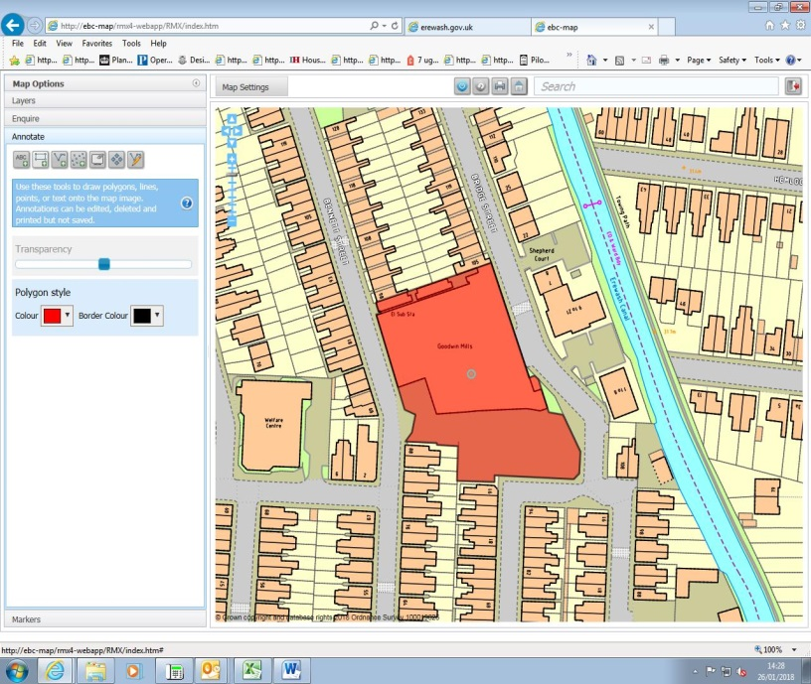

Site details:
Site reference (EELS) | EELS 026
Site name(s) | Goodwin Mills
Settlement | Long Eaton
Description | Single-storey mill premises now operating as a factory manufacturing furnishings
Occupiers | United Fillings Ltd
Current use classes present | B2
Size (ha) | 0.4ha
Building age(s) | Constructed early c20th, with south-eastern annex added during mid-c20th.
Building quality | Average – external aspects acceptable, with sturdy metal roofing covering the majority of the premises.
Site assessment:
Prox. to strategic road network | Site 3.4km away from J25 (A52/M1 intersection) 3
Local prominence | Site is located amongst residential properties away from a major road 2
Public transport | Regular bus service along College Street 10
Relationship to workforce | Site within Long Eaton 10
Planning policy considerations | Undesirable vehicular access (for trade vehicles) using residential roads and premise surrounded on all sides by residential properties. 8
Environmental setting | Hard-surfaced area south of buildings where staff parking and some limited storage space exists 6
Flexibility of premises | Some scope for physical expansion south, but would remove car parking and service areas 4
Demand/Commercial desirability | The premises are occupied in their entirety by United Fillings Ltd 8
Final score & status | (Out of 73) 51

Site commentary:
Site description:
Goodwin Mills is an industrial premise located in a largely suburban part of Long Eaton, characterised by late-Victorian terraced properties and interwar housing stock. Originally constructed as a lace factory, the building, with its reinforced ridged, multi-pitched roof (two pitches at west-elevation, and three at eastern-end) now accommodates a business which manufactures quality cushion interiors for the furniture upholstery and soft furnishings industry. Vehicular access to the premises for visitors, staff and trade vehicles is taken off Bennett Street, although a smaller disused gated access is visible leading onto Bridge Street. The building’s reception and office facilities are accessed off Bridge Street at the north-eastern most corner in a noticeably more recent addition to the main Mills. Each of Goodwin Mills end elevations are visually interesting with protruding brick columns extending from floor to roof, and a number of windows which for security reasons have each been fitted with a wire-mesh guard. Two service bays can be seen at the building’s eastern end, although it is unclear as to whether these remain in use.

Planning policy:
As set out already, the site is located within a predominantly residential area of Long Eaton. The roads between the premises and the nearest main roads (Derby Road (A6005) and Longmoor Road (B6002)) are tight with on-street parking highly evident. As such, trade vehicles travelling to and from Goodwin Mills are not wholly suited to the surrounding roads. Additionally, with housing in such close proximity, it is likely that some of the manufacturing activities taking place on the site are likely to conflict with maintaining a high level of residential amenity.

Site flexibility:
The site enjoys a predominately residential setting which limits physical expansion of the current premises east and west due to adjacent highways. Domestic properties adjoin Goodwin Mills immediately north leaving some land within the curtilage of the site to the south as the only direction in which the existing building could extend in. However, this area serves as parking for staff and visitors, so the removal of this would displace cars onto neighbouring roads, creating unacceptable parking conditions on narrow public highways.

Demand and commercial desirability:
The building is currently occupied in full by United Fillings Ltd who have been at the premises for a number of years.

Final conclusion:
Goodwin Mills is an example of industry sited amongst an increasingly residential part of Long Eaton. Industrial premises immediately east on Bridge Street have now been redeveloped for flats, demonstrating the vulnerability of such facilities in built-up areas. Whilst some aspects of the building’s exterior appear dated, a fairly recent roof replacement shows investment by the current occupiers United Fillings Ltd that can be taken as a longer-term commitment to the premises.

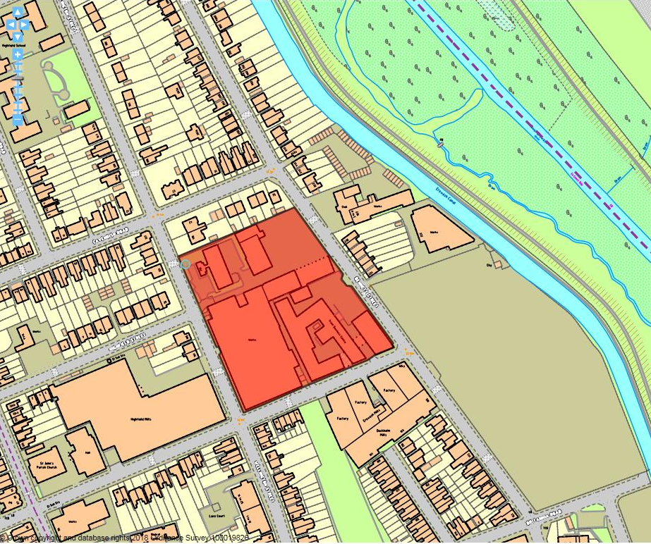

Site details:
Site reference (EELS) | EELS 027
Site name(s) | Trent Business Centre, Wellington Mills and adjacent Works
Settlement | Long Eaton
Description | Diverse grouping of Mill premises, managed workspace and modern business facilities
Occupiers | JDP Furniture Group, Power Electronic Measurements Ltd, John Whiteman Engineering and all occupants of Trent Business Centre
Current use classes present | Many B1(a) & B1(c) uses in Trent Business Centre and B2 elsewhere
Size (ha) | 1.2ha
Building age(s) | Construction on site began in early-c20th with Business Centre build in mid-c20th with further additions in late-c20th
Building quality | Mixed across the site
Site assessment:
Prox. to strategic road network | Site 2.8km to J25 (M1/A52) 4
Local prominence | Adjoining three roads all unclassified local highways 2
Public transport | Frequent Indigo service routes along nearby College Street 10
Relationship to workforce | Site within Long Eaton settlement 10
Planning policy considerations | Adjacent residential, constrained local roads to accommodate trade traffic and TPOs on-site 7
Environmental setting | Mixed. Gloucester House surrounded by numerous trees, but rest of the site largely built-up with little landscaping evident 6
Flexibility of premises | Trent Business Centre premises largely altered internally to create numerous enclosed units, although other premises across site constrained by their surroundings 6
Demand/Commercial desirability | Seven vacant units at TBC currently from 60 units. All other premises on-site are occupied 8
Final score & status | (Out of 73) 53

Site commentary:
Site description:
Diverse site made up of separate premises, ranging from former Mill buildings constructed for the manufacturing of lace/furniture, to a modern business premise (Gloucester House) set in a pleasant environment differing from that evident elsewhere around EELS 027. Trent Business Centre (TBC), the site’s largest building, is set within its south-east corner. A former furniture factory, around 33,000 sq.ft. of floorspace is contained across three floors with approx. 60 office and workshop units ranging in size from 100sq. ft. to 3,000 sq.ft. and available on yearly rental arrangements. The premise is well served by extensive off-street car parking within its curtilage. Immediately east is Wellington Mills which displays long elevations with Canal St. and Wellington St. The main entrance to the premises is taken from the latter, with extensive showroom and office facilities found inside the Mills in a more modern two-storey addition to the original building. As with most Mills stock of this age in the surrounding area, the building employs a saw-tooth roof arrangement, with pitches running in an east-west alignment. Further north along Wellington St. is Gloucester House, a more modern business premise recessed back from the highway behind a line of mature protected trees and staff car park. Its two-storey frontage is mainly glazed, with a vehicular access running along its southern boundary which allows access into a yard where JDP Frames houses timber supplies, although vehicular trade access is prohibited and instead diverted to the yard’s Bennett St entrance where other smaller storage buildings can be found lining this space. Immediately north of the site are adjoining residential properties located along Wellington St. and also those at the eastern end of Cavendish Road.

Planning policy:
As with other industrial locations which are set within a wider residential environment, the nature of manufacturing activities and associated operations within the surrounding yard area accessed off Bennett Street is likely to generate some low-scale noise disturbance to neighbouring properties and particularly if outside within their curtilage. Additionally, the local road network sees narrow highways which in many instances are further reduced in width through on-street parking lining both sides. The size of service vehicles causes difficulties in that such roads struggle to accommodate larger-scale HGVs which wish to access the premises, compromising the highway safety along roads between EELS 027 and the higher order roads (A6005 Derby Road and B6002 Longmoor Road). A number of TPO trees line the western and southern boundaries of Gloucester House, which help to provide a greener environment at this part of the site, but it is noticeable how aspects such as a staff car park encroach right up to the protected trees.

Site flexibility:
The form of surrounding roads ultimately limit scope for any of the businesses sited here to expand curtilages outwards. Wellington Mills will likely have been adapted over a period of time for particular manufacturing activities, and Gloucester House accommodates a single occupant. Trent Business Centre has displayed the greatest level of site flexibility given its modernisation and internal sub-division to create a large number of units. It is understood that some flexibility exists to modify some units to create different space configurations.

Demand and commercial desirability:
Occupancy is high across the site. At TBC, only seven of sixty units have recently been vacant suggesting the facilities continue to be popular for small, start-up enterprises.

Final conclusion:
The facilities on this site display a mix of long-term occupancy (JDP Frames) and short-term tenancy at the TBC. Space at the latter serve an important use for a number of local business enterprises, providing small-scale facilities for SME’s to establish themselves.

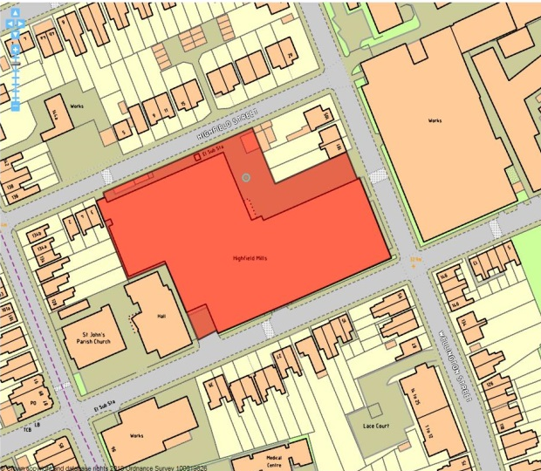

Site details:
Site reference (EELS) | EELS 028
Site name(s) | Highfield Mills
Settlement | Long Eaton
Description | Large-scale Mills building constructed in two phases.
Occupiers | Wade Springs
Current use classes present | B2
Size (ha) | 0.6ha
Building age(s) | Southern part fronting Canal St – early c20th, northern part fronting Highfield St – circa 1970’s.
Building quality | Average – ageing timber casement windows on Canal St. elevation, although building appears in reasonable condition for what use is accommodated.
Site assessment:
Prox. to strategic road network | Site 2.7km to J25 (M1/A52) 4
Local prominence | Site fronts onto three largely residential streets 2
Public transport | Trent Barton services ‘Indigo’ & 15 serve nearby College Street 10
Relationship to workforce | Site within Long Eaton settlement 10
Planning policy considerations | Buildings located amongst adjacent residential development, trade vehicles accessing premises along narrow residential roads. 8
Environmental setting | Buildings provide very little environmental setting with long stretches of elevation blank. No recess of building on two frontages, directly abutting the street 4
Flexibility of premises | Constrained expansion due to surrounding roads, homes and local highways. Reconfiguration at northern end 5
Demand/Commercial desirability | Just a single occupant on-site within the premises 8
Final score & status | (Out of 73) 51

Site commentary:
Site description:
Highfields Mill, originally built in early-c20th for lace manufacturing, is a sizeable low-rise red brick industrial building fronting onto three separate local roads (Canal St, Highfield St and Wellington St.) where a large number of residential properties are to be found. While the premises are contiguous, the facilities at the site are clearly separated into two distinct phases of construction. The original Mills premises fronting Canal St. and Wellington St. show a distinctive ‘sawtooth’ roof with its pitches running in an east-west alignment, creating an interesting roofline that faces out across Wellington St at gable’s end. The roofing materials appear recent, helping to secure the facilities inside. A more functional and recent addition to the original Mill fronts Highfield St looking northwards. Along this elevation, the building, with its irregular roof heights and elevated façade displaying the business name, is situated behind a brick wall topped with security railings - obscuring views of the building from ground level. The main vehicular access for trade vehicles into the Mill complex is taken through gates off Wellington St opposite and next to residential properties, opening into a sizeable service yard. A secondary access exists on Highfield St. although this appears no longer operational with the gates locked. Some evidence of modernisation exists on the northern part of the building with a small recently-added two-storey reception and office block building positioned at the end of the industrial buildings, with most of the roofing along the Highfield St elevation also appearing to be relatively recent.

Planning policy:
The site sits within an urbanised area of Long Eaton. No specific spatial policies are relevant to this site, but some issues of residential amenity are evident due to the closeness of the Mill to directly adjacent houses. While facilities such as these were located amongst residential areas to ensure proximity to workforce, the changing nature of travel and ability for narrow local highways to facilitate householder parking and play a role in moving produce from factory to main roads may be starting to impinge upon the residential amenities of those in the vicinity of the site. This would be applicable to residents along Wellington St. (the primary route to the A6005 Derby Road, and also from those households on Highfield St. who are in close proximity to Wade Springs loading yard just beyond a brick wall.

Site flexibility:
The form of the surround highways network prevents any outward expansion of the Wade Springs premises with roads forming the site’s north, south and east boundaries. Due to the size of the premises, there could be scope for greater utilisation of floorspace within the buildings should a diversification of operations be necessary. Given the site’s urban and residential surrounds, intensification of operations at Highfield Mill would begin to provide greater conflict with the site’s neighbours.

Demand and commercial desirability:
The premises have been occupied by Wade Springs for a sizeable period of time. As such, it can be assumed that the facilities meet the requirements of the company. As mentioned above, a recent permission from 2007 (ERE/1207/0001) was granted by EBC allowing the consolidation of a number of factories in the northern part of the Mill to form a single works unit. This suggests Wade Springs remain committed to their current location.

Final conclusion:
Part of Long Eaton’s network of Mills originally constructed to produce lace; Highfield Mill has gone on to become an important location for a well-established company in Wade Springs, a notable contributor to the town’s upholstery sector. Whilst surrounds become ever-more residential in character, the sizeable premises here provide important space for local manufacturing and a key source of specialised jobs.

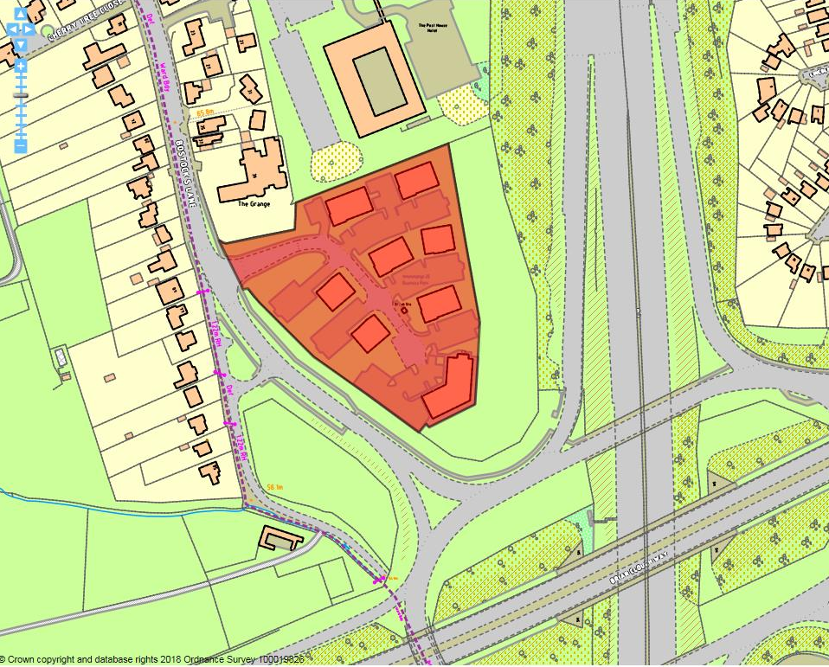

Site details:
Site reference (EELS) | EELS 029
Site name(s) | Interchange J25 Business Park
Settlement | Risley
Description | Modern business park with several blocks of office facilities and main HQ building at southern end of site.
Occupiers | Gamestec, AirIT, Monica Healthcare, Renew Holdings PLC.
Current use classes present | Predominantly B1(a)
Size (ha) | 1.46
Building age(s) | Approx. 15-20 years old
Building quality | Very good
Site assessment:
Proximity to M1, A52 or A38 | Almost immediately adjacent to J25 (M1 & A52) 9
Local prominence | Visible from the M1 5
Public transport | i4 service through Risley crossroads 10
Relationship to workforce | Adjoins Risley village settlement 7
Planning policy considerations | No obvious conflicts with local planning policies 10
Environmental setting | Good quality setting with green surrounds – a noticeable mixture of mature trees and shrubs throughout the site, and around its perimeter helping with sense of place 8
Flexibility of premises | Several distinct blocks of functional and purpose-built B1a accommodation. Possibility of sub-dividing buildings on basis of floors (most premises two-storey) 5
Demand/Commercial desirability | Only a single building currently vacant and being marketed by FHP 8
Final score & status | (Out of 73) 62

Site commentary:
Site description:
Interchange 25 is a fairly modern business park, home to several individual blocks of office accommodation and set in a pleasant, landscaped environment in close proximity to Junction 25 of the M1 given the facility excellent accessibility to the strategic road network. Constructed in late c20th, the facilities are typical of other office accommodation built during that era, although a notable amount of greenery exists around the site in the form of mature trees, serving to screen views in and out to surrounding residential development on the western side of Bostock’s Lane. Seven two-storey buildings are positioned around a central service road which each block having dedicated parking within their immediate setting. Furthest south is the largest of the buildings on-site (Octavia House), three-storeys in height, which makes it particularly visible from the interchange between the A52 and M1 where the ground level slope away towards the adjacent motorway.

Planning policy:
The site adjoins the settlement of Risley which sweeps around the west and north of the business park, although the land is ‘white land’ falling outside of the Green Belt. As referred to above, the site benefits from a substantial amount of green landscaping and a group Tree Preservation Order (DC5 243) designation covers the majority of the land. The use of the land does not appear to adversely affect the protected trees, with their presence adding to the higher quality setting the business park enjoys. No obvious planning policy constraints appear evident at the time of assessment.

Site flexibility:
The business park is set out in a manner which means further built development on the site would intensify the layout, impacting on its character. Whilst there is scope for modest additions to be made to existing buildings, this would begin to erode from the site’s green setting, possibly prejudicing the commercial demand enjoyed by the current employment facilities.

Demand and commercial desirability:
Of the eight buildings at Interchange 25, only one is currently vacant showing that floorspace here is in healthy demand. The vacant building is presently being marketed to let by Fisher Hargreaves Proctor for an annual rent of around £60,000. The site’s location adjacent to the strategic road network and the quality of the environment in which the buildings are set is thought to represent a strong factor in the current healthy status of occupancy. Those present in the facilities span an eclectic range of service sector-based uses, including healthcare, legal and IT services.

Final conclusion:
Interchange 25 business park is a relatively isolated example in Erewash of a purpose-built facility offering a relatively high-quality setting with sizeable amounts of modern, open plan office floorspace. With an extremely favourable and accessible location, it is envisaged that demand from prospective occupants will remain high into the future. With few notable planning policies constraining the existing uses occurring on the site, the facility makes an important contribution to the local economy by offering good standard office floorspace.

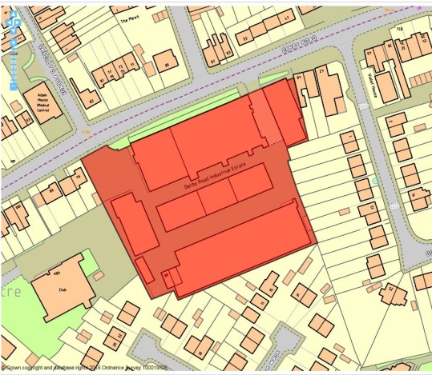

Site details:
Site reference (EELS) | EELS 030
Site name(s) | Derby Road Industrial Park
Settlement | Sandiacre
Description | A former pair of Lace Mills, modified and expanded into a Trading Centre.
Occupiers | U-Fit Trade Windows, CH Precision Finishers, Autosparks, Stephen Michael Designs, Simlar 2, Choice Custom Carpets and Posh Nosh.
Current use classes present | Mainly B2
Size (ha) | 0.9ha
Building age(s) | Buildings furthest back in site date from turn of the c19th, while building fronting Derby Road is inter-war with its later expansion occurring during the 1960’s.
Building quality | Average
Site assessment:
Prox. to strategic road network | Site 1.3km to J25 (M1/A52) 7
Local prominence | Site fronts the B5010 Derby Road 3
Public transport | The regular i4 service routes along Derby Rd 10
Relationship to workforce | Site within Sandiacre settlement 10
Planning policy considerations | Relationship between industrial activities on-site and nearby residential properties 9
Environmental setting | Narrow band of grassed space at frontage of site softening the setting, but mainly hard surfacing & buildings 7
Flexibility of premises | Extent of site taken by buildings leaving little remaining space. Recent approval to extend central building 6
Demand/Commercial desirability | No evidence of vacant units from site visit 8
Final score & status | (Out of 73) 60

Site commentary:
Site description:
A popular industrial area located on the busy B5010 Derby Rd almost adjoining the defined Local Centre of Sandiacre situated a few metres to the site’s east. Originally, the two single-storey buildings situated at the rear of the site were constructed as lace mills around the turn of the c19th. The southern-most building (named Precision House due to its long-term occupants CH Precision Finishers) has seen work to alter its footprint with a newer wing running parallel to the southern elevation added during the inter-war period. More recent additions can be seen at its eastern end with the construction of a functional two-storey office block with flat pitched roof. The central building remains largely unaltered in its size and form matching its neighbour, although recent occupants have made a series of cosmetic external alterations, while internally the building has been adapted for current business operations. Permission was granted in 2016 for an addition at its western end, but this appears to have not yet been implemented. The building fronting onto Derby Rd is a later addition and divides into three clear sections representing the staggered time of construction. The central part of the structure is oldest, constructed during the inter-war period and is an archetypal industrial building of its time with saw-tooth roofing pitches and tall frontal windows, although these have all been brick-filled with smaller glazed windows within. Flanking this section are two brick/concrete 1960’s additions, with a wing to its west and a taller wing to the east which has attempted to replicate the original section, although its fenestration and use of glazing is more contemporary in appearance. This is also where a noticeable vehicular entrance into the rear of the site exists, passing beneath the upper floor of the structure which spans the entry point. A second vehicular access exists in the north-west corner of the site, with internal roads linking this to the other entry point at its opposite end. The final building of note on site sits at its furthest western point, positioned gable-end facing Derby Rd. This largely two-storey brick building (with single-storey extension at front) with mono-pitched roof dates from the early c20th and sits separately to the other buildings in arrangement. The spaces in-between the aforementioned buildings contain ample space for staff, trade and visitor parking.

Planning policy:
Largely the site is free of planning policy constraints, although its proximity to surrounding residential development is noticeable with some operations on-site likely to cause low levels of disturbance to those situated most immediately at properties on Hampshire Drive and Norfolk Walk.

Site flexibility:
The site largely consists of buildings and structures, so little space exists for sizeable new additions of employment premises or extensions to existing buildings. However, a recent permission (ERE/0216/0011) gained permission to extend the site’s central building further west. This has yet to be implemented but demonstrates some small-scale opportunities to provide additional floorspace at a well-established industrial estate. Records also exist of some units changing use suggesting that units are adaptable internally to accommodating different employment-orientated operations.

Demand and commercial desirability:
As already mentioned, no evidence of vacant floorspace or units from the site visit demonstrates the ongoing success of this facility in providing local business space to a number of companies.

Final conclusion:
A successful local trading estate which is home to a number of established local businesses.

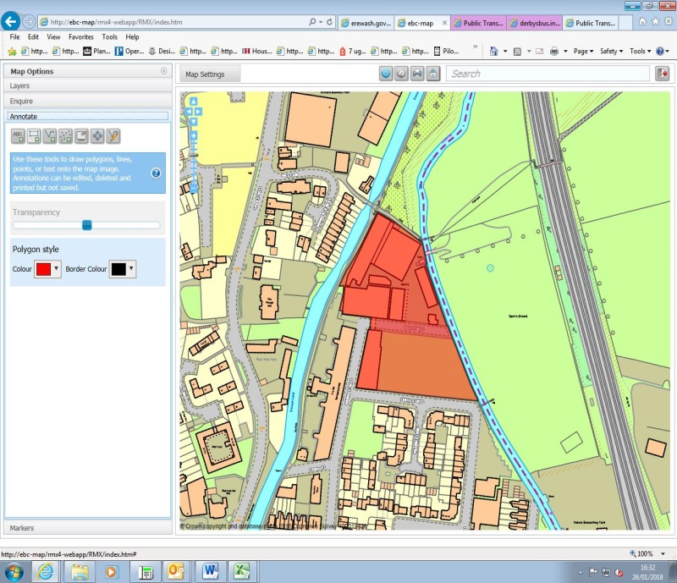

Site details:
Site reference (EELS) | EELS 031
Site name(s) | Gas Street Industrial Area
Settlement | Sandiacre
Description | Area of manufacturing positioned between the Erewash Canal and River Erewash
Occupiers | Wade Upholstery, Cintique & Parker and Farr.
Current use classes present | B2
Size (ha) | 1.2ha
Building age(s) | Oldest building on-site (between Gas, Bridge and Cross St) from late-c19th with remaining buildings dating from mid-c20th
Building quality | Average
Site assessment:
Prox. to strategic road network | Site 1.9km to J25 (M1/A52) 6
Local prominence | Site adjoins Bridge and Gas Street, two minor roads 2
Public transport | Site short walk from B5010 Station Rd and a number of bus services 10
Relationship to workforce | Site within Sandiacre settlement 10
Planning policy considerations | Contaminated land, adjacent residential area (noise and access), neighbouring Listed Buildings, local wildlife site and forms part of Conservation Area 5
Environmental setting | Some unkempt shrubs surround surface car parking on Cross Street, but very little greenery evident 5
Flexibility of premises | Northern portion of employment site tightly constrained due to proximity of buildings – open space in south but required for car parking 3
Demand/Commercial desirability | All units and premises currently occupied 8
Final score & status | (Out of 73) 49

Site commentary:
Site description:
The site, owned by Wade Furnishings Ltd and currently occupied by the JDP Furniture Group (including Cintique and Parker & Farr), forms a roughly triangular flat piece of land which is bounded on its west and east sides by the Erewash Canal and the River Erewash respectively. The site (north of Gas Street) formerly home to a gasworks, operational between 1905 and 1930, before being extensively redeveloped to accommodate mainly upholstery-based business. Factory premises extend southwards across Gas Street (directly facing Springfield Mill), linked to the main premises by an internal footbridge spanning the road at first floor level. The buildings at each end of the footbridge are typical of their age by displaying south-facing saw-toothed roofs. The main grouping of premises sit north of Gas Street, with a number of buildings positioned around a service yard where trade vehicles are able to enter into the employment site. The largest buildings are situated in the north-west part of EELS 031, these being traditional examples of brick industrial stock with single, yet high-pitched roofs providing ample internal working space. A sizeable area of hardstanding sits between Gas and Cross Street (accessed from the former), serving as car parking for staff at the premises. The site sits within much-altered surroundings, with a significant number of recently built homes south of Cross Street, a sizeable number of apartments converted from Springfield Mill – a former lace mill. A number of modern three-storey homes now also overlook the Canal and the industrial area from a north-westerly direction – helping to demonstrate a largely residential setting that these factory premises now find themselves within.

Planning policy:
The vast majority of the land which these premises sit upon (north of Gas Street) is contained on the Borough Council’s register of contaminated land. Whilst this presents manageable issues for the current occupants, any alterations to the premises may be constrained due to ground contaminants left as a legacy of the site’s former gas workings. The premises here also form part of the setting for two adjacent listed buildings; Grade II Listed Springfield Mill and further north, a Grade II Listed Canal Bridge allowing access from Mill Lane to the eastern side of the Canal – also a local wildlife site (ER215). The settings for both are slightly affected by the quality of development evident through the majority of EELS 031. The same applies for a Conservation Area (CA) designation which includes buildings at each end of the footbridge across Gas Street, with the CA’s setting slightly impacted by the remainder of the industrial buildings that adjoin those inside the boundary. As mentioned within the site description, the remaining industrial premises in this part of Sandiacre find themselves increasingly isolated due to recent residential developments. It is expected this could create amenity-based issues over time, with the nature of operations and trade-related vehicular access to and from the site being at odds with the area’s largely residential character.

Site flexibility:
The dated nature of premises on-site, and the presence of some buildings within the Conservation Area, makes alterations or additions unlikely.

Demand and commercial desirability:
Whilst all premises are occupied, the relatively poor quality of premises and inflexibility of stock would be an issue should the current occupants cease to trade from this location.

Final conclusion:
With the gradual encroachment of residential development, the long-term future of this site in its current use is uncertain, although ground contamination may restrict/limit redevelopment.

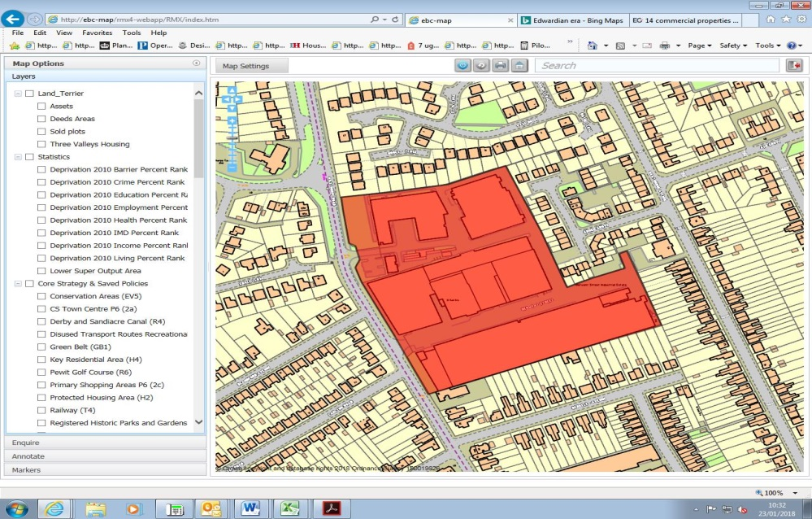

Site details:
Site reference (EEL) | EELS 032
Site name(s) | Derwent Street Industrial Estate
Settlement | Long Eaton
Description | Mill-based industrial estate split into numerous units
Occupiers | Gascoigne Designs, Webbes Self Storage, Dream Machine Ltd, E.S.P Cars, Ratchet Clothing & Leather Care Services
Current use classes present | Principally B2, but also B1(c), B8, A1 and Sui Generis
Size (ha) | 3.17 ha
Building age(s) | Central Mill buildings and part of southern building immediately post-WWI, remaining southern and northern premises post-WWII, with northern part of site remodelled late-c20th.
Building quality | Average
Site assessment:
Proximity to M1, A52 or A38 | 3.1 km to M1/A52 (J25) 3
Local prominence | Does not adjoin, nor is visible from a classified road 2
Public transport | Short walk (<250m) to stop served by Notts & Derby service 12 & Yourbus service 19. Less than 500m to Long Eaton railway station 10
Relationship to workforce | Within Long Eaton urban area 10
Planning policy considerations | Relationship with adjoining residential development 9
Environmental setting | Small green areas at frontage of Ind. Est. and some isolated trees intermittently located along Derwent St. 6
Flexibility of premises | Limited expansion prospects, but notable evidence of piecemeal internal adaptation shows flexibility of stock 5
Demand/Commercial desirability | A single vacant unit in dilapidated building at the entry to the northern section of the Ind. Est. Strong level of occupancy elsewhere throughout site. 8
Final score & status | (Out of 73) 53

Site commentary:
Site description:
Diverse employment area situated SW of Long Eaton Town Centre with two clear sections, influenced by separate vehicular access points off Wilsthorpe Road. The northern section sees two large factory premises north of an internalised access road. These are both standard design industrial premises with some notable ancillary office accommodation set within the buildings. Both have multi-pitch roofs, some appear recent and the various building bays generally run east-west in alignment. The factory premises in the NE of the site has access around the entirety of its perimeter, incorporating areas of loading and parking for staff and visitors. South of the internal access road just inside the site is a vacant single-storey flat-pitch roof building in a poor state of disrepair with a small area of dedicated parking between it and the site’s frontage. Further back, access is taken to the northern sections of the main Mill building which spans almost the entirety of the centre of the site, with four distinct building bays orientated east-west. A number of parking bays adjoin the buildings at its eastern-most elevation, although there is no access to the southern section of the Ind. Est. This section is accessed further south on Wilsthorpe Road, with a sporadically tree-lined Derwent Street running centrally between the aforementioned central Mill buildings to its north and a further continuous Mill building lining the southern side of the road. Along Derwent Street’s northern side, Mill premises house a number of employment uses, but at its western end are heavily reconfigured buildings which now used as modern storage space. Moving further east along the building, it reverts back to a more original appearance with the frontages of sub-divided units containing loading bays and traditional fenestration detailing seen on Mills. The building is recessed slightly from Derwent St, allowing for limited car parking. South of Derwent Street is another long Mill premise with imposing traditional brick chimney containing telecommunications equipment positioned at its south-eastern corner. This building is much-altered, both internally and externally, with much of its internalised space now open-plan and accommodating a car sales and storage use. Again, similar to the opposite building, it is set back from Derwent Street to allow staff and visitors to parking. Residential development of varying ages now directly surrounds the site on three sides, the most recent addition being a number of new homes immediately east on Gough Grove.

Planning policy:
Generally the employment premises do not run contrary to planning policies in the Local Plan. The only area of concern is the increasing encroachment of residential development towards this established area of employment. Some of the industrial operations taking place here may cause some limited detriment to residential amenity to households on Hooley Close, Wyse Drive, Hawthorne and Birchwood Avenue.

Site flexibility:
This is mixed around the site. The premises in the northern part of the site are set within more spacious surrounds, allowing for reconfiguration and possible expansion should the need arise. However, the Mill buildings which line Derwent Street, whilst having been extensively adapted internally to meet the occupants requirements, have limited scope for extension given their layout which limits the site’s potential.

Demand and commercial desirability:
Little vacant floorspace was noticeable across the site at the time of visit. The age of stock here offers lower quality premises which may reflect in its affordability to local businesses.

Final conclusion:
By and large aging industrial stock, the gradual encroachment of housing to the site’s boundaries represents a threat going forwards to ensure it remains in employment use. Recent redevelopment indicates some flexibility to accommodate storage-based uses.

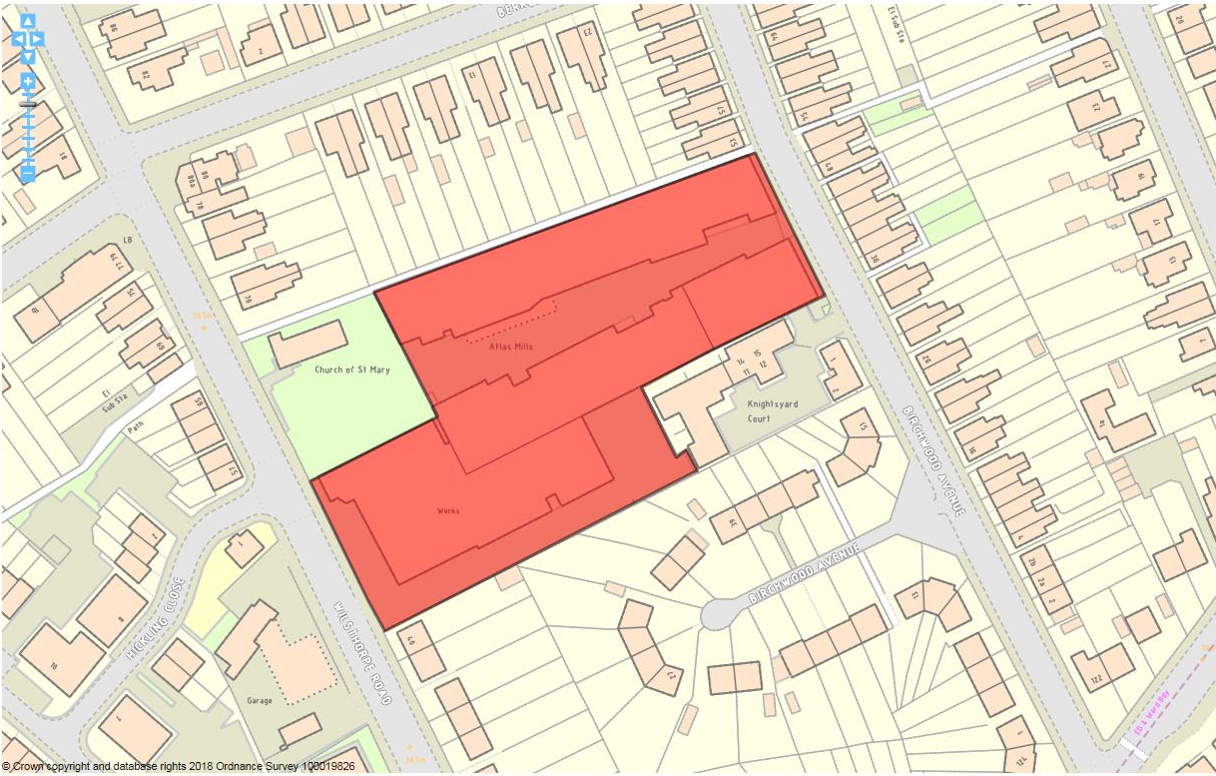

Site details:
Site reference (EEL) | EELS 033
Site name(s) | Atlas Mills & Paragon Works
Settlement | Long Eaton
Description | Mill-style employment complex sub-divided into several separate units
Occupiers | Atlas Mills - Whitehead upholsterers, Polly Model Engineering, Timber Trade Products Ltd & Frame Design Ltd. Paragon Works - Sherwood Electricals and Flowfayre plumbing & heating.
Current use classes present | Principally B2, with ancillary B1(a) & B1(c) workspace
Size (ha) | 0.73 ha
Building age(s) | Mainly early-c20thcentury, with mid-c20th additions at south-west and eastern ends of premises.
Building quality | Mixed. Condition of premises better at each end of site reflecting the newer build. Central mill-style units are aging in condition, but still accommodate active manufacturing operations.
Site assessment:
Proximity to M1, A52 or A38 | 3.4 km to M1/A52 (J25) 3
Local prominence | Does not adjoin, nor is visible from any classified highway 2
Public transport | Within short walk (<250m) to SkyLink service on Tamworth Rd and Long Eaton railway station 10
Relationship to workforce | Within Long Eaton urban area 10
Planning policy considerations | Residential amenity affected on Birchwood Avenue and neighbouring Local List Building 8
Environmental setting | No landscaping, setting mainly hardstanding for car parking and loading/unloading 5
Flexibility of premises | Very limited owing to layout of estate and surrounding form of development 3
Demand/Commercial desirability | All units across the site are actively occupied 8
Final score & status | (Out of 73) 49

Site commentary:
Site description:
The site can be sectioned into two separate industrial areas, with Atlas Mills (post-WWI lace works) at its eastern end and accessed off Birchwood Avenue, while premises at Paragon Works (fronting Wilsthorpe Road) being a later addition around WWII, but constructed similarly to Atlas Mills. Vehicular access points enter the site from both sides, although no through access internally is possible. At one side of the Birchwood Avenue entrance, a functional two-storey administrative annex (Atlas House) appears out of character with the rest of the site, whilst the other side sees a decorative elevation provide notable visual contrast. Within the Mills complex, facing rows of single-storey factories look across a widening central yard which accommodates parking bays immediately outside the north row of units. A recent flat complex at Knightsyard Court sits immediately south of this section of industrial space, whilst more-established housing extends north along Birchwood Rd and moving around to the west on Berkeley Avenue. The southern section of Mill premise accessed off Birchwood Road directly adjoins premises accessed off Wilsthorpe Road. Originally these will have comprised one continuous industrial Mill premise, but subsequent subdivisions have resulted in separate parts being accessed from different sides of EELS 033. The frontage of buildings facing out over Wilsthorpe Rd (but recessed back from the highway’s edge) is visually interesting with notable differences in heights and widths of the two components of what is referred to as Paragon Works. The northern-most section is two-storey and has exaggerated gable-end detailing, whilst the southern section is single storey, wider and has a loading bay door incorporated left of the building’s entrance. Vehicular access occurs down the southern side of the building, passing alongside its southern elevation (a minor-sized chimney) which has a number of openings, before opening out into a small service yard now overlooked by a three-storey block of flats at Knightsyard Court.

Planning policy:
Few constraints evident, although the recent construction of flats at Knightsyard Court has served to bring residential development ever closer to industrial operations taking place on the southern side of the site. The extremely close proximity of housing here and at other locations around the site’s perimeter does risk impacting on household amenity, with some of the noisier manufacturing operations occurring on the northern side of Atlas Mills within a sound shadow of homes on Birchwood Ave & Berkeley Ave. Neighbouring the site to its north-west is the Church of St. Mary. This is included in the Borough’s List of Local Buildings of Interest, and the industrial area in general does not afford it the level of setting which an asset like this may otherwise deserve.

Site flexibility:
The oldest Mill buildings which run centrally through from Birchwood Ave to Wilsthorpe Rd have been subdivided over decades, but their aging nature suggests that further adaptation may prove awkward and unviable to oversee. Little other space exists elsewhere on-site, hindering any scope to extend current units/premises or incorporate new standalone stock.

Demand and commercial desirability:
Little vacant or underutilised space was evident from a site visit, although one of the centrally-positioned workshop units on the southern side of Atlas Mill is currently vacant and is being actively marketed.

Final conclusion:
Similarly to accommodation at nearby EELS 032, a number of local businesses benefit from relatively low quality, largely unfurnished workshop units at this site. Potential risks from encroaching residential may in time place doubt over the continued ability for industry and housing to co-exist so closely.

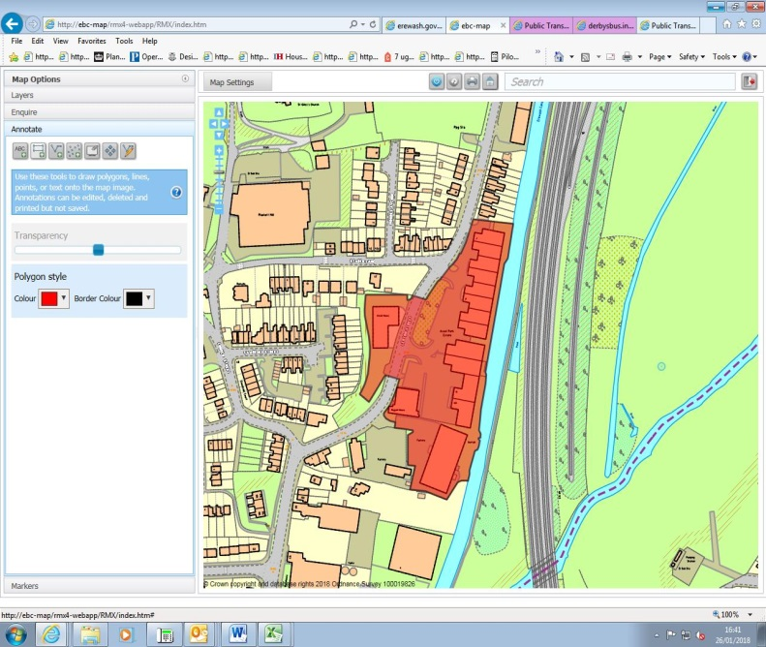

Site details:
Site reference (EELS) | EELS 034
Site name(s) | Ascot Park Industrial Area
Settlement | Sandiacre
Description | Modern industrial estate on site of former Excelsior Iron Foundry
Occupiers | Richdale Sofas, Your Time Leisure, Premier Hire Taxis, JT & D Patchett, Status Metrology Solutions Ltd, Health & Safety Engineering Ltd, Eagle Scientific Ltd, Premier Solutions Ltd, HPM Ltd, QCIG Ltd, Monitor Environmental, Muscle Food, Elegant Doors, OKC Manufacturing, Stapleford Hydraulics, Laystone Ltd, Autumn Engineering and Matrix Tooling Services
Current use classes present | Various – mainly B2, but also B1(b) & B1(c) and Sui Generis
Size (ha) | 1.5ha
Building age(s) | Majority of estate dates from late-c20th
Building quality | Largely good
Site assessment:
Prox. to strategic road network | Site 2.3km to J25 (M1/A52) 5
Local prominence | Site fronts Lenton Street; a busy but unclassified road 2
Public transport | 14 and i4 bus routes pass close by along Church St 10
Relationship to workforce | Site within Sandiacre settlement 10
Planning policy considerations | Neighbouring residential properties at north end, with site adjoining a local wildlife site (ER215: Erewash Canal) 8
Environmental setting | Units set back from highway behind sizeable landscaped area of grass and small trees 7
Flexibility of premises | Modern premises thought able to accommodate a number of general or light industrial uses. Some space on site in which existing units could expand/be modified 7
Demand/Commercial desirability | All units appeared occupied during recent site visit 8
Final score & status | (Out of 73) 58

Site commentary:
Site description:
Set across most of the former Excelsior Iron Foundry, the majority of this site is arranged into a modern industrial estate which at its northern-most is set back from Lenton Street behind an area of soft landscaping helping to strengthen its immediate setting. A row of eight industrial units of standardised design and appearance run in north-south orientation and face outwards over dedicated areas of off-street car parking. The units have generous ceiling heights allowing for good internalised workshop space, and each has a small area of office accommodation based in single-storey block annexes projecting outwards at ground floor level. A loading door is evident into each unit’s frontage. Further south, more units are housed within similarly-constructed buildings, although these display a slightly different configuration from its neighbours. These premises notably benefit from ample forecourt space given their more distant positioning away from Lenton Street. In the south-eastern corner of the site, a large factory premise (the Pencil Works) is present, again with a generous area of hardstanding at its frontage, although its vehicular access is separate from other units being positioned further south along Lenton Street on the curve of the bend. The same access also runs into a sizeable yard which at its southern-most point is a row of former residential cottages that now accommodate a taxi rental business. The western side of the yard provides parking and access to a former Chapel, which later operated as a Sunday School before being converted into business premises. Moving northwards along Lenton Street is Regent House, a small factory premise positioned just beyond the public highway. On the western side of the road, physically separated from all other employment premises, is Ascot House – a highly visible business premise building due to a notable rock outcrop behind it with a number of residential properties recessed back from the edge of the higher ground and rising above the two-storey building. Off-street parking space is south of the block-orientated brick building which has a small loading area immediately to its north. Both of which are accessed directly off Lenton Street.

Planning policy:
The majority of the site is fairly well enclosed given its position back from the neighbouring highway. However, at its northern end, industrial units do direct adjoin a row of established residential properties which could result in some low-level disturbance to household amenity, particularly where residents are within their garden space and more exposed to noise omitted from industrial operations.

Site flexibility:
The industrial units constructed on-site during the late-c20th appear to be functional and would allow for a number of light and general uses to be accommodated. The site’s layout is much less dense further south, so possibilities of extensions to certain buildings could be possible, or even the building of further small-scale units if demand was strong.

Demand and commercial desirability:
The level of occupancy at the time of the site visit appeared strong, with no industrial units appearing to be vacant. Availability of space within the former residential cottages at the site’s southern-most end was difficult to evaluate given the unclear nature of how the building was internally configured.

Final conclusion:
A popular business area within Sandiacre, Ascot Park Ind. Est provides functional industrial space for a host of local companies. Despite the wider area (east of Town St.) becoming more residential in character, this Estate is expected to remain commercially popular.

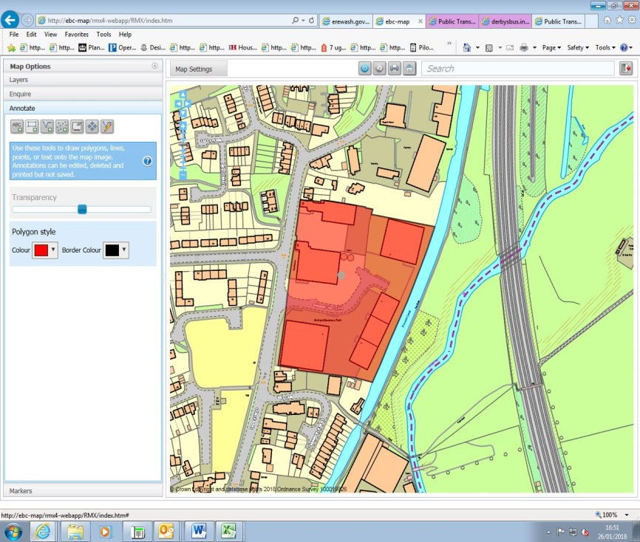

Site details:
Site reference (EELS) | EELS 035
Site name(s) | Orchard Business Park
Settlement | Sandiacre
Description | Cluster of large industrial units arranged around a ‘drive-in’ estate
Occupiers | Sandiacre Metal Solutions, Hydroscand Ltd, Came Automatic Gates, Vollmer, Litmans and Midlands Logistics Services Ltd.
Current use classes present | B1(c), B2, B8 & Sui Generis
Size (ha) | 1.9ha
Building age(s) | Largely recent with most of Estate built from 1980’s onwards
Building quality | Mostly good
Site assessment:
Prox. to strategic road network | Site 2.1km to J25 (M1/A52) 5
Local prominence | Site fronts Town Street; a busy but unclassified road 2
Public transport | 14 and i4 bus routes pass close by along Church St 10
Relationship to workforce | Site within Sandiacre settlement 10
Planning policy considerations | Neighbouring residential development, adjoins local wildlife site (ER215: Erewash Canal) 8
Environmental setting | Some basic soft landscaping event at site frontage, with occasion planted shrubs lining Mornington Close 6
Flexibility of premises | Most premises set within spacious curtilages so expansion thought possible. Units relatively modern so thought capable of adaptation 6
Demand/Commercial desirability | All modern premises occupied currently, although vacant space was evident at 131 Town Street 8
Final score & status | (Out of 73) 55

Site commentary:
Site description:
A predominantly modern industrial area located between Town Street and the Erewash Canal, Orchard Business Park contains a number of sizeable employment premises with low-density layout. Accessed off Town Street, a central estate road (Mornington Close) runs through the area and provides access to all but one of the industrial units. Two large-scale individual premises and a row of three units positioned south, east and north-east of Mornington Close are constructed in identical building materials, although their appearance differs due to variations in shape and scale. All premises are equip with a loading bay door offering elevations which whilst mainly red-brick, also accommodate sizeable panels of glazing to allow clear views into and out of individual units. Two separate premises are north of the junction between Mornington Close and Town Street. Nearest the junction, another sizeable building with utilitarian two-storey office block annexed to its frontage faces out onto the highway. At its rear are two sizeable circular storage tanks and high loading bay door. Further north and accessed directly off Town Street is the final (and smallest) industrial unit. This is orientated east-west with both end elevations displaying a loading bay door. Similar to other estates built in this period, significant parking provision is made for each premise which provides a rather bland immediate environment each of the industrial facilities across the site with minimal shrubs and landscaping evident along the various boundaries between Mornington Close and each individual unit. Whilst the Canal forms the eastern limit of EELS 035, the site’s other surrounds are mixed in character. A recent residential scheme is found to the south by following the Canal towards the centre of Sandiacre, whilst the area west of Town Street is also residential in character having been recently extensive reconfigured with old housing association stock replaced with modern units. North of the site are the residential properties 133-143 Town Street, and the employment site’s northern boundary with the curtilage of no.143 stretches almost the entirety of EELS 035.

Planning policy:
As the site description above mentions, nearby residential development, but that north of the site located in-between EELS 034 & 035, will likely be subjected to low-level disturbance - mainly from noise omitted by some of the operations taking place in the northern section of the employment area. Additionally, the adjacent local wildlife site designation covering the Erewash Canal (ER215) gives rise to the need for the waterway’s setting to be higher in quality than the current environment consisting of a relatively modern industrial estate.

Site flexibility:
The estate overall is fairly low-density in its layout, despite several large units being present. The surroundings for premises would allow for their extension if necessary, although all units appear to have been largely unaltered since their construction. With the relatively large areas dedicated for parking, a small new-build unit could be possible although this would inevitably require re-design of the site where such development was planned.

Demand and commercial desirability:
All the newer units across the site are currently occupied. However, the premises at 131 Town Street, which have been previously occupied by logistics and distribution uses, appeared under-utilised with some parts of the building looking vacant. The recent loss of Comet from one of the units at the site’s entrance (121 Town Street) saw the building swiftly re-occupied by Hydroscand demonstrating the demand for more recent industrial floorspace.

Final conclusion:
Despite being situated in a part of Sandiacre which sees an altering environment towards residential, the majority of facilities on-site are relatively modern and will remain attractive to current and future occupants.

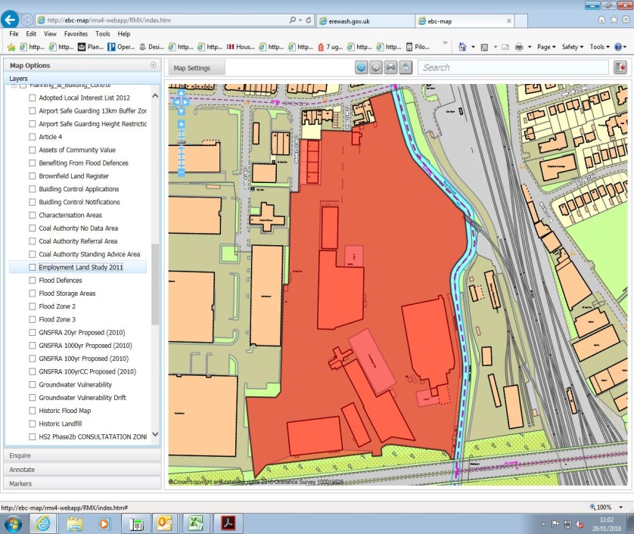

Site details:
Site reference (EELS) | EELS 036
Site name(s) | Progress Rail (formerly Balfour Beatty)
Settlement | Sandiacre
Description | Dispersed site accommodating a number of buildings involved in the casting and manufacture of parts and accessories for rail infrastructure
Occupiers | Progress Rail Services UK Ltd
Current use classes present | B2
Size (ha) | 5.4ha
Building age(s) | Mixed – much-altered site sees buildings constructed across a wide period of time
Building quality | Average
Site assessment:
Prox. to strategic road network | Site 1.9km to J25 (M1/A52) 6
Local prominence | Site visible from passing A52 Brian Clough Way 4
Public transport | Trent Barton i4 service routes along Station Rd 10
Relationship to workforce | Site within Sandiacre settlement 10
Planning policy considerations | Flood risk (small part of site within Flood Zone 3A) 9
Environmental setting | Vast area of hardstanding and buildings across the site providing minimal greenery and landscaping 4
Flexibility of premises | Business operating over a significant area, allowing flexibility to adapt site to meet operational requirements and recent permissions granted to facilitate this despite sited in sensitive area as a consequence of flood risk 7
Demand/Commercial desirability | Bespoke site occupant with one user, so site is fully utilised 8
Final score & status | (Out of 73) 58

Site commentary:
Site description:
A sizeable site situated right on the Borough’s boundary with adjoining Broxtowe (and Nottinghamshire), which has recently seen Progress Rail Services UK Ltd expand their operations across it, leading to securing planning permissions to continue the site’s reconfiguration. Accessed off the B5010 Station Road and via a continuation of Osmaston Street beyond a security barrier, several large-scale buildings are visible from the site’s main vehicular entrance. The former Midland Iron Foundry previously stood in the southern part of the site, with some buildings remaining and modernised. Production of track and other rail-related infrastructure occurs in buildings mainly located within the south of the site, with a sizeable castings facility positioned in its south-eastern corner. Evidence of former rail sidings across the site remains, although most track is now lifted and has been replaced with hardstanding around the various buildings and structures. It is however still accessible by rail with a single line carried over a small bridge spanning the neighbouring River Erewash and a straightened course of River from its traditional meander forms the majority of the site’s eastern boundary. This line links into the wider railway yards at the adjacent Toton Sidings. Large areas of open storage exist are to be found across EELS 036, with land utilised to help store some of the products manufactured at the facility. Overall, the industrial area here is well defined from its surrounds with the aforementioned River separating the site from neighbouring Toton Sidings, while an elevated section of A52 runs along its southern boundary. Further west is another area of industry with buildings accessed off Mark Street (see EELS 057) and north is the busy Station Road which links the settlements of Sandiacre and Stapleford.

Planning policy:
With the surroundings as described above demonstrating that the Progress Rail facility is sufficiently distant from nearby homes as to not impact on residential amenity, few planning policies are assessed as being in conflict with the uses on-site. One issue which arises as a consequence of the site’s location aside the River Erewash is that small eastern fringes are within the extent of Flood Zone 3a indicating a high vulnerability to flooding.

Site flexibility:
The site’s size provides opportunities for reconfiguration based on operational requirements. This is highlighted by recent applications submitted by Progress Rail to develop new facilities which have been approved by the Borough Council.

Demand and commercial desirability:
With the site occupied by a single company, the facilities here are orientated towards the production of rail infrastructure such as points, track and other products. The facility is therefore highly specialised for its occupant’s requirements, with its nearby connectivity to the main railway line believed to be a key commercial requirement.

Final conclusion:
A vast area of rail-based manufacturing providing a number of local jobs and continuing the area’s long-term association with the rail industry, the site is an important economic location and support for its local retention should be provided given the bespoke locational requirements and proximity to the line of the future HS2 route just further east which could deliver long-term benefits.

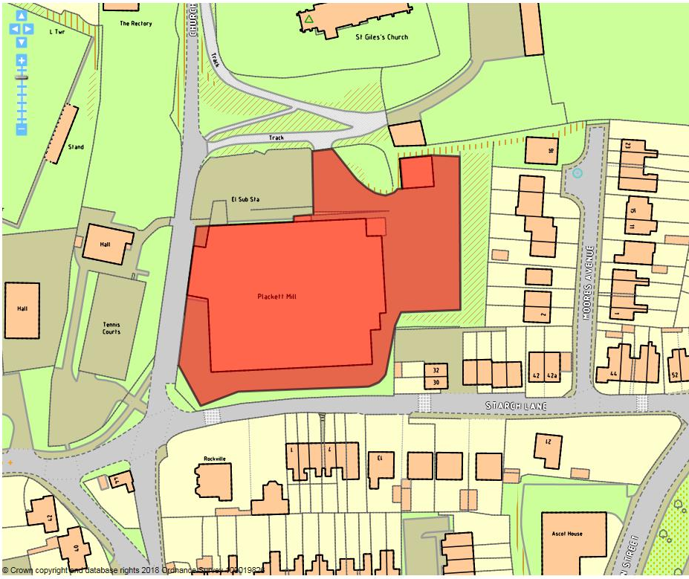

Site details:
Site reference (EELS) | EELS 037
Site name(s) | Plackett Mill
Settlement | Sandiacre
Description | Brick factory split between two-storey admin block and single-storey manufacturing premises.
Occupiers | Esprit Automation
Current use classes present | B2
Size (ha) | 0.5ha
Building age(s) | Premises date from around 1960-70.
Building quality | Average
Site assessment:
Prox. to strategic road network | Site 2.3km to J25 (M1/A52) 5
Local prominence | Site situated in its own local setting away from any higher order road 2
Public transport | Services i4 and 14 serve roads a short walk from the site 10
Relationship to workforce | Site within Sandiacre settlement 10
Planning policy considerations | Within Sandiacre Cloudside Conservation Area, within the setting of St. Giles Church (Grade II Listed), adjacent to residential properties 7
Environmental setting | Curtilage of site largely hardstanding (combination of parking and service area), but surrounding trees/greenery adds some visual interest to the site’s setting 7
Flexibility of premises | Not sizeable surrounds to expand current premises, and presence within Conservation Area likely to restrict ‘like for like’ additions to Plackett Mill 4
Demand/Commercial desirability | Single occupants of site (Esprit Automation) 8
Final score & status | (Out of 73) 53

Site commentary:
Site description:
Plackett Mill is located in the north of Sandiacre within the town’s Cloudside Conservation Area. Served largely by narrow lanes in a surrounding setting which is largely rural in character, the site is somewhat isolated from other areas of business within Sandiacre whilst providing a rare example of urbanised development in the Conservation Area. Sitting on the site of a former lace mill positioned at the road frontage with Church Drive, the site was extensively reconfigured from the 1960’s onwards, with the final result a functional manufacturing facility which is annexed by a more modern office block housing the current occupant’s head office. The appearance of on-site structures are fairly bland, typical of industrial development from 1960’s & 70’s. Two points of site access exist, the first almost at the junction of Church Drive, Church Street and Starch Lane providing access to car parking at the frontage of the office block and trade deliveries to be made on the southern side of the works premises. Secondary access is taken from a private track off Church Drive (serving Church Farm) entering a sizeable area of car parking situated north of the works building. The site is noticeable for how densely it is screened by trees immediately south and north, while further trees, albeit less dense in their coverage, help provide a visual break between Plackett Mill and residential properties on the western side of Moores Avenue.

Planning policy:
As already mentioned, the site forms part of Cloudside Conservation Area (CCA). The building’s ‘functional’ appearance is incongruous with this heritage designation, thus making it difficult to demonstrate any sort of a positive contribution made to the character of the CCA. Additionally, the employment site is located in very close proximity to St. Giles Church, a Grade I Listed Building. Whilst a strong screening of tall, mature trees offer a visual break between the two, the short distance results in further detrimental impact to the Church’s setting. With the employment premises sited within what is almost predominantly a residential area of Sandiacre, the issue of whether roads serving the site are suitable is a justifiable concern. Whilst the premises would not be expected to receive sizeable volumes of large trade vehicles/HGV’s, the narrow and quiet nature of local lanes to accommodate such traffic is likely to adversely impact residential amenity of those living on those highways.

Site flexibility:
The site is fairly well enclosed by surrounding physical and natural features on all sides, preventing further expansion of its curtilage. The sizeable building on-site leaves only small amounts of surrounding hardstanding to utilise, and with narrow lanes serving approaches to the site, the need for off-street car parking for visitors and employees is paramount to maintain highway safety. Also, the site’s presence inside a Conservation Area and close to the setting of a Grade I Listed Church is likely to impact on any reconfiguration plans.

Demand and commercial desirability:
Only a single occupant of Plackett Mill who have been present since 1998. Given this length of time, it is expected that premises have been adapted and configured for the current operations taking place inside the buildings.

Final conclusion:
Whilst the site sits within a historically sensitive area of Sandiacre, the fact the buildings have a long-standing occupant demonstrates a commitment to the area on the part of the Esprit, with a number of specialist jobs providing diversity to the local economy.

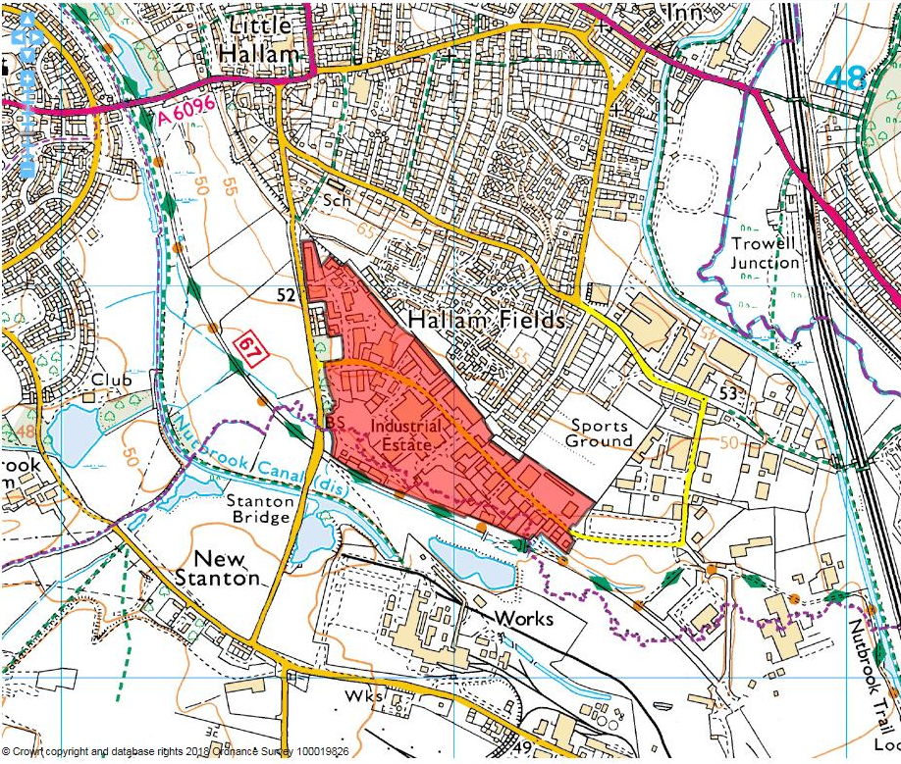

Site details:
Site reference (EELS) | EELS 038
Site name(s) | Quarry Hill Industrial Estate
Settlement | Ilkeston
Description | Sizeable industrial park located on the southern edge of Ilkeston
Occupiers | Various
Current use classes present | B1(a), B1(c), B2, B8 and Sui Generis
Size (ha) | 21.8ha
Building age(s) | Most date from 1990’s when Industrial Estate was constructed – some more recent buildings added
Building quality | Average to good
Site assessment:
Prox. to strategic road network | Site 6.2km to J25 (M1/A52) 0
Local prominence | Site accessed off Quarry Hill Road (QHR) and Merlin Way, both unclassified highways 2
Public transport | Number 15 service routes along QHR just west of the entrance into the Ind. Est. 10
Relationship to workforce | Site within Ilkeston settlement 10
Planning policy considerations | Contaminated land and small area of site situated within Flood Zone 3a 8
Environmental setting | Small grassed areas alongside verges of Ind. Est’s spinal road (Merlin Way), but little elsewhere across the site. Presence of waste management facilities detract from the wider area’s quality of environment 4
Flexibility of premises | Units across the site of modern construction and many have been adapted in line with occupants needs 8
Demand/Commercial desirability | High level of occupancy evident throughout the site with only a small number of vacant units 8
Final score & status | (Out of 73) 50

Site commentary:
Site description:
Quarry Hill Industrial Estate was constructed during the 1990’s, replacing works and sidings associated with the adjacent Stanton Ironworks that were cleared during the 1970’s. A modern, functional Industrial Estate with the vast majority of its units constructed to a similar design specification, its facilities are centred around a central road, Merlin Way, which at its western end shares a junction with Quarry Hill Road, and continues eastwards eventually meeting Crompton Road allowing vehicular access into further areas of industry (EELS 039 & 040) and the south-eastern parts of Ilkeston. A sizeable number of premises can be found across the employment site, with side roads off Merlin Way feeding into several court arrangements with smaller units clustered around communal yards providing parking and servicing areas. In addition to the smaller units, many larger specifications of industrial premise are evident, usually set within sizeable areas of curtilage affording generous parking and loading spaces. Also within the confines of the site along much of its southern boundary are the premises of Wards Recycling, a waste management facility with sizeable outdoor yard areas where imported waste material is treated using a number of methods and fragmenting and compacting machinery.

Planning policy:
The Industrial Estate enjoys a degree of physical separation from surrounding areas of Ilkeston so broadly conforms to most planning policies in the Council’s Local Plan. However, the site’s former use provides a strong likelihood that ground contamination may be present. The current industrial use is more compatible with lower quality ground conditions, although should extensive redevelopment for an alternative use occur in the future, widespread remediation would likely be necessary. Also of note is the south-west corner of the site being located within an area of Flood Zone 3a confirming its vulnerability to fluvial forms of flooding.

Site flexibility:
The specifications of the larger industrial units ensure extensions to such stock are readily achievable. It is evident around the Quarry Hill Estate how many of the existing premises have already been subjected to work to adapt the original structure, with new annexes – typically consisting of ancillary office accommodation and extra industrial floorspace is fairly common throughout. Whilst few opportunities exist to deliver new standalone business premises, the ability to modify industrial units is a positive characteristic.

Demand and commercial desirability:
Quarry Hill Industrial Estate is a popular location for local businesses given its range of units and premises. As such, occupancy of units has remained historically high here and a recent site visit showed only limited vacancies being commercially advertised. Given the size of the Estate, it is likely that some interdependencies exist between different businesses who may form parts of a supply chain and who have chosen to trade from an area close to complementary enterprises.

Final conclusion:
The Industrial Estate is one of the largest, and most high profile locations for industrial operations in the Borough. Its high rate of occupancy and relatively modern building specifications make it a desirable location to trade from. This is likely to remain the case for the immediate future, although the redevelopment of Stanton Regeneration Site on the south side of the Nutbrook Trail will require work to ensure noise arising from the Wards facility does not lead to detrimental residential amenity conditions for new homes north of Lows Lane.

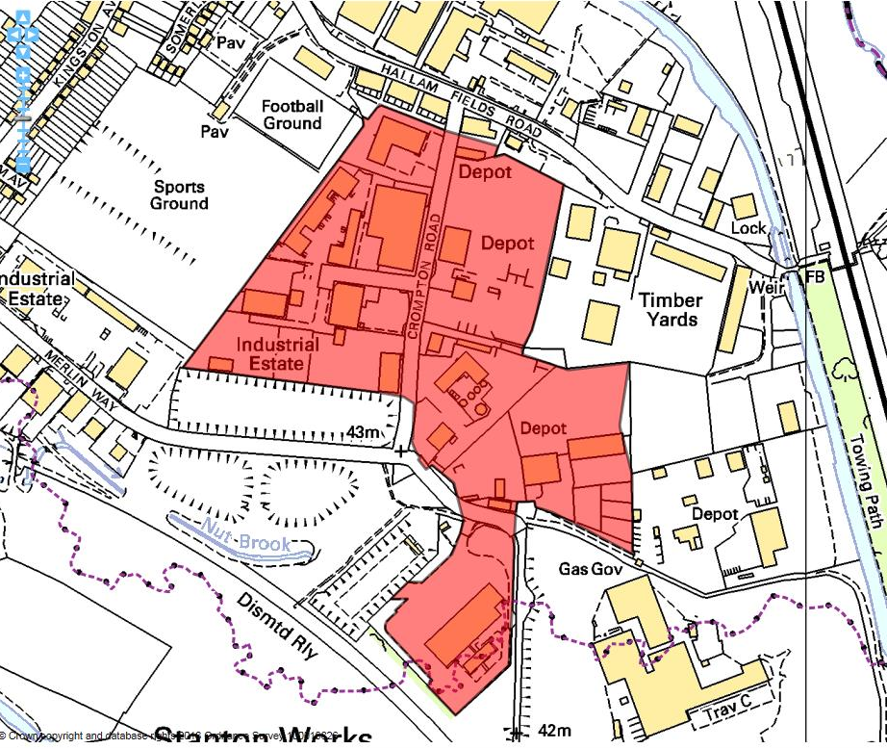

Site details:
Site reference (EELS) | EELS 039
Site name(s) | Crompton Road Industrial Estate
Settlement | Ilkeston
Description | Industrial Estate and Depot facilities situated on eastern edge of Ilkeston
Occupiers | Various
Current use classes present | B2, B8 and Sui Generis
Size (ha) | 12.4ha
Building age(s) | Majority of Industrial Estate constructed throughout 1980’s replacing an area of residential development
Building quality | Mixed
Site assessment:
Prox. to strategic road network | Site 5.3km to A52 0
Local prominence | Site accessed along Crompton Road, an unclassified highway 2
Public transport | Bus services 20 & 21 accessed at corner of Corporation Rd & Longfield Ln approx. 750m from site 5
Relationship to workforce | Site within Ilkeston settlement 10
Planning policy considerations | Likely ground contamination, adjacent to Grade II Listed structure and adjacent residential properties directly north of employment area 7
Environmental setting | Some soft landscaping evident around individual units in west of site, but largely hardstanding across area 5
Flexibility of premises | A number permissions granted for alterations and additions to properties within extent of site 7
Demand/Commercial desirability | No evidence of any vacant units after recent site visit, although difficult to determine in east of site 8
Final score & status | (Out of 73) 44

Site commentary:
Site description:
This employment area is sectioned into two clear parts with a traditional Industrial Estate located west of Crompton Road and a more dispersed layout of industrial uses found to the east. The premises within the west of the site consist of functional stock of minimal design interest, with a mixture of buildings accommodating a single business or several enterprises. The largest property occupied by Amcor Flexibles, sees ancillary office space at its southern-most end, with manufacturing areas throughout the remainder of the property. A number of other, smaller units are positioned around a short stretch of road (also Crompton Road) which provides access into several yard areas. The east of EELS 039 is characterised by more open employment use, with the large outdoor space within the curtilage of Long Eaton Plant Hire almost covering as much area in size as units west of Crompton Road. Moving south along Crompton Road are two notable industrial premises; firstly buildings at Castle Environmental Limited, a supplier of specialist waste treatment, recycling and disposal services. In addition to standard industrial premises, a number of tanks are situated across a site which is also heavily utilised as storage space around its periphery. At the site’s southern-most point and beyond the mini-roundabout junction between Crompton Road and Merlin Way is Johnson’s Aggregates and Recycling, another specialist company with on-site facilities to process aggregates and clean construction and demolition material. As with Castle Environmental, the premises sit centrally within a large site mainly comprising hardstanding surrounds and a perimeter access road.

Planning policy:
The site’s previous use of railway sidings entering from a south-westerly direction will have seen contaminants deposited into the ground from rolling stock using the lines. While current employment uses are constructed to be compatible with such ground conditions, this would likely hinder the ease in which the site could be utilised for other development uses. Adjoining the site to its north is the now-closed St. Bartholomew’s Church, of which the corner tower of the structure remains Grade II Listed. Once located within a more residential setting, the employment uses at the northern end of EELS 039 now provide an incongruous setting for a designated heritage asset. Finally, a row of residential premises remain facing out onto Hallam Fields Road, but which back on to the northern-most part of the industrial estate. These properties are likely to be affected by often noisy operations occurring not just occurring across EELS 039 but also the site immediately north at EELS 040.

Site flexibility:
With a range of premises across the site, the flexibility of each to grow or for new standalone facilities to be developed on underutilised land varies. Some alterations to existing units and buildings are evident, especially to the larger businesses who have greater scope to make amendments to their premises in order to meet changing demands, some regulatory and others to cater for growth opportunities.

Demand and commercial desirability:
Occupancy levels appear high across the site with the industrial units in its west almost at maximum capacity. With Amcor, Castle and Johnson’s all based within the site, these businesses have over time adapted their facilities to create highly bespoke premises which meet operational needs and are unlikely to become available in the near future.

Final conclusion:
A mixed employment site with a diverse range of conventional units, highly specialised premises and open yard areas. For the most part, EELS 039 is situated some way from adjoining areas and plays an important role in accommodating industrial uses that cannot realistically be located any closer to neighbouring housing areas in South Ilkeston.

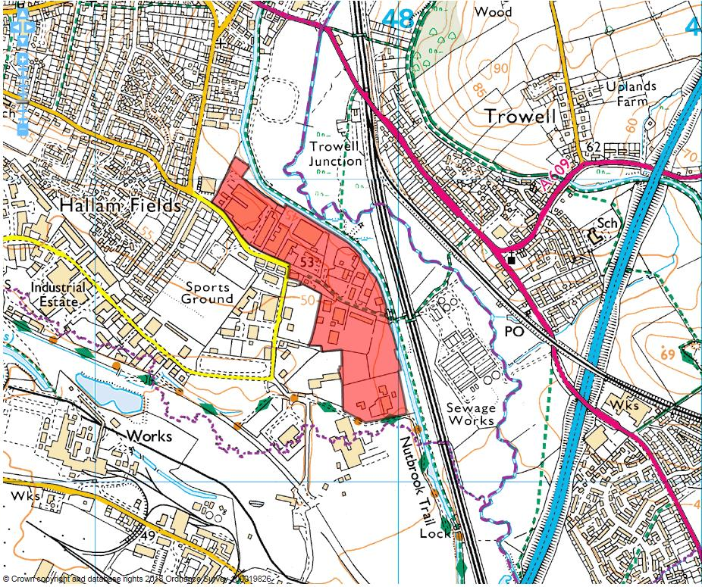

Site details:
Site reference (EELS) | EELS 040
Site name(s) | Hallam Fields Road Industrial Estate
Settlement | Ilkeston
Description | Diverse range of industrial premises located alongside the Erewash Canal
Occupiers | Various
Current use classes present | B1, B2, B8 and Sui Generis
Size (ha) | 18.7ha
Building age(s) | Majority originate from the 1970’s when the Estate was developed
Building quality | Diverse
Site assessment:
Prox. to strategic road network | Site 5.0km to A52 0
Local prominence | Site accessed by Hallam Fields Road, an unclassified public highway 2
Public transport | Majority of site located within 500m of bus services 20 & 21 which serve Longfield Ln & Corporation Rd 10
Relationship to workforce | Site within Ilkeston settlement 10
Planning policy considerations | Adjoining designated local wildlife site (ER215: Erewash Canal), proximity to three Listed Buildings, likely contaminated ground and neighbouring residential areas 6
Environmental setting | Very poor environment at east/south-east end of the site, despite adjoining green infrastructure 3
Flexibility of premises | Good. A number of premises, particularly larger ones north of Hallam Fields Lane have been subject to alterations/extensions 7
Demand/Commercial desirability | Limited number of industrial units and yard space available, although majority of premises across the site are occupied 8
Final score & status | (Out of 73) 46

Site commentary:
Site description:
Constructed from 1970’s onwards, the Ind. Est. comprises two distinct sections north and south of Hallam Fields Road (HFR). The majority of land south of the road was formerly part of Stanton Ironworks, with a dense arrangement of industrial buildings present. After clearance, the site was laid out to accommodate a number of industrial uses which, due to their unsociable nature required sufficient separation from nearby housing areas to safeguard levels of residential amenity. Today, this section of EELS 040 has diversified somewhat, with the construction of some newer, traditional industrial premises (Webster Brothers Industrial Estate). Despite this, the area contains a number of large-scale yards and depots accessed off HFR catering for uses connected to road haulage, scaffolding, timber works and the storage of building supplies. Generally low-quality industrial environments, many of the yard-based premises take vehicular access along unmade roads either beyond HFR or also from a continuation of Crompton Road past its junction with Merlin Way. North of HFR, similar uses as described above are found at the road’s eastern end. Moving westwards, larger industrial units sit between HFR and the Erewash Canal, the latter forming the site’s northern and eastern boundaries. These premises are of standard design and appearance, with ancillary office accommodation fronting the building and service bays evident along lengthy side elevations. Centrally positioned north of EELS 040 is a modern two-storey office/HQ building with spacious parking provision within its curtilage, somewhat out of character with surrounding employment buildings. Located west of the site is a mix of established and newer housing, with industrial units on the northern side of HFR now adjoining a modern housing development on the site of the former Charnos Factory. South, additional industrial land is situated inside the boundary of the Stanton Regeneration Site.

Planning policy:
The majority of EELS 040 east and south of HFR offers a fairly low-quality environmental setting impacting upon the setting of the adjoining Erewash Canal, a local wildlife site and important area of biodiversity. The Estate’s setting is also relevant to three Listed Buildings (all Grade II) on the area’s boundary; the tower of disused St. Bartholomew’s Church, a bridge over the Canal beyond HFR and lastly, Hallam Fields Lock. For similar reasons as stated in EELS 039, it is likely that a sizeable area of the ground will have been subject to contamination given its former use as part of Stanton Ironworks castings facility and rail sidings which would have seen rolling stock regularly enter the site. The relationship between industrial uses and surrounding residential areas has always been relevant to this site, but homes adjoining to the west are likely to be impacted by the operations which are carried out.

Site flexibility:
Sizeable flexibility of stock and land is evident. Many premises have undergone alterations, predominantly to increase floorspace. Many of the more open yard areas have sizeable areas which could perhaps be better utilised and accommodate additional industrial facilities.

Demand and commercial desirability:
Few vacancies were evident from a recent site visit. Some smaller industrial units were being commercially marketed, but represent only a small proportion of the available stock across the site.

Final conclusion:
A diverse industrial area, recent housing development replacing industrial stock to the west of the site could pose a threat to now-neighbouring business premises moving forwards. Site continues to makes provision for a large number of non-conforming industrial uses and plays a helpful role in siting these operations some way from nearby homes.

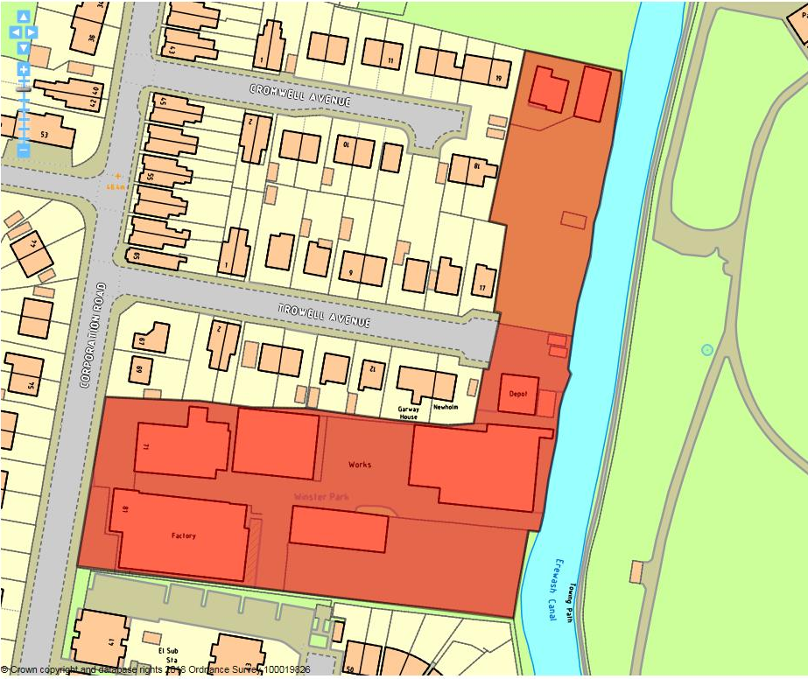

Site details:
Site reference (EELS) | EELS 041
Site name(s) | Winster Park Industrial Estate
Settlement | Ilkeston
Description | Industrial Estate accommodating several traditional works premises
Occupiers | HTF Stainless Steel Fabrications, Timber Frames Nottingham, R&S Furnishings and Winster Building Products
Current use classes present | B2 and B8
Size (ha) | 0.9ha
Building age(s) | First factory (occupied by HTF) built in 1960’s with other buildings on-site constructed during 1970’s.
Building quality | Poor to average
Site assessment:
Prox. to strategic road network | Site 4.7km to A52 0
Local prominence | Site fronts Corporation Road, a busy, but unclassified highway 2
Public transport | Short walk to A609 Nottingham Rd where a number of frequent bus services run 10
Relationship to workforce | Site within Ilkeston settlement 10
Planning policy considerations | Adjacent residential areas, neighbouring local wildlife site 8
Environmental setting | Trees around R&S Furnishings, but little other ‘softening’ of the industrial estate 4
Flexibility of premises | Buildings all low-quality so unlikely that any would support modifications and surplus space on-site minimal 3
Demand/Commercial desirability | Premises at front of site (71 Corporation Rd) currently vacant, but other four premises occupied 8
Final score & status | (Out of 73) 45

Site commentary:
Site description:
This industrial site, with its primary access off Corporation Road, but also a secondary access off Trowell Avenue serving only the premises furthest east (R&S Furnishings) has seen new residential development encroach right to its southern boundary over the last several years. With more established 1950’s housing immediately north of the site, the wider setting of this estate is becoming increasingly residential in its nature. On site, two premises front Corporation Rd, albeit recessed somewhat back from the roadside. The premise to the left is currently vacant, and appears to have had a more recent addition to its frontage containing ancillary office space to a more traditional works premise with chimney at its rear. Positioned either side of a central access road are further traditionally constructed factory works premises with multi-pitched roofs and orientated both north-south and east-west. More space can be found towards the rear/east of the site with areas of parking between the two northern buildings, whilst Winster Building Products understandably have a sizeable area of curtilage in which some of their goods and products are stored. Forming the eastern boundary of the site is the Erewash Canal, with some imposing trees providing the buffer between this area of industry and an important asset of green infrastructure.

Planning policy:
As mentioned, the site directly adjoins the Erewash Canal, with some of the industrial operations on site not fully in conformity with the need to provide a good environmental setting for an adjacent designated local wildlife site (ER215). For the same reason, this is also the case for neighbouring residential development – some of which has only relatively recently been constructed to the south of the industrial area.

Site flexibility:
The site demonstrates little flexibility due to the ageing nature of the industrial premises on-site, as well as the lack of space evident in which buildings would be able to expand, or replacement premises able to be constructed on larger footprints.

Demand and commercial desirability:
Only one of the units on-site (71 Corporation Road) is currently vacant, although a site visit showed no form of commercial marketing currently taking place to secure new occupant(s). All other businesses appear to have been on site for a prolonged period, indicating that premises have been tailored to meet specific operational requirements.

Final conclusion:
A site with largely lower quality industrial premises, it nonetheless provides useful employment space to established local businesses. With recent residential development now meeting the site at its southern boundary, the remaining industrial premises here are now somewhat isolated from the nearby industrial area at Hallam Fields Road (see EELS 040) and with its location aside the Erewash Canal, could see pressure to accommodate further residential development in the future.

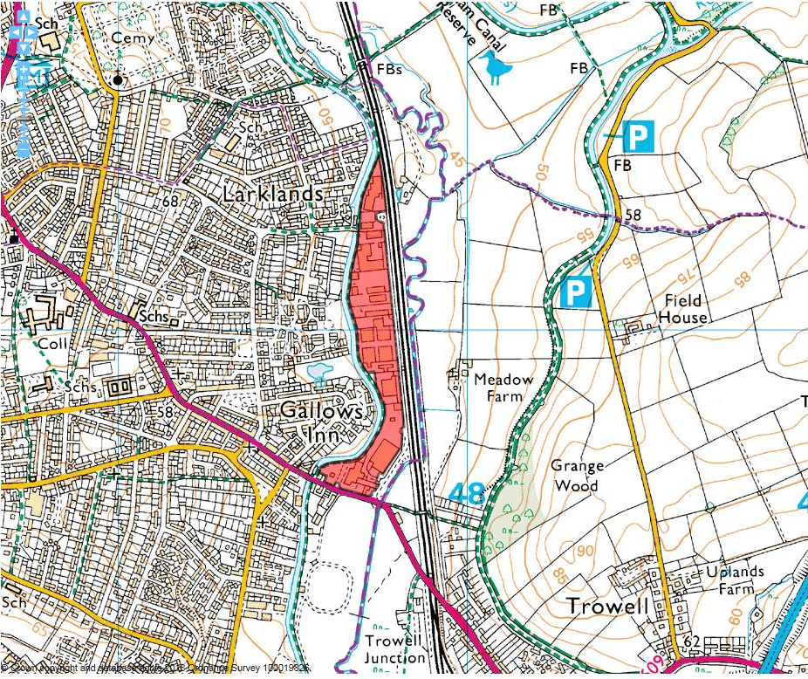

Site details:
Site reference (EELS) | EELS 042
Site name(s) | Furnace Road Industrial Estate
Settlement | Ilkeston
Description | Long, linear-shaped industrial estate situated on the eastern fringe of Ilkeston
Occupiers | Various, but main occupants inc. Dri Pak, West Transport, Breasley Foam, CustomPak, Belfield Furnishings & KRM Building Supplies
Current use classes present | Various, but predominantly B2-uses.
Size (ha) | 8.4ha
Building age(s) | Oldest buildings date from 1960’s with some recent additions
Building quality | Mixed, but largely average/functional
Site assessment:
Prox. to strategic road network | Site 4.1km to A52 1
Local prominence | Southern end of site adjoins A609 Nottingham Rd 4
Public transport | Several routes serve A609 Nottingham Rd 10
Relationship to workforce | Site within Ilkeston settlement 10
Planning policy considerations | Adjoins local wildlife site (Erewash Canal), listed building (Soughclose Lock) and part of site within FZ3 7
Environmental setting | Benefits from adjoining Erewash Canal along western boundary, but little landscaping on the site itself 5
Flexibility of premises | Most units set within spacious surrounds, so extension and modification to premises thought possible 6
Demand/Commercial desirability | No evidence of vacant business units from recent site visit 8
Final score & status | (Out of 73) 51

Site commentary:
Site description:
This is a long, linear industrial area which sits on the eastern-most edge of Ilkeston and Erewash Borough, positioned between the Erewash Canal and the Nottingham to Sheffield rail line. Formerly the site of Ilkeston Iron Furnaces, the site remained vacant for several decades until the construction of the Industrial Estate during the 1970’s. The site is served by a single highway, Furnace Road, which provides access to all premises off the A609 Ilkeston Road which are almost exclusively positioned to the west of the road. The industrial estate is a mixture of a depots, factories and warehouses, most having ancillary office accommodation evident from the exterior of the premises. Each premise is set within ample surrounds, with notable yard space and dedicated off-road car parking. Despite this, a site visit showed a number of cars parked intermittently along both sides of Furnace Road, sometimes obstructing the path of oncoming HGV’s attempting to access premises sited in the north of the industrial estate. In the centre of the site, units which appear to have been recently modernised are arranged in a row positioned at right-angles to Furnace Road demonstrating the variety in premise size which exists on the Estate. One of the largest land-users here is West Distribution who operates their trailer rental service on a sizeable site around halfway along Furnace Road. At the northern tip of the site is the most recent addition to the Estate, a series of staggered warehouses.

Planning policy:
With the site located between the Erewash Canal and River Erewash, it is unsurprising that a large proportion of the Industrial Estate sits within Flood Zone 3. Whilst industrial and business uses are more compatible with areas of heightened flood risk, gaining permission for new development (or modifications of existing stock) will be more difficult given the need to demonstrate that development displays greater resilience to flood events. Towards its northern-most point, the site also adjoins the Grade II Listed Soughclose Lock on the Erewash Canal. The neighbouring industrial buildings, despite being situated behind a line of tall trees, doesn’t necessarily afford the Lock premises and immediate surrounds the setting such a heritage asset is perhaps worthy of. On a similar theme, the site forms a considerable neighbour to the Erewash Canal which forms almost the entirety of EELS 042’s site boundary. Again, the uses occurring in and around premises at Furnace Road are slightly incongruous with an adjoining area of environmental sensitivity given the Canal’s status as a local wildlife site (ER215).

Site flexibility:
The general level of flexibility is assessed to be average across the site. Whilst space to construct new premises at Furnace Road is now somewhat limited due to a number of recent permissions being granted to erect small steel framed units, the typically spacious surrounds of those larger business premises would typically allow for the extension of these facilities should an operational need arise.

Demand and commercial desirability:
As referred to above, a number of planning permissions have been granted for various developments across the wider site. This shows a good level of commitment towards the site from current occupants of buildings. No vacancies were evident at the time of visit, so this is a strong sign that facilities here remain commercially popular.

Final conclusion:
An example of a large edge-of-town industrial estate with a variety of premises and operations present, Furnace Road provides a range of industrial facilities located away from residential development, allowing it to exist as a successful estate which owing to high levels of occupancy makes a strong contribution to the local economy.

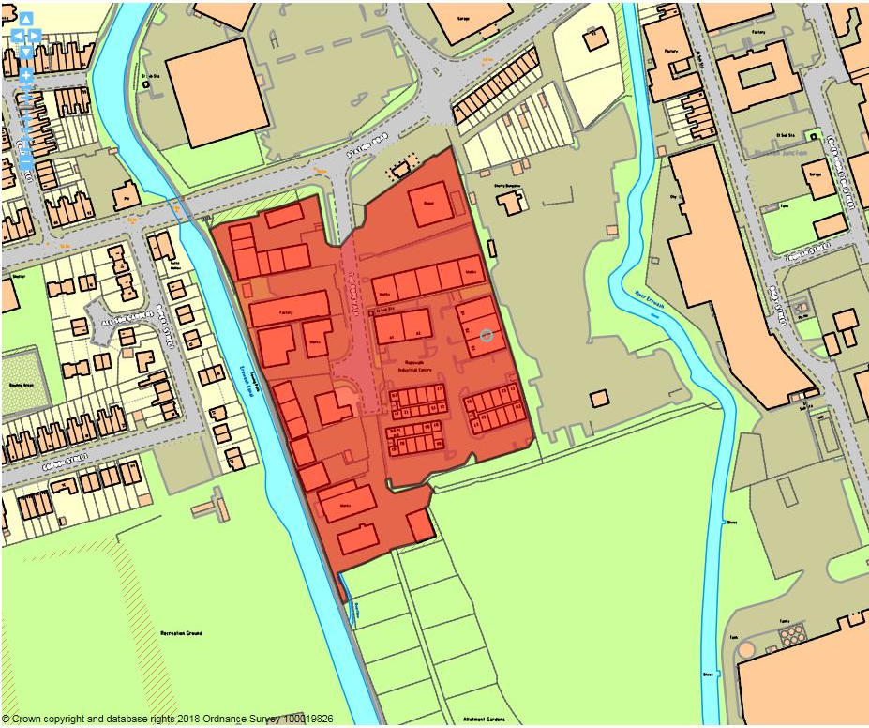

Site details:
Site reference (EELS) | EELS 043
Site name(s) | The Ropewalk Industrial Estate
Settlement | Ilkeston
Description | Industrial Estate located in east Ilkeston between the River Erewash and Erewash Canal
Occupiers | Various
Current use classes present | Mainly B2, but some B1(c) and Sui Generis
Size (ha) | 2.2ha
Building age(s) | Industrial estate developed throughout 1970’s
Building quality | Average to good
Site assessment:
Prox. to strategic road network | Site 3.1km to A610 3
Local prominence | Site sits just off Station Rd, a busy but unclassified road 2
Public transport | The 27 service routes along Station Road 10
Relationship to workforce | Site within Ilkeston settlement 10
Planning policy considerations | Site adjoins local wildlife site (ER215: Erewash Canal) 9
Environmental setting | Limited trees planted around the site softening the landscape, but still largely hardstanding 6
Flexibility of premises | Limited flexibility inside units given because of communal areas situated at rear of individual units 5
Demand/Commercial desirability | Three units vacant at the time of site assessment, although Estate was at maximum occupancy back in early 2017 8
Final score & status | (Out of 73) 53

Site commentary:
Site description:
The industrial estate, formerly the site of a sports ground, was constructed during the early 1980’s and sits close to the recently re-opened Ilkeston Railway Station located a few hundred metres east along Station Road. The site enjoys a single vehicular access, off The Ropewalk, with an internal road passing centrally in a north-south alignment beyond a gated entry point. A number of largely identical units can be found east of the central access road, with most displaying full height roller shutter doors, with open plan space inside as well as internally partitioned ancillary office floorspace. Some of the units appear to have been recently re-roofed, incorporating roof lights to enable more natural light into workspaces. Ample parking exists in areas between the various rows of buildings on this side of The Ropewalk site. More industrial units exist west of the central access road, although these premises are generally of brick construction and are grouped around smaller courtyards with more limited space for car parking and service loading. The form and positioning of these premises are noticeably more irregular than those found on the opposite side of the industrial estate.

Planning policy:
The Industrial Estate largely conforms with local planning policies, although the facilities do adjoin a local wildlife site (ER215: Erewash Canal), providing an uncertain setting for an area of recognised ecological importance.

Site flexibility:
The units themselves have permission to operate B1, B2 and B8 uses making each adaptable in accommodating a range of business operations. Internally adaptation and reconfiguration is likely to be difficult given that a large number of units have a single door through to a rear corridor that provides access to communal facilities (WC’s, kitchen etc.). Whilst sizeable areas of hardstanding exist in the west of the Estate, these areas play key roles in providing car parking and servicing space, so the further intensification of the site with new units looks to be unachievable without taking a wider, more comprehensive approach to the layout of the Estate.

Demand and commercial desirability:
At the time of visit, three units across the site were being marketed commercially to attract new occupants. However, this is only a small proportion of units across The Ropewalk, so the healthy occupancy levels are an indication that the facilities here are in relatively high demand.

Final conclusion:
Industrial floorspace at locations such as The Ropewalk are likely to benefit from the reopening of a Railway Station in Ilkeston, providing greater accessibility to facilities on the eastern side of the town. A number of these units look to have been modernised in recent years showing investment in facilities at the site and ensuring that floorspace here remains commercially attractive, not only to those present, but also to potential occupants who may wish to locate at The Ropewalk.

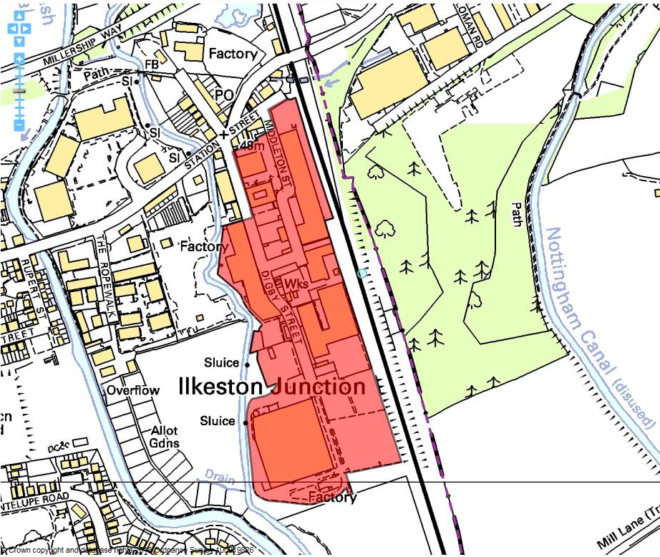

Site details:
Site reference (EELS) | EELS 044
Site name(s) | Digby Street Industrial Estate
Settlement | Ilkeston
Description | Industrial area centred around Digby Street containing mix of old Mill factories and more recent employment premises
Occupiers | Armstrong’s Mill Factory Shop, Labone, Goldbury Coatings, Rainbow International Ltd, Amcor Flexibles and a number of smaller operations at units west of Digby St.
Current use classes present | B1(a) & (c), B2 & A1 and Sui Generis
Size (ha) | 7.9ha
Building age(s) | Varied – Mills on east side of site date from mid-c19th whilst newer premises constructed mid-c20th onwards.
Building quality | Mixed
Site assessment:
Prox. to strategic road network | Site 3.1km to A610 3
Local prominence | Most of site visible from nearby A6096 Millership Way 4
Public transport | Bus services route along adjacent Station Road 10
Relationship to workforce | Site within Ilkeston settlement 10
Planning policy considerations | Flood Zone 3b 9
Environmental setting | Site largely consists of hardstanding for parking/servicing, but some premises have basic green landscaping 6
Flexibility of premises | A number of premises on site demonstrate flexibility for internal reconfiguration, although this would be limited for Mill premises. Some land on site to allow new build, but area constrained by being functional flood plain 4
Demand/Commercial desirability | Limited vacant units, with space empty in Mill buildings and units in Digby Business Park. 8
Final score & status | (Out of 73) 54

Site commentary:
Site description:
An edge-of-town site sees a mix of industrial and other employment-based uses centred on Digby, Middleton and Lower Middleton Street. The area contains the two prominent Mill buildings, Armstrong’s and Albany Mill, each of sufficient scale (at their highest, four storeys tall with the former displaying a notable chimney) to dominate the immediate urban landscape on the eastern side of Ilkeston. The site’s eastern boundary is the railway line. Sidings off this route ran to the rear of both Mills allowing for loading/unloading of goods. Newer premises are occupied by Labone’s, who operate from three separate buildings on each side of Middleton Street. The northern-most of the three enjoys a spacious curtilage with ample space for staff & visitor car park, whilst its adjacent building to the south looks to fulfil office/administrative functions. The centre of the site houses a number of yard-based uses making little contribution to the urban realm, whilst moving further towards the south of EELS 044, two large and similarly-designed factories with multi-pitch roofs are based at the end of Lower Middleton Street; the eastern building having a sizeable service and storage area extending southwards before reaching a large grassed space. At the southern tip of EELS 044 is Amcor, clearly the largest building in terms of area. The building sits enjoys a degree of separation from the remainder of the site, accessed beyond Digby Street and set within sizeable surroundings including a perimeter service road, collections of industrial storage tanks and a large surface car park located between the premise and the neighbouring railway line. Northwards and to the west side of Digby Street is Digby Business Park; a single industrial unit with sizeable highway frontage which has been subdivided into twelve units. The building is of concrete frame construction beneath a combination of pitched and flat roofing. At the rear, is a detached portal frame unit with a steel-clad exterior with yard space sweeping around the west of the building.

Planning policy:
The main issue stems from the site’s proximity to the River Erewash, and the heightened possibility of flooding arising from this. Recent flood modelling undertaken on behalf of the EA in 2016, now incorporated into the Council’s SFRA shows a majority of the site situated within Flood Zone 3b, the functional flood plain. This has implications for restricting most forms of new development and previous flooding events have impacted upon this part of Ilkeston. A number of sites within and adjoining this area were identified as part of the Ilkeston Gateway SPD, recognising that the reopening of the nearby Ilkeston railway station could act as an economic catalyst to the area’s regeneration.

Site flexibility:
Whilst notable amounts of space exist across this area of employment (such as a grassed area of land east of the Amcor premises), the inclusion within Flood Zone 3b places strict restrictions on the ability to construct new development. Mill premises on-site may have potential for a mixture of new uses within the buildings.

Demand and commercial desirability:
Albany Mill is currently being commercially marketed for sale, but has occupants. Only few vacancies around the site are evident demonstrating a strong level of demand for the facilities here.

Final conclusion:
A diverse range of employment floorspace exists across the site, from low quality yard-based uses in its centre, to specialised premises (Labone, Amcor) and the most visible stock at the two prominent Mill premises on the east side. The area is likely to benefit from the reopening of the town’s Railway Station a few hundred metres north-east.

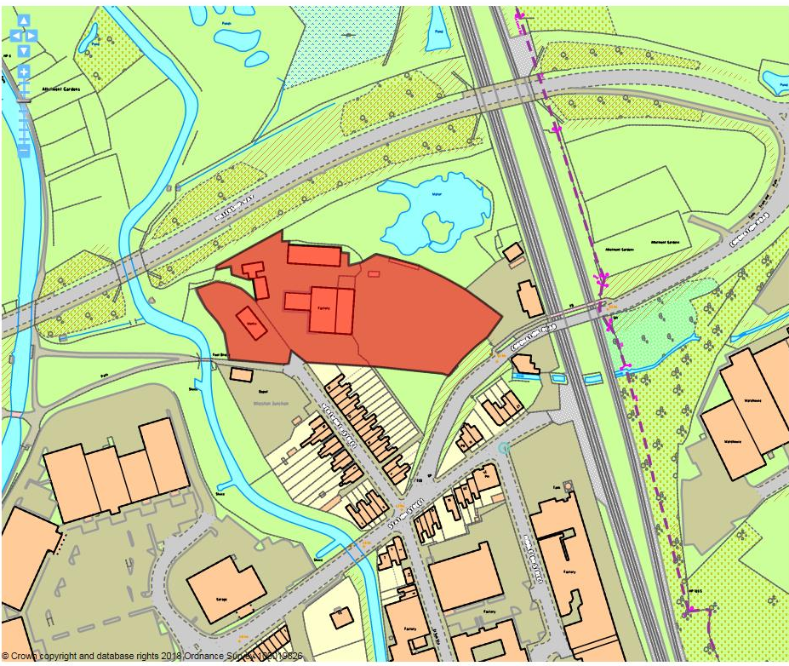

Site details:
Site reference (EELS) | EELS 045
Site name(s) | Works at Wentworth Street
Settlement | Ilkeston
Description | Grouping of workshops, storage buildings and commercial yards located at the end of Wentworth Street.
Occupiers | Rayden Engineering Ltd, Moorgreen Peas Ltd
Current use classes present | B2
Size (ha) | 0.9ha
Building age(s) | Earliest buildings constructed during 1970’s, later addition of a unit in west of area approx. 1990’s.
Building quality | Moderate
Site assessment:
Prox. to strategic road network | Site 2.9km to A610 4
Local prominence | Site visible from A6096 Chalons Way 4
Public transport | Service 27 routes along nearby Station Road 10
Relationship to workforce | Site within Ilkeston settlement 10
Planning policy considerations | Residential amenity of neighbours, access arrangements at junction of Wentworth St & Station St, Flood risk 7
Environmental setting | Site exclusively comprised of hardstanding and buildings. Nature of operations risks creating a negative impact on surroundings 3
Flexibility of premises | Sizeable yard space in east of site allows scope for intensification of use, but situated in sensitive flood zone which limits opportunities for development 3
Demand/Commercial desirability | All units/yard space on site appears to be in active use from the site visit 8
Final score & status | (Out of 73) 49

Site commentary:
Site description:
The site sits within an area of Ilkeston characterised by industrial operations close by to the recently-opened Ilkeston Railway Station. Vehicular access is restricted to a single point of entry at the end of Wentworth Street beyond where terraced properties end on the road’s eastern side, forcing all vehicles visiting the site to navigate the awkward junctions at the loose confluence of Station St, Wentworth St, Digby St. & Coronation Rd. The site was set out for industrial usage during the 1970’s, with most remaining buildings constructed at this time. Historic maps indicate the central and largest building, a pair of attached premises (one with conventional single-pitch roof and its neighbour with a semi-circular design) originally projected further east into an area now occupied by a commercial yard. Annexed to these at their western-end is a conventional single-storey office building containing the reception and administrative areas of Rayden Engineering with car parking spaces positioned around. Other smaller single-storey brick buildings are to be found around the perimeter of the site, with these all believed to be occupied by Rayden as indoor compounds. Unit 2 is currently occupied by local food manufacturer and supplier, Moorgreen Peas Ltd, whilst a sizeable yard area currently stores a mix of large-scale piping and machinery of different types - although much of this area was unoccupied at the time of site visit showing large areas of hardstanding up to the site’s eastern boundary close to the railway station.

Planning policy:
The site sits in close proximity to a number of late-Victorian terraced properties lining both sides of Wentworth Street, but particularly those on the eastern side whose gardens abut the commercial yard situated east of the Rayden premises. The nature of manufacturing works on-site has previously generated noise which has raised amenity concerns, although this was not evident at the time of visit. Nevertheless, operations undertaken by Rayden are likely to give rise to some periods of noise possibly impacting on residential amenity of those in the nearby area. Additionally, the residential nature of Wentworth St. is not ideal for accommodating trade vehicles owing to residential parking on both sides of the highway. This is compounded by the complicated arrangement of junctions at the end of Wentworth St. where a number of other roads meet Station St, and visibility left when turning out of Wentworth St. is severely impaired owing to the layout of homes relative to the highways. Whilst smaller domestic cars could navigate this, larger trade vehicles would find access and egress into Wentworth St. much harder. Flood modelling of the nearby River Erewash shows the site vulnerable to the risks of flooding. The majority of the assessed site sits within Flood Zone 3a (a 1-in-100 year likelihood of a flood event), whilst a small element of Flood Zone 3b (1-in-20 year), the functional floodplain, encroaches into the site’s curtilage at its northern-most part.

Site flexibility:
As mentioned above, concerns about the close proximity to residential properties, limitations of the highway arrangements and the vulnerability of land at this part of Ilkeston to flood are all justifiable reasons to suggest the site has extremely limited flexibility to further intensify.

Demand and commercial desirability:
Rayden Engineering have been present for a significant time, suggesting this is a suitable location for their operations. No units on site appeared vacant at the time of visit.

Final conclusion:
Whilst industrial operations here are noisy in their nature, Rayden are an established presence on the site and it is expected that facilities have been customised over the years to support the work done from the premises.

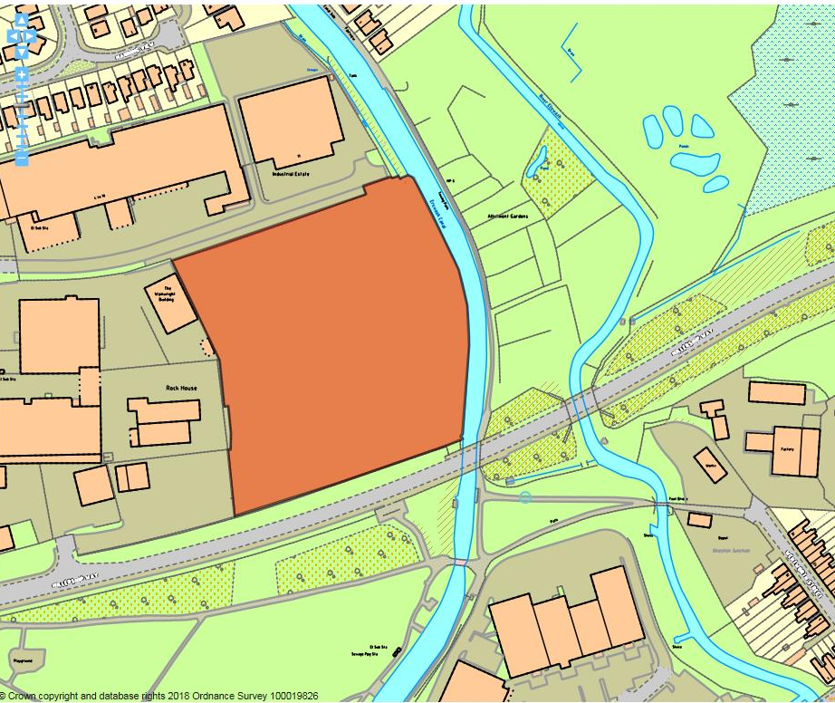

Site details:
Site reference (EELS) | EELS 046
Site name(s) | Land off Belfield Street
Settlement | Ilkeston
Description | An area of vacant, partially-cleared land situated on the edge of Ilkeston’s built-up area.
Occupiers | N/A
Current use classes present | N/A (thought to be in a B2 use previously)
Size (ha) | 2.0ha
Building age(s) | No buildings or structures on site
Building quality | N/A
Site assessment:
Prox. to strategic road network | Site 3.1km to A610 3
Local prominence | Site visible from A6096 Millership Way 4
Public transport | Site greater than 1km away from nearest bus route 5
Relationship to workforce | Site within Ilkeston settlement 10
Planning policy considerations | Adjacent to a Local Wildlife Site (ER 215), Ilkeston Gateway SPD 9
Environmental setting | Site largely made up of broken hardstanding and overgrown self-seeding shrubs. Adjacent Canal offers potential to improve setting here 6
Flexibility of premises | With the site vacant and few restrictive planning policies, this site offers excellent flexibility to provide a range of end employment uses 9
Demand/Commercial desirability | With no occupant on-site, the site cannot demonstrate any current commercial demand 0
Final score & status | (Out of 73) 46

Site commentary:
Site description:
This large vacant site alongside the A6096 Millership Way is a prime opportunity location for new employment uses on a prominent entry corridor into the town of Ilkeston. Sandwiched between the Erewash Canal on its east, Rutland Industrial Park (EELS 055) to the north/ west and the aforementioned A6096 bordering to the south, the site, intriguingly without any sort of use since the wider area was set out for industrial uses from the 1960’s-onwards, offers a logical extension to the surrounding Industrial Estate or a suitable location for a campus/HQ-style development. The site is currently accessed from its northern side onto Belfield Street. Whilst access to Millership Way is possible, the change in land levels between the A6096 and the site (which is lower) would make formulating a workable vehicular access challenging, particular due to the current speed limits in operation on Millership Way. With the site having no obvious use over recent decades, there are a number of dense pockets of shrubs evident across EELS 046, although at this stage, it is not expected that such vegetation would be of sufficient merit to formally justify its designation as a Local Wildlife Site.

Planning policy:
The site was assessed as that which demonstrated the greatest potential to deliver new economic development uses through the production of the Ilkeston Gateway Supplementary Planning Document (SPD). This considered a number of factors, but emerged as the top-ranked site largely as a result of its vacant status and potential to accommodate a scheme showcasing strong levels of design quality owing to its visibility on approach to the town from the east. Currently, the site does not neighbour the Erewash Canal particularly well. A site visit showed high levels of waste of varying types (trade and domestic) had been discarded, some of which would prove harmful to a standing open water habitat and sensitive canal-bank environments.

Site flexibility:
With the site vacant, this offers great flexibility for a possible employment-based development. It would also provide an excellent opportunity to enrich the Canalside setting and create and area which forms a strong association with a neighbouring area of biological and wildlife importance. Given the site’s size (2.0ha) it is thought that despite surrounding heavier industrial uses to the north, but more notably to the west, sufficient space could be utilised to provide an adequate buffer to mitigate any negative impacts from those adjacent land-uses.

Demand and commercial desirability:
Despite the site’s qualities and undoubted potential to support new economic development as highlighted by the Ilkeston Gateway SPD, land here has remained vacant and under-utilised for a number of decades. Recent discussions with those acting on behalf of the landowner back in 2015 offered hope that a development scheme could have been forthcoming, although initial discussions have not reached any substantive progress.

Final conclusion:
As identified by the Ilkeston Gateway SPD, the redevelopment of this site has been earmarked as playing a major role in helping to promote and increase the economic performance of an area close to the newly-reopened Ilkeston Railway Station. The Borough Council would welcome discussions to explore the most effective use of this site and bring about a high-quality development which forms a focal point of entry to those travelling into Ilkeston from the east.

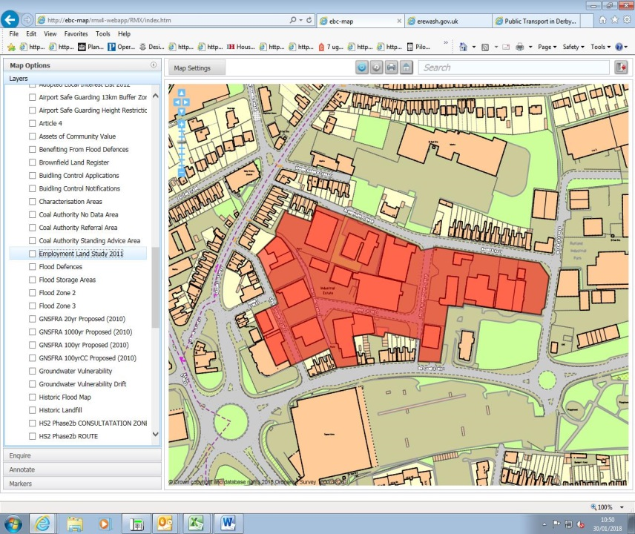

Site details:
Site reference (EELS) | EELS 047
Site name(s) | Abbey Street Industrial Estate
Settlement | Ilkeston
Description | Area of largely industrial and warehousing uses located north-east of Ilkeston town centre.
Occupiers | Mapledale, Orchard Kitchens, Pollards Holloware, Craft Engineering, Auto Fix, Kens Electricals, Manor Foundry, Industrial Pipeline Solutions, GHD Deliveries, Granby Motors, Clark and Partners, Halfords, Southern Car Hire, Minofirm Ltd, Zinda Scrap Metal and JW Engineering.
Current use classes present | B1(c), B2, B8 and Sui Generis
Size (ha) | 2.7ha
Building age(s) | Most premises date from 1960’s when industrial buildings replaced an area of terraced housing
Building quality | Average
Site assessment:
Prox. to strategic road network | Site 3.6km to A610 2
Local prominence | Site shares parts of frontage with A6096 Rutland St. 4
Public transport | A number of bus services route along Granby Street just beyond western edge of site 10
Relationship to workforce | Site within Ilkeston settlement 10
Planning policy considerations | Neighbouring residential development 9
Environmental setting | Little soft landscaping or greenery evident across the site. Largely characterised by yards, areas of parking & servicing space 5
Flexibility of premises | Most buildings standalone and set within spacious curtilages allowing for extensions and reconfiguration 6
Demand/Commercial desirability | No vacant units observed on recent site visit 8
Final score & status | (Out of 73) 54

Site commentary:
Site description:
This general industrial area between Rutland Street and Barker Gate, north-east of Ilkeston town centre is home to a large number of businesses. Formerly an area characterised by streets of terraced properties, wide-scale demolition during the 1960’s paved the way for its replacement as an industrial area to accommodate uses not suitable in close proximity of housing. Access by a number of roads which run through, and in some cases, meet within the extent of the site. The main point of vehicular access is Belfield St which forms EELS 047 eastern-most boundary, although industrial premises can be found fronting Barker Gate, Lower Bloomsgrove Rd, Abbey St, Rutland Terrace, Rutland St, Bloomsgrove Rd and Lower Granby St demonstrating the dispersed nature of this area. Whilst there is diversity in the size and appearance of stock throughout the site, buildings are functional with little notable design features. Some newer business premises have been constructed in recent years, notably a Halfords car care facility fronting Rutland St, whilst some display modern extensions which have allowed for business growth. Many of the premises and yards are located behind security fencing, set back off public highways which permeate EELS 047 serving to create a somewhat isolated, sterile environment with clear a division between public and private space. The remnants of terraced housing stock can still be found around the site’s perimeter, with homes remaining on Barker Gate, Bloomsgrove Road and Rutland Street set within an area now characterised by industrial and business premises.

Planning policy:
With the area now largely industrial in character, remaining households at locations mentioned above find themselves within close proximity of a sizeable number of business uses. This naturally creates the scope for residential amenity to be compromised to a small degree as a result of industrial operations occurring at industrial premises in the vicinity.

Site flexibility:
As mentioned in the description, a significant number of premises throughout EELS 047 are set within spacious surrounds which would allow individual businesses some scope to expand should a commercial need exist. The site has few opportunities however to locate new standalone buildings within it without widescale estate reconfiguration occurring.

Demand and commercial desirability:
Occupancy throughout the area appears strong with no signs of commercial lettings or sale boards visible from a recent site visit.

Final conclusion:
An established industrial area, Abbey Street Industrial Estate provides a location for a number of non-conforming employment uses which would struggle to occur within residential areas without demonstrably and adversely impacting on levels of household amenity. As such, facilities here are important to allow for industrial uses which require a degree of separation from surrounding forms of development and are helpfully situated in close proximity to Rutland St and Millership Way to allow for fairly direct road access to the strategic road network.

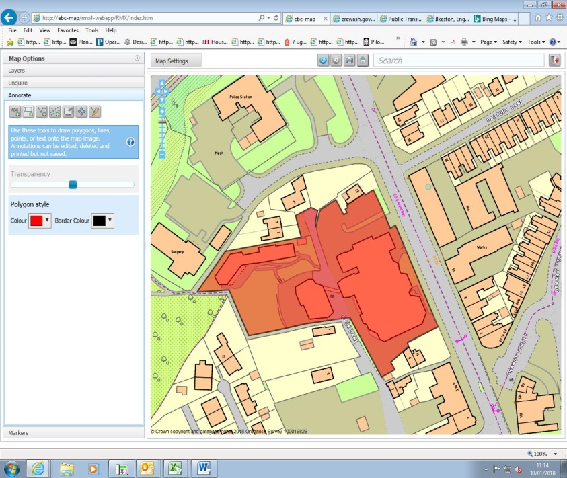

Site details:
Site reference (EELS) | EELS 048
Site name(s) | Weleda Works and Business Premises
Settlement | Ilkeston
Description | Factory premises also incorporating a store and natural retreat building
Occupiers | Weleda
Current use classes present | A1 (small area at front of building for on-site sales in pharmacy) & B1(c)
Size (ha) | 0.7ha
Building age(s) | Buildings originally constructed back in 1939
Building quality | Good
Site assessment:
Prox. to strategic road network | Site 3.9km to A610 2
Local prominence | Site fronts the busy A6007 Heanor Road 4
Public transport | A number of localised routes serve Heanor Road 10
Relationship to workforce | Site within Ilkeston settlement 10
Planning policy considerations | Adjacent to residential properties 9
Environmental setting | Front (eastern) part of site lacking in green aspects, however rear of site (western) includes notable area of small woodland and retreat garden 7
Flexibility of premises | Space to the rear of buildings, although its loss would be of detriment to the wider site’s character 5
Demand/Commercial desirability | Single long-term occupant of premises (Weleda) 8
Final score & status | (Out of 73) 55

Site commentary:
Site description:
The site, located just north of Ilkeston Town Centre, accommodates the UK headquarters of Weleda; a multi-national company who manufacture holistic natural cosmetics as well as pharmaceuticals for anthroposophical therapy. The site is notably divided into three sections; the main building which fronts onto Heanor Road was originally constructed and designed by George Neames just prior to WWII for Michael House (a Rudolf Steiner school). It has a distinctive architectural style, with striking light pink coloured render and tall two-storey central section rising above wings either side that are limited to a single level. To the rear of this, a smaller building with irregular roof levels is built in identical style and appearance and is located immediately west of Back Lane. It is linked to the main building by an angled footbridge at first-floor level. Further to the north-west is a rising landscaped garden with single-storey retreat building looking over it. This building has a modern annex which adjoins to its west. The site is on a generally uneven topography which notable changes in land level across the campus and despite the relatively large size of buildings across it, little parking exists around the site’s perimeter.

Planning policy:
Few planning policies are of relevance here. The site visit did show that the rear part of the site can be accessed along Back Lane, a relatively narrow highway which serves a handful of properties at its northern-most end beyond the Weleda premises. This shared vehicular access arrangement enabling people to access the Weleda premises and also residential properties may be to the detriment of homes at the end of the dead-end highway.

Site flexibility:
Whilst there is unbuilt space in the site’s west, it is thought the landscaped gardens and small wooded area are intrinsic to Weleda’s presence here given the company’s main business and ethos. On the built-up part of the site, little remaining space exists for further expansion of buildings. An extension to the warehousing building to the rear of the main premises was undertaken around 2005, but it is unlikely that sufficient flexibility exists for further on-site additions.

Demand and commercial desirability:
Weleda, the sole site occupant, have been present at these premises for a number of decades now, investing in additions to the original buildings. This indicates the company are committed to the location.

Final conclusion:
A notable company ‘name’ in the Ilkeston area, the Weleda premises appear to have been continually modernised over decades to create an important employment site that supports a diverse range of jobs within the local economy.

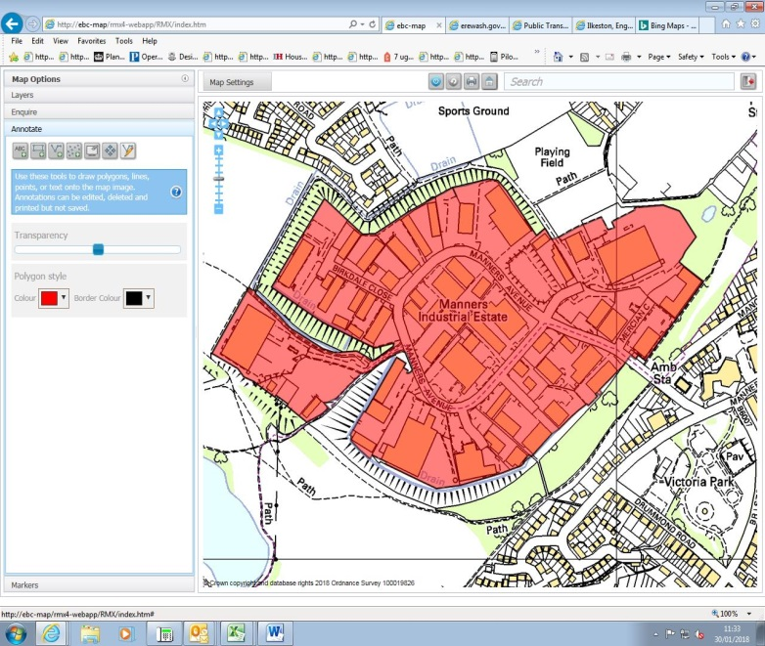

Site details:
Site reference (EELS) | EELS 049
Site name(s) | Manners Industrial Estate
Settlement | Ilkeston
Description | Large and established self-contained industrial area west of Ilkeston town centre based upon a circular road network
Occupiers | Various
Current use classes present | Mixed, although B2 is most prevalent across the site
Size (ha) | 23.3ha
Building age(s) | Most units date from 1980’s-onward when Estate constructed – some more modern stock generally located at the periphery of the Ind. Est.
Building quality | Average to good
Site assessment:
Prox. to strategic road network | Site 4.2km to A610 1
Local prominence | Estate located at end of Manners Avenue, an unclassified local highway 2
Public transport | Nearest bus services are accessed at Mason Road north of site and Lord Haddon Road to east of site – both between 0.5-1km of Ind. Est. 5
Relationship to workforce | Site within Ilkeston settlement 10
Planning policy considerations | Historic landfill present (site of former colliery) & likely ground contamination 9
Environmental setting | Noticeable greenery and soft landscaping evident around the Estate, particularly used to divide different courts with grassed areas just beyond some roadsides 7
Flexibility of premises | Wide diversity in the stock available across the site, with different sized units – many have been able to adapt premises to meet operational needs 8
Demand/Commercial desirability | The site is extremely popular with nearly all units currently occupied across the site 8
Final score & status | (Out of 73) 50

Site commentary:
Site description:
Manners Industrial Estate is a thriving industrial area which began trading back in the 1980’s, after the land, vacant for several decades since the closure of the Manners Colliery which previously stood on this site, had been extensively cleared and cleaned. Accessed via a single road (Manners Avenue), the Estate’s layout sees Manners Avenue loop around the centre of the area. A number of access roads leave the road, radiating outwards into a number of well-enclosed courts (Greens, Buxton, Rutland, Lyndale, Falcon, Shipley, Enterprise, Ellesmere, Ashbourne and Erewash) and business parks (Orchard Park & Mercian Park) that surround Manners Avenue and which each have their own dedicated car parking and service spaces. Given the Estate’s age, all units remain functional and some recent alterations and modifications to the larger premises now provide several examples of more visually interesting industrial properties. There is substantial variety in stock across the Ind. Est; from small workshop-based premises to larger detached HQ buildings which house industrial processes and ancillary office floorspace. Under-utilised space around the fringes of the Estate has over time been developed out, with newer industrial buildings tending to be set in spacious surrounds to provide suitable buffers between themselves and neighbouring units, often to mitigate the effects of noise. The Estate is well enclosed, with sufficient distance to surrounding residential development – although recent housing developments along Mason Road (Shipley View) and Far Dales Road (Heanor Road scheme) have served to reduce this buffer. In general, the nature of operations here remains an adequate distance from surrounding residential areas, although this provides drawbacks in the remoteness from public transport and the strategic road network. DCC operates a household waste and recycling centre from the Ind. Est, the town’s only such facility.

Planning policy:
With the Industrial Estate being built on the site of a former Colliery (Manners Coal Mine), there is record of landfill situated beneath ground level here. Whilst units presently exist at this location, any further and future extensive redevelopment of premises has a limited potential to disturb harmful landfill if such works are not conducted correctly.

Site flexibility:
With the site offering a great range of industrial premises and facilities, Manners Industrial Estate displays great flexibility in accommodating diverse business needs. A recent site visit showed a substantial number of units having been altered, adapted and enlarged to meet specific operational requirements. Given the Estate’s layout, detached units have good scope to modify in order to allow for business growth.

Demand and commercial desirability:
The very low level of unit vacancies evident across the site is testament to the Estate’s success and commercially desirability. Manners Ind. Est. has an excellent reputation as a place of business, and vacancies which arise are generally only short term until new occupants are able to be found.

Final conclusion:
Manners Industrial Estate provides a great range of good and flexible accommodation which makes a valuable contribution to Ilkeston’s economy. Continued support should be given to the business needs of those currently on-site to ensure the facility retains its present level of desirability.

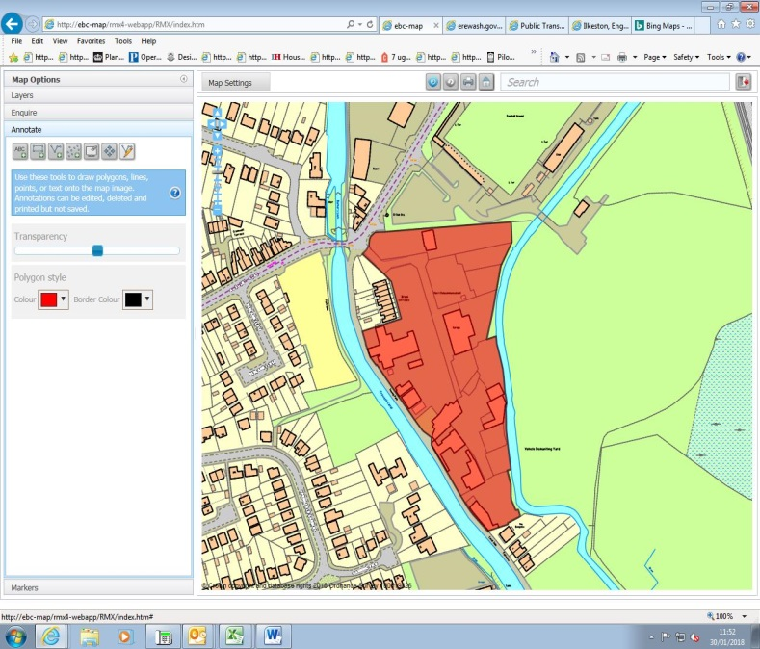

Site details:
Site reference (EELS) | EELS 050
Site name(s) | Awsworth Road Industrial Estate
Settlement | Ilkeston
Description | A dispersed collection of buildings and yards located between the River Erewash and the Erewash Canal
Occupiers | Various
Current use classes present | B2, B8 & Sui Generis
Size (ha) | 1.9ha
Building age(s) | Oldest building on-site dates from c19th, but majority of structures are later c20th.
Building quality | Mostly poor
Site assessment:
Prox. to strategic road network | Site 2.7km to A610 4
Local prominence | Site accessed off Awsworth Road, an unclassified highway 2
Public transport | Bus available from junction of Nelson St. & Duke St. 10
Relationship to workforce | Site within Ilkeston settlement 10
Planning policy considerations | Adjoins Local Wildlife Site, flood risk, vehicular access to and from employment site 7
Environmental setting | On-site environment is extremely nondescript, although surrounding setting (Canal & River) enhances this 5
Flexibility of premises | Large areas of space located across the various enclosed areas, but high risk of flooding makes future site investment unlikely 3
Demand/Commercial desirability | Difficult to establish from visit which yards & premises were currently occupied, but most contained signs of activity 8
Final score & status | (Out of 73) 49

Site commentary:
Site description:
Positioned between the Erewash Canal and the River Erewash, this site, accessed off Awsworth Road just aside a narrow, traffic light-controlled hump-back bridge over the Canal, is mainly comprised of small enclosed yards, some of which contain basic compound shed buildings, and is of low environmental quality. The yards are positioned around a central area of hardstanding which expands into a wide area at its southern-most point. A separate access, splitting from the central spinal track close to entrance into the employment site, provides access into a self-enclosed area within the west of the site. At its centre, this ‘sub-area’ sees a late-c19th building with dual-pitched roof and single-storey brick extension surrounded by a number of basic storage containers, but with some more recent modular buildings extending further south. The yard plots in the other section of the site, some of which appear to store timber and building materials, are almost exclusively confined to its edge, separated from the River Erewash by an occasional tree along its bank. Moving north, the other sizeable on-site building is occupied by car repairs garage and positioned just east of the central access road. This is adjoined on its north-side by a large enclosed area where a number of vehicles are parked, most likely connected to the neighbouring repairs garage. A telecommunications mast is positioned north-east of the garage which is visible from both on and off-site locations. Just inside the entrance to the employment site is a car dealership displaying an extensively-sized forecourt containing a large number of vehicles for sale. Bookending the site at its northern and southern-most ends are a row of residential properties. Both those at the north, Brook Cottages (inter-war) and the properties further south along the towpath pre-date the site’s setting out for low-quality industrial uses.

Planning policy:
The most notable aspect of this site is its location aside the River Erewash which sees small areas around its eastern boundary fall inside Flood Zone 3a. Additionally, EELS 050 adjoins a sensitive area of biodiversity with the Erewash Canal designated as a local wildlife site (ER215). Some of the low-quality employment uses which adjoin the Canal and towpath are not entirely compatible with the sensitivity of the immediate environment. Lastly, vehicular access arrangements into the site are compromised to a degree by the adjacent narrow bridge carrying vehicles over the Canal. With a weight and width restriction, this limits the direction in which larger commercial vehicles can access the site from.

Site flexibility:
The layout of the site with its series of large enclosed yards would allow for new structures and employment buildings to be sited within EELS 050. The low quality built environment would benefit from newer employment stock, although the restrictive presence of flood risk in parts of the site adds difficulty in securing permission for new business premises in the vicinity of the River Erewash and Erewash Canal. Access limitations will also prohibit the potential for trip-intensive uses at the employment site.

Demand and commercial desirability:
Many of the premises here are occupied, and the majority of yard spaces throughout the site appeared to be in active use from the recent site visit. The area, with its physical distance from residential areas, appears popular with low-quality, noisy and disruptive employment uses. Such sites are best suited for edge-of-urban locations given the lower scope for impacting upon residential amenities.

Final conclusion:
EELS 050 is a site accommodating a number of non-conforming employment/industrial uses which require physical separation from nearby residential areas. Whilst the quality of the environment here is low, the site nevertheless serves an important role in enabling businesses to operate away from locations which would cause harm to amenity.

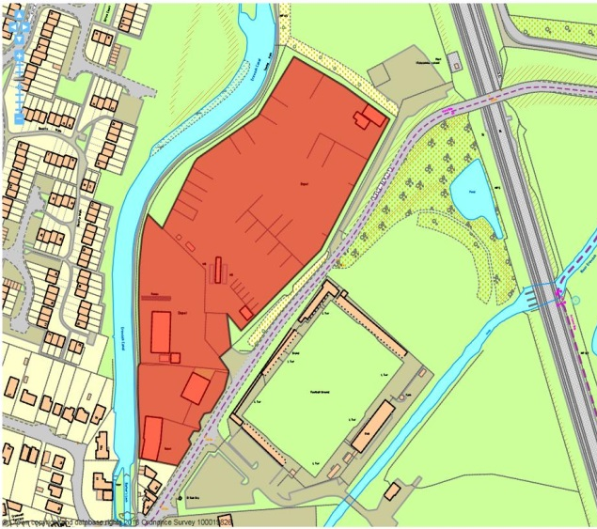

Site details:
Site reference (EELS) | EELS 051
Site name(s) | Coal Bagging Plant and other premises positioned east of the Erewash Canal
Settlement | Ilkeston
Description | Mainly open storage space; a large distribution yard and buildings accommodate car, transportation and construction-based uses.
Occupiers | Unique Autos and Exports UK Ltd, Ilkeston Auto Breakers, CPL Derbyshire Coal Distribution Ltd, Paul Watson Transport Services Ltd, ID Construction Ltd, C&A Motors Ltd.
Current use classes present | B2, B8 and Sui Generis
Size (ha) | 2.7ha
Building age(s) | Two buildings closest to Canal constructed during 1970’s with newer unit near main site entrance built early-c21st
Building quality | Mixed
Site assessment:
Prox. to strategic road network | Site 2.6km to A610 4
Local prominence | Site accessible from Awsworth Road, an unclassified public highway 2
Public transport | Premises at southern end of site within 500m of i4 bus service at Duke St/Awsworth Rd junction 10
Relationship to workforce | Site within Ilkeston settlement 10
Planning policy considerations | Neighbouring local wildlife site (ER215: Erewash Canal) and road access from west of Canal over bridge 8
Environmental setting | Surrounded by screen of trees, although site is covered extensively by hardstanding while its coal storage and distribution use could impact negatively on surrounds 3
Flexibility of premises | Coal storage facility has seen minor alterations to curtilage, while a new industrial unit has been constructed towards the site’s frontage 7
Demand/Commercial desirability | All units and space at the site appeared to be fully occupied from a recent site visit 8
Final score & status | (Out of 73) 52

Site commentary:
Site description:
Beginning its life as a Depot back during the 1970’s, this sizeable site now sees several occupants situated at its southern-most end with a primary coal storage and distribution operation accounting for around two-thirds of the land within its boundaries. The businesses at the southern end of the site sit behind security palisade fencing, each with separate gated entrances into their yard areas. A newer partial brick, partial metal cladded unit is positioned closer to Awsworth Road, accommodating a motor repairs business. The unit has a bay at each end of its principal frontage. Immediately north is a wide main entrance off Awsworth Road, with internal road accessing a low-quality industrial building housing several businesses situated at the rear of the employment site, and the large open area accommodating the coal-based business sweeping around to the north. The spacious yard in which CPL Distribution’s facility is based has been configured over time for open storage and ease of access for wagons distributing the coal products with a large number of bays and loading towers positioned around this part of the site. The site is clearly defined by its surrounds, with the Erewash Canal forming the entirety of its eastern boundary, while Awsworth Road does likewise to its west. At its northern-end, the employment site bounds a sports ground marked out with a number of junior-size football pitches.

Planning policy:
With the site situated on the eastern-side of the Erewash Canal, the uses here enjoy a degree of separation from houses on Nelson Street and Rodney Way on the opposite side of the waterway. However, the site’s proximity to the Canal affords the latter a relatively poor quality setting for a designated local wildlife site (ER215). Additionally, vehicular access from larger vans, lorries and HGVs to EELS 051 is problematic from the western side of the Erewash Canal as a consequence of limitations to the road bridge which carries Awsworth Road across it. A weight restriction, narrow highway width and road level over the bridge places limits on access.

Site flexibility:
The assessment concludes a reasonably good level of flexibility exists on the site. Whilst space across the site currently appears under-utilised given the amount of land required by the coal distribution facility, future opportunities to deliver new employment premises is thought to be possible. The construction of a more modern commercial building in the south of the site also demonstrates its ability to support new forms of development.

Demand and commercial desirability:
All industrial and commercial space across the site appeared to be fully occupied from a recent site visit. Some operations taking place upon EELS 051 are relatively specialised and require a particular layout ensuring that the facilities would not be of high commercial interest given most of the site’s configuration as a coal bagging plant.

Final conclusion:
Another site which despite limitations on vehicular access from the west of the neighbouring Erewash Canal plays an important role in providing space for an industrial operation which would not be suitable any closer to residential areas. The site displays good potential for future redevelopment to accommodate replacement or new business uses given its detached location from nearby areas of housing reducing impacts on residential amenity.

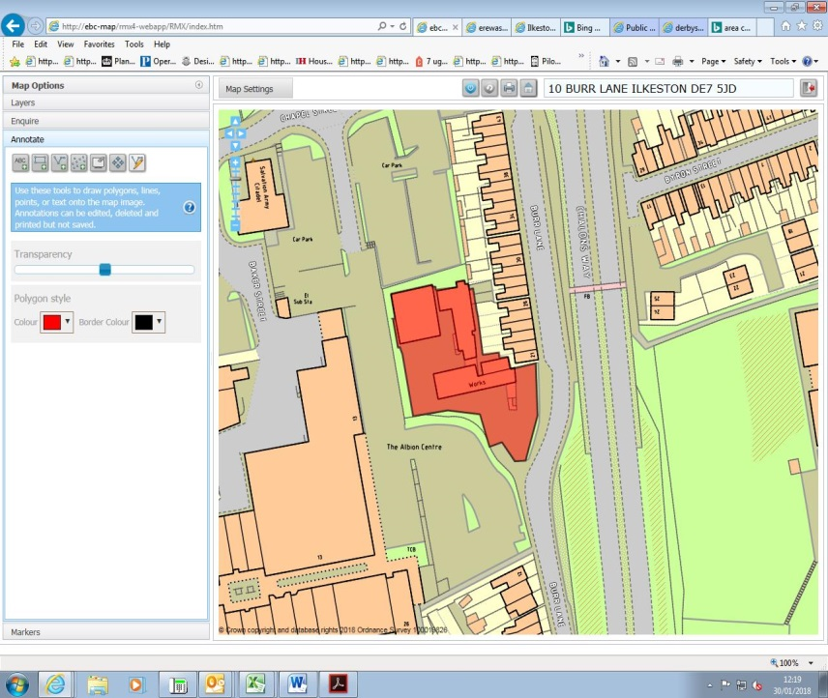

Site details:
Site reference (EELS) | EELS 052
Site name(s) | Albion Works, Burr Lane
Settlement | Ilkeston
Description | Former Mill premise, now part of a wider Works with later additions
Occupiers | Baltex (W. Ball and Son Limited)
Current use classes present | B2
Size (ha) | 0.2ha
Building age(s) | Ranging between 1840’s and 1990’s
Building quality | Average
Site assessment:
Prox. to strategic road network | Site 3.8km to A610 2
Local prominence | Site accessible only off Burr Lane, a local residential road 2
Public transport | Short walk to services on Station Rd/Bath St. 10
Relationship to workforce | Site within Ilkeston settlement 10
Planning policy considerations | Listed building (Grade II), works adjoin residential properties on Burr Lane 8
Environmental setting | Site heavily screened by surrounding trees around site boundary, mainly conifers. No soft landscaping within the site 6
Flexibility of premises | Flexibility of central building (former Mill) severely constrained by its Grade II Listed status. Most of site built on with structures so little room for new/extended facilities  2
Demand/Commercial desirability | Single occupant (Baltex - W. Ball & Son Ltd) 8
Final score & status | (Out of 73) 48

Site commentary:
Site description:
Albion Works contains as its most prominent building a four-storey original Lace Factory constructed around mid-c19th, now nestled in between a wide expanse of adjoining surface car parking that serves the Albion Shopping Centre and residential properties located along Burr Lane. The building, Grade II Listed, has a south-facing elevation of interest, sectioned into a number of bays with the central ones projecting outwards slightly and also noticeable for a striking clock face as well as a Welsh slate roof. Other buildings have also been added to the former Lace Factory around the site’s curtilage, the most notable of which is a much smaller side elevation added in the late-c19th around half the height of the original building. Projecting in a northwards direction, a single-storey building around the same age as the side addition extends away from the Listed Building, before turning eastwards at a ninety-degree angle. This reaches a modern, incongruous addition to the employment site; a functional industrial unit, split between brick-base and sheet-metal panelled upper elevations before reaching a shallow mono-pitch roof. Its southern elevation faces out onto the service yard, with a high clearance entrance bay. Generally, views of the site are well-obscured from surrounding location points. This is mainly due to dense screenings of established and tall conifer trees situated around the site’s western, northern and south-eastern perimeter, but also is as a consequence of the area’s topography which sees higher ground in the west sloping away to the east. To the south of the site, moving around to the west, a line of mature trees provide further screening and the clearest vista of the building’s southern elevation is available through the only point of vehicular and pedestrian access into the site taken off Burr Lane. Through this entrance, a forecourt opens up in front of the buildings and this sweeps around the west of the site, providing access to the rear of the premises and the newest-constructed building.

Planning policy:
The central building, the four-storey section, is Grade II Listed which heavily restricts the type and scale of alterations which can be made to the building or aspects within concern its immediate setting. Additionally, the buildings on site almost adjoin the backs of the late-Victorian properties on Burr Street. Whilst the buildings and the factory will have had a long, historic association, the close proximity of the industrial premises will inevitably affect residential amenity for those properties between 21-30 Burr Lane, particularly when residents are in the confines of their garden space.

Site flexibility:
Little of the site is now free of buildings and structures which presents little scope for any further additions or extensions to the current premises.

Demand and commercial desirability:
The site is full occupied by Baltex Ltd, and has been in for some years showing that the premises have been customised for the operational needs of the company – with a modern additional building in the north-western corner of the site showing recent investment in facilities.

Final conclusion:
Whilst largely obscured by surrounding urban form and mature forms of landscaping, these premises, dating back to the mid-c19th have been home to textiles manufacture for more than a century. The listed central building is naturally of significant historic interest, although industrial activities taking place on site has managed to preserve its character. This site is an important aspect of the town’s industrial heritage, playing an important economic role.

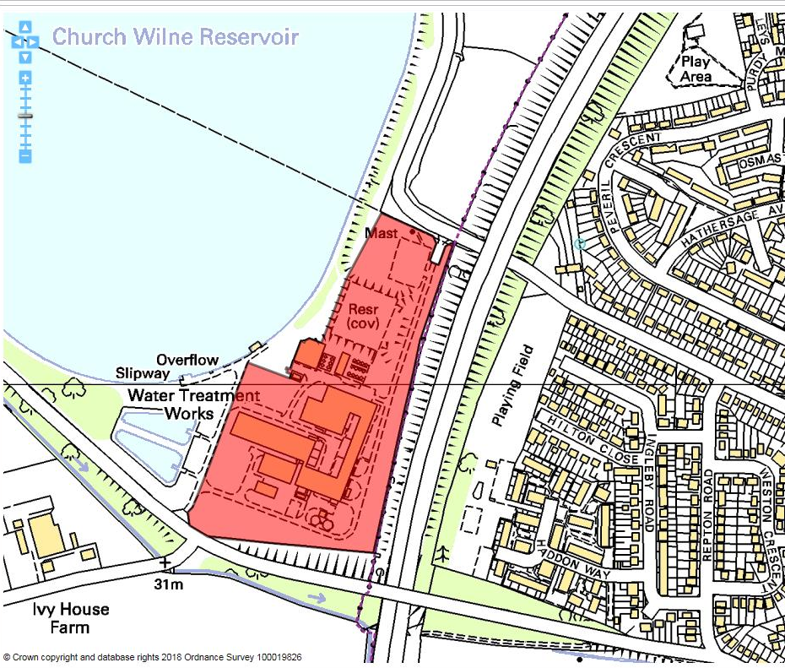

Site details:
Site reference (EELS) | EELS 053
Site name(s) | Severn Trent Water Treatment Centre and Works
Settlement | Church Wilne
Description | Water treatment facility with a number of operational buildings located aside Church Wilne Reservoir
Occupiers | Severn Trent Water (STW)
Current use classes present | B2
Size (ha) | 6.4ha
Building age(s) | Reservoir and buildings originally opened in 1967. Most original structures remain with some more modern additions
Building quality | Good to average
Site assessment:
Prox. to strategic road network | Site 3.8km to A50 2
Local prominence | Visible from M1 between J24 and J25 5
Public transport | Site more than 1km from nearest bus service 5
Relationship to workforce | Site adjoins main Long Eaton built-up area 7
Planning policy considerations | Green Belt & Local Wildlife Site (ER038) 8
Environmental setting | On-site buildings and infrastructure set in green surrounds sizeable amount of soft landscaping 8
Flexibility of premises | Sizeable areas of unused space remain allowing for additional facilities to be added if necessary 6
Demand/Commercial desirability | Sole occupier of the premises are STW 8
Final score & status | (Out of 73) 49

Site commentary:
Site description:
This site is home to a sizeable water distribution centre (WDC), constructed simultaneously alongside the Church Wilne Reservoir in 1967 and is responsible for pumping water to thousands of households across the surrounding area. A number of specialised buildings are present on-site which accommodate such facilities as laboratories, storage tanks and general water-based machinery, making this a vital component of local infrastructure. Vehicular access can be achieved from the north (Sawley Road) and south (Wilne Road) of the site, although given the importance of the centre it is understandably secured by perimeter fencing to closely regulate access. On-site buildings are connected by a number of internal access roads which stretch between the two vehicular access points. In addition to the main buildings on site along the eastern side of the site (making them highly visible from the adjacent M1 motorway), there is also a covered reservoir and a notable communications mast sited close to the northern access point on Sawley Road.

Planning policy:
The site is situated within the Nottingham-Derby Green Belt, restricting the scope for what development would be considered appropriate in the unlikely event that the water distribution facility ceased to operate. The STW campus is also situated alongside a Derbyshire Local Wildlife Site (ER038), with the Church Wilne Reservoir recognised for being one of the most important sites for wintering wildfowl in the County. Also of note is recognition for the margins of the Reservoir containing tall reeds, tall grassland, scrub and bramble. This collective habitat supports a diverse range of breeding birds, and given the proximity of the facilities which store and distribute water, some concern exists about the compatibility of this relationship.

Site flexibility:
As already pointed out overleaf, the WDC appears to have reasonably large areas between on-site facilities which could accommodate additional facilities to add capacity to its operational capabilities. However, with a directly adjoining Local Wildlife Site, further intensification of the site could serve to damage its relationship with its sensitive surrounding habitats.

Demand and commercial desirability:
Severn Trent Water is the sole occupiers of the Church Wilne facility which is highly specialised and bespoke for its operational requirements. With this in mind, it is extremely unlikely that this space will be available in future to accommodate any other employment-based uses, with a continuation of a WDC at this location necessary to help distribute water around this part of the region and meet infrastructure expectations.

Final conclusion:
Whilst the site is classed as a B2 use because of the nature of operations taking place at the facility, it is unconventional in the sense that the site is highly customised, with buildings being configured over the years since the WDC became operational around STW infrastructural needs. This therefore is an important facility within the Borough and should be safeguarded wherever possible.

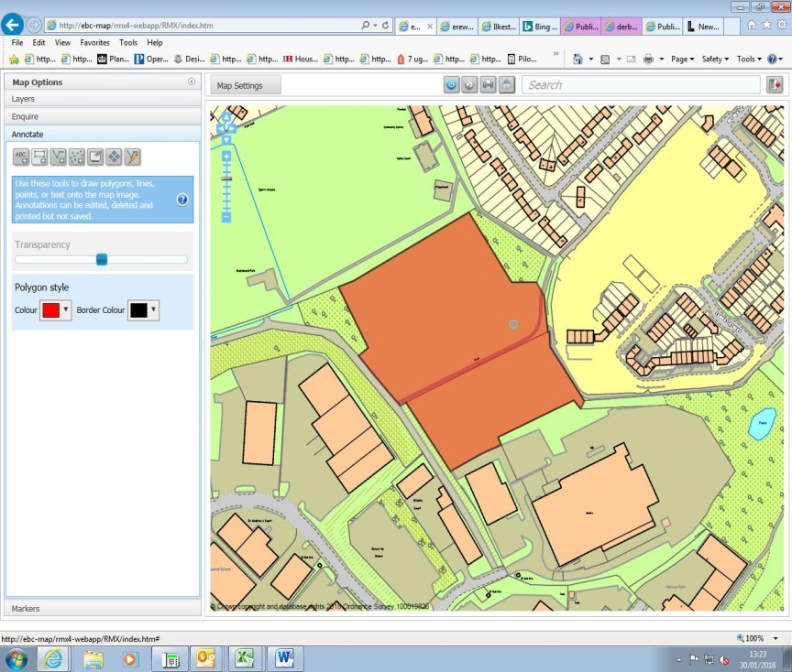

Site details:
Site reference (EELS) | EELS 054
Site name(s) | Land east of Manners Industrial Estate
Settlement | Ilkeston
Description | Vacant land adjoining the successful and popular Manners Ind. Est. currently being commercially marketed for B-use development
Occupiers | N/A
Current use classes present | N/A
Size (ha) | 2.1ha
Building age(s) | N/A
Building quality | N/A
Site assessment:
Prox. to strategic road network | Site 4.7km to A610 0
Local prominence | Accessed off an internal road serving other commercial buildings on the Manners Ind. Est. 2
Public transport | Closest service routes along Mason Rd, accessible by footpath around 750m from the site 5
Relationship to workforce | Site within Ilkeston 10
Planning policy considerations | None 10
Environmental setting | Site surrounded by screening of trees on three sides (north, west & east) creating good setting 6
Flexibility of premises | Given the site is currently vacant, excellent flexibility exists to develop land to meet bespoke business needs. PP also granted for new industrial building 8
Demand/Commercial desirability | Site currently being commercially marketed by Fisher Hargreaves Proctor with intentions of developing an industrial unit(s) upon the land – but vacant now 0
Final score & status | (Out of 73) 41

Site commentary:
Site description:
This site, most recently operating as part of a playing field until planning permission was granted to build employment facilities, is located to the north-east of the busy Manners Industrial Estate in Ilkeston. Existing business units on the Estate are located immediately south and west of this, a sports ground adjoins to the north and the newly-constructed Heanor Road housing development is situated further east. The site is well-enclosed by relatively thick screening of trees around the majority of its perimeter, helping to provide a visual buffer between the site and surrounding land-uses. Vehicular access to the site is likely to be taken from the south, where an existing outline planning permission has established this arrangement.

Planning policy:
A number of planning permissions have been granted, enabling business units with an open B-use to operate from this site. Whilst the site is reasonably close to new properties located off Heanor Road (north-east of the site), the granting of consent for an employment use demonstrates that the Borough Council are satisfied that sufficient space exists between the two locations and mitigation measures are able to maintain residential amenity at nearby properties.

Site flexibility:
With the site remaining undeveloped, but being readied for a new unit with enabling infrastructure, it offers a large degree of flexibility. The Borough Council has previously granted outline permission for new B1, B2 or B8 development here, so any new-build(s) will have to conform to the principles of the outline permission, although interested parties could always submit a new application in an attempt to alter the wider parameters of what the Council deem acceptable.

Demand and commercial desirability:
As mentioned previously, the site (known as the Winster Site) is currently being marketed by FHP and is on the market for a price of £450,000. A design and build option is available, and the commercial marketing advises that there is no developer tie which may heighten interest in the site.

Final conclusion:
The Borough Council has, through the granting of outline PP for a B1, B2 & B8 use, demonstrated that it wishes to see the development of employment premises at this site and given its location adjoining the Manners Industrial Estate, it represents a logical location to promote new employment units at.

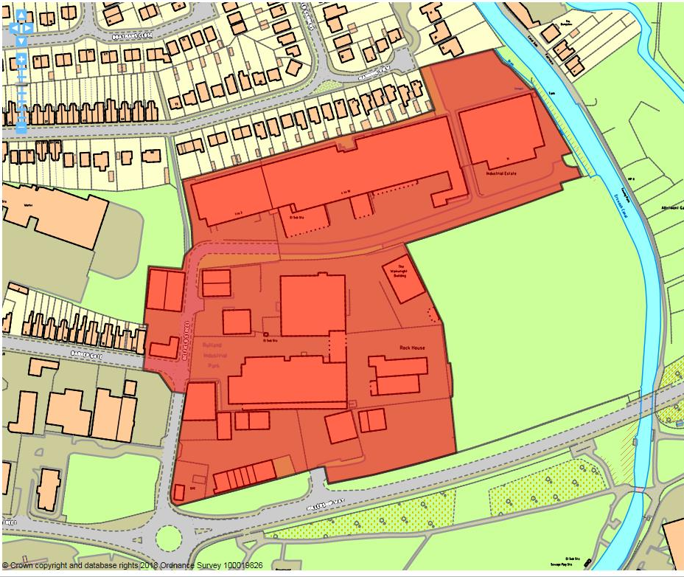

Site details:
Site reference (EELS) | EELS 055
Site name(s) | Rutland Industrial Estate
Settlement | Ilkeston
Description | Large area of industrial premises located north of A6096 Millership Way, east of Ilkeston town centre
Occupiers | Pro CNC Engineering, Plastic & Metal Components Ltd, Milltek Sports Ltd, Highland Leather, Linmart Windows, Auto Reserve, Harts, MPac Packaging, Soar Valley Timber, Ilkeston Garage, Hawkeye Transport, Norton Plastics, Granby Motors, NRA Roofing and Belfield Fabrications – plus other occupiers of smaller units on-site
Current use classes present | Mainly B2 uses, but some Sui Generis
Size (ha) | 4.95ha
Building age(s) | Majority of buildings date originally from 1960’s/70’s
Building quality | Mainly average, with some poor quality yard areas
Site assessment:
Prox. to strategic road network | Site 3.4km to A610 3
Local prominence | Site adjacent to A6096 Millership Way 4
Public transport | Around 300-400m from bus services running along Granby Street 10
Relationship to workforce | Site part of Ilkeston settlement 10
Planning policy considerations | Gasworks on southern part of Estate (contaminated land) and proximity to residential area directly north 8
Environmental setting | Little soft landscaping evident across the Estate, mainly hardstanding (yards, car parking etc.) 5
Flexibility of premises | A number of buildings on-site appear to have been recently modified, and some scope for intensification 6
Demand/Commercial desirability | Few vacant units situated around the site. High level of occupation evident from recent visit 8
Final score & status | (Out of 73) 54

Site commentary:
Site description:
Developed from 1960’s onwards, Rutland Industrial Estate is now a busy area of mixed employment uses located within close proximity to Ilkeston town centre and the A6096 Millership Way. This allows for relatively easy vehicular access to the A610 and the strategic road network beyond. Two roads provide access into the site, with Belfield Street linking the Estate to Millership Way (which forms its southern boundary), and Barker Gate which moving west of the site passes into a nearby residential area before reaching Granby Street. A third entry point exists directly off Millership Way, allowing access into an area which serves several smaller detached industrial buildings. The stock around the Rutland Industrial Estate is a typical mix of brick buildings with sheet metal exteriors at higher parts and more basic steel portal framed premises. The oldest section of the Estate is positioned centrally, with a sizeable building displaying single-pitch roof orientated east-west. At its eastern end beyond a long annex running at right-angle to the larger building is a sizeable yard area. Newer industrial premises now surround this building on all sides, leaving minimal vacant, undeveloped space back from Millership Way to Belfield Street. North of Belfield Street, a lengthy row of ten units is set back at different distances to the road. These are uniform in design and appearance, some having had open-access canopy’s constructed at their frontage extending the building forwards and providing covered space for the loading and unloading of goods. The eastern-most units face out southwards over the vacant EELS 046 site, and beyond these at the end of Belfield Street (Unit 11) a separate two-bay industrial building in average condition can be found which currently accommodates a timber merchants company. To its rear is a sizeable area of car parking. This sits in-between the residential properties of 12 and 17 Manning View, although no through access is possible. Immediately beyond the site’s northern boundary is an established residential area, while further homes adjoin to the west before reaching another area of industry (EELS 047). East of the site is the Erewash Canal which prevents Belfield Street’s continuation.

Planning policy:
The south of what is now Rutland Industrial Estate previously accommodated Ilkeston Gas Works which is likely to have left some concentrations of ground-based contamination beyond its operational life. While current units should not be affected by this, future partial or full redevelopment of the site may see ground conditions impact upon the ease in which this can be undertaken and a new development use achieved.

Site flexibility:
The variety of units across EELS 055 provides different forms of industrial stock at this location. As described above, units on the north side of Belfield St. have seen covered areas erected at their frontages to facilitate the safe transfer of goods to and from each premise. Also, a number of more recent steel-frame units have been constructed around the site showing its ability to absorb further standalone structures. Some areas of the Ind. Est. appear to display limited potential for some additional small-size units.

Demand and commercial desirability:
Very few vacant industrial units were visible around the Ind. Est during a recent visit, demonstrating strong demand for floorspace at this location. Set towards the centre of the site, some noisier operations were evident, and given this area’s remoteness from nearby residential development, facilities which cater for such activities and which do not adversely affect residential amenity are likely to continue to be in demand.

Final conclusion:
A relatively vibrant Ind. Est with an eclectic range of industrial uses and operations taking place, its position close to the A6096 and Ilkeston Railway Station is likely to see this area remain popular with local businesses requiring good links to the transport network.

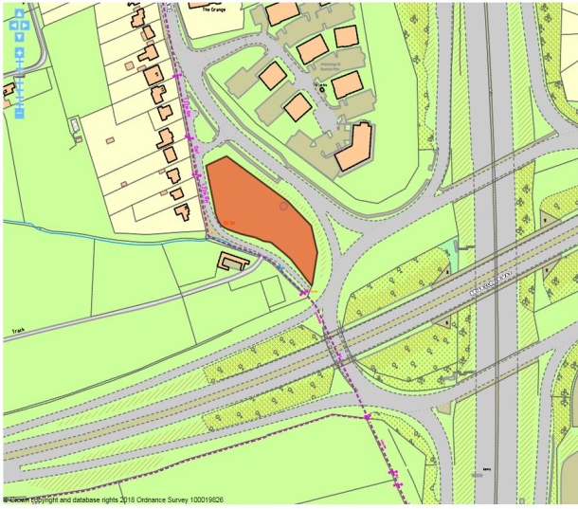

Site details:
Site reference (EELS) | EELS 056
Site name(s) | Land opposite Interchange 25 Business Park
Settlement | Risley
Description | Small parcel of agricultural land, previously permissioned for B2 in close proximity to the M1/A52 interchange at J25.
Occupiers | N/A
Current use classes present | N/A
Size (ha) | 0.4ha
Building age(s) | N/A
Building quality | N/A
Site assessment:
Prox. to strategic road network | Site 150m to J25 (M1/A52) 9
Local prominence | Site visible from A52 4
Public transport | Regular i4 services run along the B5010 10
Relationship to workforce | Site directly adjoins settlement of Risley 7
Planning policy considerations | Adjacent housing on Bostocks Lane, Group TPO listing along southern boundary of the site 8
Environmental setting | No development on site at moment, but a reasonable surrounding setting with farmland to south and business park on opposite side of Bostocks Lane 7
Flexibility of premises | With the site undeveloped, the site has reasonably good flexibility for any new build to cater for a new businesses specifications 7
Demand/Commercial desirability | Several previously-approved permissions granted for variations of office development, showing interest in establishing an employment site – albeit no scheme has been implemented 7
Final score & status | (Out of 73) 59

Site commentary:
Site description:
The site is located in close proximity to busy traffic interchange between the M1 & A52. Currently a small agricultural enclosure situated between a row of interwar properties on Bostocks Lane and Interchange 25 (EELS 034), land here has been the subject of much development interest over the past decade. With the site sloping in level from a higher north, to a noticeably lower southern part this makes it particularly prominent from those driving on the northern side of the interchange junction as well as those down Bostocks Lane from Risley crossroads. A small access road helps enclose the site on its western boundary. This access serves a row of aforementioned houses and eventually leads to a track which links a couple of local farms located someway from the site. Isolated trees can be seen interspersed around the site’s boundary, which on its frontage with the main Bostocks Road side, also displays a mature hedgerow. Along its western boundary, a more sprawling hedgerow growing around timber post and rail fencing helps with enclosure, and beyond where the public access to the track ends, a small number of trees line the edge of the site.

Planning policy:
The site falls within a small area of ‘white land’, and is therefore located outside the extent of Risley’s village envelope as well as being away from nearby Green Belt. Its status as ‘white land’ in addition to its location just off J25 of the M1 has resulted in a number of planning applications submitted, seeking permission for a ‘headquarters’ style premise. A number of permissions for such development have been approved by the Borough Council, although none have been implemented. Development of the site will have an impact on the houses away the main alignment of Bostocks Lane as previously-approved plans show the main access into the site utilising the same access for the existing homes. The urbanisation of the land would undoubtedly alter the character of the immediate area with the additional vehicular activities, although the business of an office-type scheme would likely generate only minimal noise and disturbance. Also of note is a group TPO designation (DC5 – 338) around the southern periphery of the site. Any future development will need to respect the presence of these trees (a combination of oak, ash and cherry), not only to preserve their existence but to also maintain a pleasant setting for a new building(s).

Site flexibility:
With the site undeveloped, there is theoretical flexibility insofar as what development could occur here. However, previous permissions (but most notably the now-lapsed ERE/1208/0045) provide a strong indication for the appearance and scale of future new-build.

Demand and commercial desirability:
The most recent demand for development on this site came from a fast-food retailer who wished to construct a ‘drive-thru’ facility which was refused by the Borough Council. It is anticipated and hoped that the site will instead serve a B-use purpose, with a lettings board at its frontage advising the site has recently been sold.

Final conclusion:
Previously granted permissions for this site demonstrate its potential to accommodate an ‘HQ’ style building. Whilst permission has recently sought permission for an unsympathetic development use, it is believed that with the principle of B1(a) use having been accepted by the LPA, it is likely that this highly-accessible and prominent site will make an important contribution to the provision of high-quality business premises in the Borough.

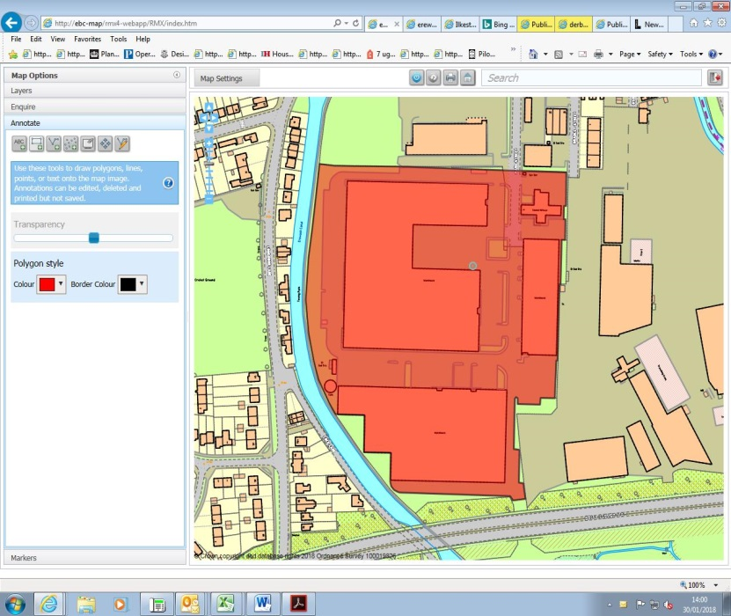

Site details:
Site reference (EELS) | EELS 057
Site name(s) | Great Bear Industrial Estate
Settlement | Sandiacre
Description | Collection of refurbished warehouse-style buildings
Occupiers | My Furniture, William West Ltd, DK Link Ltd and TCW Logistics Ltd
Current use classes present | A1, B2 and B8
Size (ha) | 5.2ha
Building age(s) | Oldest buildings on-site date from late-c19th, but later southern and eastern buildings from around 1980’s
Building quality | Average
Site assessment:
Prox. to strategic road network | Site 1.8km to A52 6
Local prominence | Site visible from elevated stretch of A52 3
Public transport | Short walk to B5010 Station Rd and i4 bus service 10
Relationship to workforce | Site within settlement of Sandiacre 10
Planning policy considerations | Adjacent local wildlife site, access arrangements for HGVs 8
Environmental setting | Site largely hardstanding for service areas, car parking – but mixed surrounds with Erewash Canal, but overshadowing elevated stretch of A52 5
Flexibility of premises | Recent refurbishment of warehousing has created opportunities to occupy premises with sub-divisions able according to those managing the estate 7
Demand/Commercial desirability | TCW Logistics recently took a 5-year lease for warehouse premises, whilst active marketing occurring for up to 40,000 sq.ft remains available. 6
Final score & status | (Out of 73) 55

Site commentary:
Site description:
This site, located on and at the end of Mark Street in Sandiacre has its origins from the late-c19th when the western side of the site was home to a sizeable gas engine works. This building, albeit much altered and modernised to allow it to accommodate warehousing purposes, remains to this date. Added to it during the late-c20th are two other buildings (one on the east of Mark Street and a much larger building at the end of the highway) constructed for warehousing uses, and are typical of construction around this time both in appearance and design with spacious hardstanding surrounds positioned around the perimeter of each premise, some of which is off-street parking for staff/visitors, but most being to facilitate the work of HGV’s in serving the buildings. Both premises feature a number of high bay doors allowing for the loading/unloading of goods, although the facility furthest south is considerably larger with several distribution bays along its northern elevation. All buildings have two-storey sections incorporated containing ancillary administrative floorspace. The site is private, and separated from the public highway of Mark Street given its location beyond a gated security barrier controlled from a gatehouse kiosk. Returning to the oldest building west of Mark Street, this has seen its recent partial change of use from a warehousing premise to one which now displays a range of furniture with manufacturing and sales area. The remainder of the building remains in a warehouse and distribution use.

Planning policy:
The site’s use, predominantly for storage and distribution, results in a large volume of HGV movements to and from the premises at Mark Street. Whilst the warehousing facilities on site make ample provision to accommodate these, HGV movements through the centre of Sandiacre (a Conservation Area) are far from ideal and take large vehicles through sensitive and historic environments bringing HGVs into close contact with shoppers and pedestrians in the settlement’s centre. The site also backs onto the Erewash Canal, and whilst there is no direct access possible from one to the other, the Warehousing does not form a particularly good neighbour to a local wildlife site (ER215).

Site flexibility:
Commercial marketing currently being undertaken by FHP suggest that the remaining unit at the site’s southern end is available to accommodate 40,000 sq.ft of storage space, although this could be disaggregated down to a minimum of 20,000 sq.ft implying that subdivision within the unit is possible. Other space on-site is currently occupied, and non-B8 uses through the introduction of ‘My Furniture’ is evidence that the premises could fulfil other economic uses.

Demand and commercial desirability:
As referred to above, not all floorspace on-site is currently occupied with the unit at the southern end of Mark Street presently vacant. However, around 40,000 sq.ft of storage and distribution space elsewhere on the site has recently been acquired on a 5-year lease demonstrating the site’s attractiveness to the logistics market.

Final conclusion:
Recent investment in improving the warehousing on the site shows a commitment to the majority of space within the premises remaining in B8 usage for the foreseeable future. The recent arrival of a new tenant (TCW Logistics) demonstrates continued interest in the Mark Street premises for warehouse-based operations.

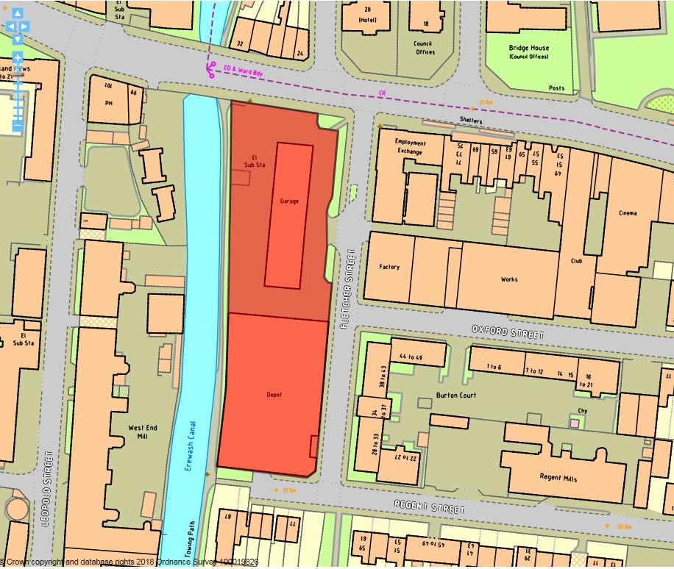

Site details:
Site reference (EELS) | EELS 058
Site name(s) | Showroom and Works Premises, Fletcher Street
Settlement | Long Eaton
Description | Split site consisting of a Topps Tiles store set in own curtilage and red-brick factory abutting road and canal
Occupiers | Midland Wipers Ltd and Topps Tiles
Current use classes present | A1 and B1(c)
Size (ha) | 0.4ha
Building age(s) | Topps Tiles building dates from 1980’s and Works date from 1940’s.
Building quality | Topps Tiles building is a functional sheet-metal panelled building and
Site assessment:
Prox. to strategic road network | Site 3.2km to J25 (M1/A52) 3
Local prominence | Site adjoins the A6005 Derby Road 4
Public transport | Several bus routes serve adjoining Derby Road 10
Relationship to workforce | Site within settlement of Long Eaton 10
Planning policy considerations | Conservation Area, Electricity sub-station on-site 8
Environmental setting | Some basic grassed areas on edge of Topps Tiles curtilage, Works immediately south extend right back to the Canal towpath 6
Flexibility of premises | Topps Tiles building sits within spacious curtilage so scope to use under-utilised land. Midland Wipers premise directly abuts surrounding roads and canal preventing expansion 6
Demand/Commercial desirability | Both premises have been occupied by current tenants for a number of years 8
Final score & status | (Out of 73) 55

Site commentary:
Site description:
This site to the west of Long Eaton town centre is located between Fletcher Street and the Erewash Canal. It comprises two buildings, both very contrasting in design and appearance. Furthest north on site are premises for Topps Tiles where products are sold to the public. The structure, one of basic appearance with a corrugated metal exterior, sits centrally within a plot which at its north fronts onto Derby Road, but mainly associates with Fletcher Street where the only point of vehicular access for visitors and trade deliveries exists. Some basic landscaping is evident at the Fletcher Street side of the site with a narrow green verge and sporadic mature trees adding some visual interest to its setting. As the retail premise sits central to the development plot, a sizeable area of hardstanding is evident between the building and the edge of the site. Some of this surrounds a small electricity sub-station, but most space appeared underutilised at the time of visit. The southern section of the employment site sees Works premises occupied by the Midland Wiper Ltd company. This factory, with its relatively decorative redbrick frontage, irregular roofline and gable-end detailing along Fletcher Street, directly abuts the highway and runs back to the edge of the canalside. A number of service entrances penetrate the Works premises giving access to inside the building, with the largest seen in a recessed bay at the southern end of the east-facing elevation. Another large service entrance exists on the southern elevation, along with a number of windows which have been removed now with concrete finish.

Planning policy:
The site forms part of the Long Eaton Lace Factories Conservation Area (LFCA). The northern section of the site (Topps Tiles) contributes little to the character of the LFCA, with the building’s appearance and concentration of surrounding hardstanding incongruous to the CA’s special status. An electricity sub-station located on the edge of Topps Tiles curtilage limits the extent to which this part of the site can be utilised for employment land.

Site flexibility:
This varies between the northern and southern halves of the employment site. The northern section sees the existing building enjoy a spacious area of hardstanding around it (albeit with a sub-station near to the boundary with the Canal) allowing for future expansion or replacement with premises designed to be more in-keeping with the special character of the LFCA, whilst the Works at the southern end are heavily constrained due to being directly abutted by Fletcher Street, Regent Street and the Erewash Canal.

Demand and commercial desirability:
Both premises within the site’s boundaries are currently occupied. Recent evidence of the occupants longer-term commitment to the site come from planning applications submitted to the Borough Council to alter aspects of each building for operational purposes.

Final conclusion:
The site, which at its northern end is a visible one given its location as a gateway into the western end of Long Eaton town centre, is an example of employment just beyond the periphery of the designated town centre. A tradition Works premise displays visual interest from street-level and has been subject to many external alterations over the decades to fit in with the operational needs of the occupants. The Topps Tiles premise, whilst A1 in use class, forms part of the wider area, but does offer opportunities for future redevelopment to capitalise on its locational advantages and Canalside setting.

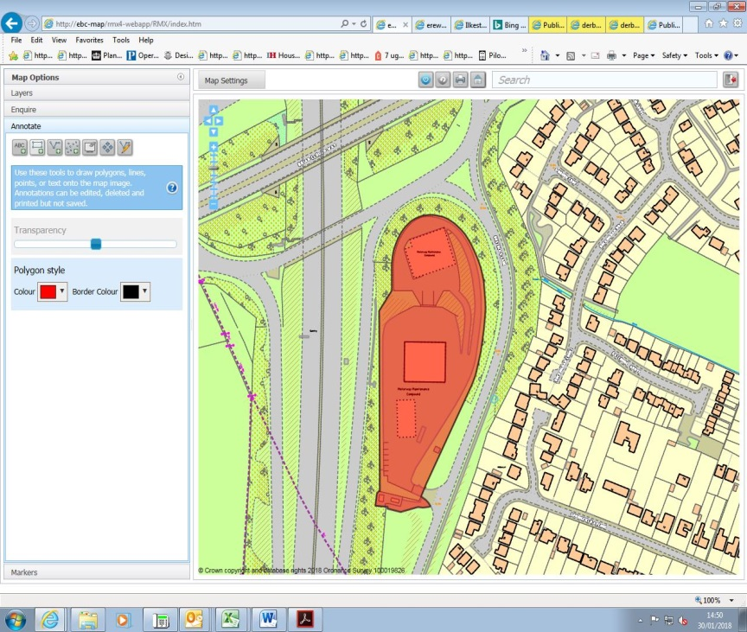

Site details:
Site reference (EELS) | EELS 059
Site name(s) | Highways England Road Maintenance Depot
Settlement | Sandiacre
Description | Motorway maintenance compound service immediate parts of the strategic road network
Occupiers | Highway England
Current use classes present | Sui generis
Size (ha) | 1.62ha
Building age(s) | Approx. 1960’s, but recent refurbishment in early c21st.
Building quality | Average functional structures on-site
Site assessment:
Prox. to strategic road network | Site 300m to J25 (M1/A52) 9
Local prominence | Visible from M1 and M1 J25 slip roads 5
Public transport | Trent Barton 15 route serves Longmoor Rd approx. 600m from site 5
Relationship to workforce | Site within settlement of Sandiacre 10
Planning policy considerations | Effected by noise generated by the adjacent M1 9
Environmental setting | Some greenery/shrubs on-site with site enclosed by mature and thick screening of trees although setting is heavily characterised by neighbouring M1 and J25 5
Flexibility of premises | Set out specifically for current user 3
Demand/Commercial desirability | Site occupied solely by Highway England 8
Final score & status | (Out of 73) 54

Site commentary:
Site description:
The facility, part of Highway England’s network of motorway maintenance depots, is located immediately adjacent to the M1 and more specifically its southbound slip road. Vehicular access to the site is taken further south along Bostock’s Lane around 300 metres away from the M1/A52 intersection. The depot is functional in its appearance and use, with three main buildings positioned centrally to the site. As a consequence of its operational purpose, much of the site consists of tarmacked hardstanding with internalised roads circulating around the buildings to allow for the loading of maintenance vehicles. The most central building provides utilitarian office accommodation, a covered store building exists immediately to its south and furthest north is a large salt-barn constructed during the 1980’s. There is a noticeable alteration in topography across the site, with the northern part greatly elevated from the southern part. The changes in site levels allows for vehicle loading with materials from the salt-barn onto waiting maintenance fleet vehicles. Despite the site’s function, some basic landscaping is evident; particularly flanking the elevated loading ramps and this contributes to a softening of an otherwise abrasive environment. The facility is notably screened around the majority of its site boundaries, helping minimise inward and outward views. The only part of the site’s perimeter devoid of tree coverage is understandably at the point of vehicular access.

Planning policy:
Few local planning policies have any sort of impact over the site’s continuing use as a roads maintenance depot and compound. The facility is adequately separated by dense rows of trees with Bostock’s Lane located between it and the nearest houses on Springfield Avenue and Buckingham Court. With its location directly adjacent to the M1, the site is expected to be within the noise ‘shadow’ of the road, particularly when traffic is free-flowing. However, the site itself omits little noise and therefore cannot be said to have an adverse impact on the residential amenity of nearby properties.

Site flexibility:
The footprint of structures and buildings across the site is fairly minimal, with more focus obviously afforded to the movement of fleet vehicles. As such, it is doubtful that the current occupant of the facility would need to substantially alter the layout of the site unless an operational need existed.

Demand and commercial desirability:
The site is occupied solely by Highway England and its contractors. A recent application to retain a two-storey portakabin just north of the central office building was approved by the Borough Council in December 2017, as well as the creation of new parking bays in the north-west corner of the site. This demonstrates HE’s commitment to the site for the immediate future, and given the strategic location of the site, it is expected that HE will wish to retain the facility across the long-term.

Final conclusion:
An operationally-important facility in close proximity to the M1 and A52, the maintenance depot contributes towards the safety of the local strategic road network. Given the site’s centrality and the ease of access between it and local roads, it is expected that Highways England will retain its presence on the site for the foreseeable future.

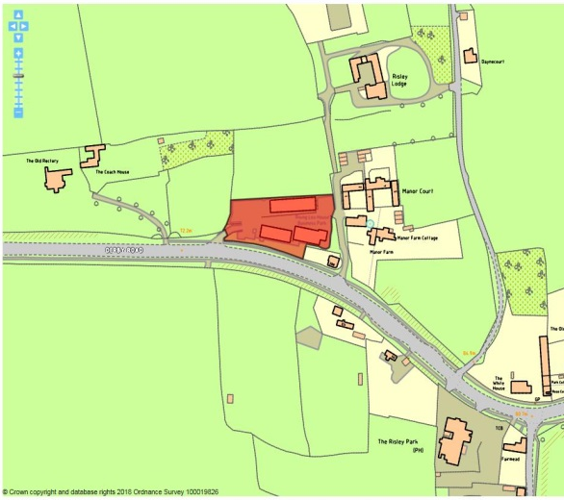

Site details:
Site reference (EELS) | EELS 060
Site name(s) | Rising Lea Business Park
Settlement | Risley
Description | Cluster of employment buildings set in rural surrounds.
Occupiers | Treetops Charity, Risley Car Sales, Swift Fire & Security and Peter Cox Ltd.
Current use classes present | B1(a), Sui Generis
Size (ha) | 0.34ha
Building age(s) | Oldest building dates from early-c20th, with later additions in mid-c20th.
Building quality | Average
Site assessment:
Prox. to strategic road network | Site 1.8km to J25 (M1/A52) 6
Local prominence | Site adjoins B5010 Derby Road 3
Public transport | Trent Barton i4 route serves B5010 10
Relationship to workforce | Site more than 0.5km away from edge of Risley settlement 5
Planning policy considerations | Risley Conservation Area, Green Belt (adj. to Manor Farm, local building of interest), TPO trees on, and immediately off-site. 7
Environmental setting | Site consists mainly of buildings and hardstanding, but some TPO trees located around periphery helping ‘green the site’ to a limited degree 7
Flexibility of premises | Matters under ‘planning policy’ restrict the ability to alter or extend the units on-site 3
Demand/Commercial desirability | Three units recently advertised as being ‘to let’ at 3a/5b/5c 6
Final score & status | (Out of 73) 47

Site commentary:
Site description:
The site, which whilst adjoining the B5010 Derby Road, sits elevated above the highway at a noticeably higher level giving the facility visual prominence, sees three separate buildings face each other across a central yard area which is lined on its northern side with a number of parking bays for staff and visitors to the employment site. The building positioned north of the yard is the largest of the three, giving the appearance of a low-quality agricultural-style building, but one which now sees a used-car sales business operating from it with a large access opening and roller shutter security door positioned on the west-facing elevation. Opposite these is a pair of staggered red-brick buildings of much better quality. Both mainly two-storey in height, these accommodate a number of professional services across both floors with modern office space found inside each of the several units. Two vehicular access points exist, with the main entry point directly off Derby Road immediately west of the site. A secondary access into the site is possible across its eastern boundary, with an access onto a private drive which further north serves the properties of Manor Farm, Manor Court and Risley Lodge.

Planning policy:
With the site within the Nottingham-Derby Green Belt, this places heavy restrictions on major adaptions to the existing premises. The site is also situated within the Risley Conservation Area, and whilst the red-brick properties which are positioned along its southern edge, the facing building and its use appear to be slightly incongruous with the design and special historic status expected of buildings inside conservation area. Also of constraint are the locations of several TPO trees within the site’s curtilage at its western-end. Whilst these contribute towards the site’s pleasant setting, their presence would serve to create a problem should the north-western part of the site ever be considered as a suitable location for a new employment premise(s).

Site flexibility:
For the reasons cited above under planning policy, this is a heavily constrained employment site with limited scope for new or vastly-altered buildings.

Demand and commercial desirability:
Recent commercial marketing material show there to be three vacant units currently at this employment site, demonstrating that it is operating at around 60-70% of its capacity.

Final conclusion:
An unusual site insofar as its surroundings in a largely rural environment, some of the premises offer what appears to be good quality office floorspace in a pleasant setting. With several premises currently vacant in the site’s southern blocks, it will be of interest to see how swiftly these facilities can be occupied. With its sensitive location, changes will be challenging to meet the provisions of current planning policy, but any opportunity to provide a building on the northern side of the site more in-keeping with its surroundings would see a stronger contribution to this part of the Risley Conservation Area.

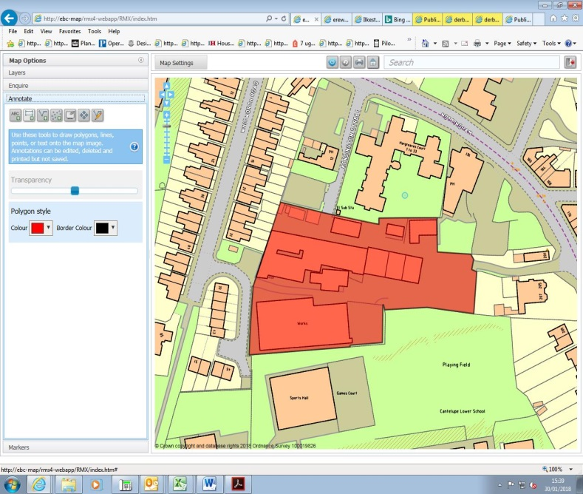

Site details:
Site reference (EELS) | EELS 061
Site name(s) | Kensington Industrial Estate
Settlement | Ilkeston
Description | Former Needleworks and Lace Making factory with later building additions to site forming an industrial estate
Occupiers | Windmill Builders Ltd, Total Home Improvements, Osborne’s Bespoke Furniture, VPRS Ltd & Pollards Roofing
Current use classes present | Largely B2
Size (ha) | 0.7ha
Building age(s) | Central factory building dates from 1822, with peripheral buildings added during early-c20th and Osborne’s premises constructed during 1970’s
Building quality | Poor to average
Site assessment:
Prox. to strategic road network | Site 4.8km to A52 0
Local prominence | Site located at end of Kensington Street, a side road which accesses the A609 Nottingham Road 2
Public transport | Range of bus routes serving Nottingham Rd a short walk north of the site 10
Relationship to workforce | Site within Ilkeston settlement 10
Planning policy considerations | Residential surrounds west and south – noise and traffic movements (from Whitworth Road) 8
Environmental setting | Little landscaping evident on site, mainly hardstanding and buildings across the industrial estate 4
Flexibility of premises | The original central factory building appears to have been subdivided into different spaces, although limited space on-site for extensions or additions 4
Demand/Commercial desirability | Some units appeared empty (or underutilised) from site visit 6
Final score & status | (Out of 73) 44

Site commentary:
Site description:
Industrial manufacturing has existed on this site since 1822 when Latham’s Needleworks and Lace Making Factory began operating. The central building orientated in an east-west alignment now displays few original features and has been extensively altered and modernised across the c20th. Notable later piecemeal additions surround the building, with ancillary office space added as well as extensions of factory space. Predominantly two-storey in height, some additions have created additional height which has established a varied roof level and fenestration has also altered across the life of the building in response to internal operations and possible subdivisions of internal floorspace. Several loading bays are evident at ground floor level, although some appear redundant. One of the site’s three vehicular accesses enters the site through security fencing from Whitworth Road, and passes between the original factory and a later c20th premise, largely rectangular in shape and characterless in appearance, which sits furthest south in the site and has a small area of parking immediately east. An assortment of buildings of varying age and appearance line the northern boundary of the site, providing smaller business units to the larger spaces available elsewhere around the Industrial Estate. Two other vehicular accesses into the site exist, with a narrow approach continuing on from the end of Kensington Street into the northern section of the site, whilst the main access is taken from the A609 Nottingham Road, heading along a sloping incline which plateau’s when arriving at the eastern end of the site’s original building. These accesses all meet as a consequence of the internalised arrangement of premises on-site. A large new residential development now adjoins the site along much of its southern boundary, while established housing is located west of the site along part of Whitworth Road.

Planning policy:
Few planning policies exist which run contrary to the provisions of the Local Plan, although the nature of operations on-site may cause a low level of disturbance to households immediately adjacent to the factory premises. Also of concern are vehicular access arrangements, but particularly at the Whitworth Road entry point where trade vehicles gaining access to the west of the employment site pass along an almost exclusively residential road.

Site flexibility:
The central building on-site appears to have been reconfigured over a number of decades to alter the internal specifications and provide different working space arrangements. Other buildings around the site have been added later for specific end uses, although some of these units now appear vacant. Little space exists for further intensification on-site, with limited areas of parking playing a key role in preventing staff parking from spilling out onto neighbouring residential roads.

Demand and commercial desirability:
As referred to above, it appears some units on the site are vacant and some appear to have had this status for a considerable amount of time. The largely dated nature of facilities at the Estate perhaps reflect in a lower level of commercial interest in these industrial premises, although some occupants have been present here for some time.

Final conclusion:
This industrial estate finds itself being increasingly surrounded by residential development, and with some vacant space and few signs of modernisation, it is questionable whether the facilities available will retain commercial interest over the coming years and decades.

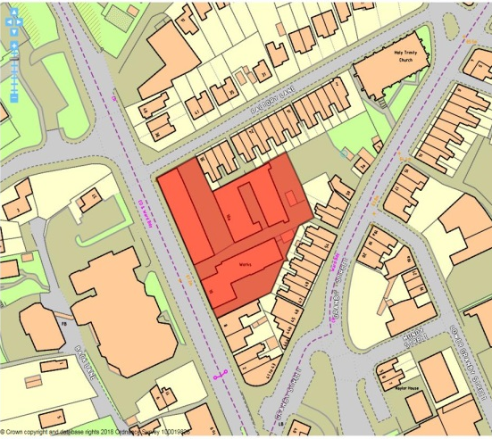

Site details:
Site reference (EELS) | EELS 062
Site name(s) | Works off Heanor Lane / Factory Street
Settlement | Ilkeston
Description | Complex of buildings including a Listed former Lace Factory to the north of Ilkeston town centre
Occupiers | Leafbone Furniture, Shed 2 Studios & Jane Stapleton Photography
Current use classes present | A2(b), B1(a) & B2
Size (ha) | 0.3ha
Building age(s) | Baileys Factory (10 Heanor Rd) dates from 1830-40, with later additions (Baileys Mill) in 1855 and 10a Heanor Road built around turn of c20th
Building quality | Mixed – some recently renovated, others in poor state of disrepair
Site assessment:
Prox. to strategic road network | Site 3.9km to A610 2
Local prominence | Part of the site adjoins A6007 Heanor Road 4
Public transport | Numerous frequent bus services serve Heanor Road 10
Relationship to workforce | Site within Ilkeston settlement 10
Planning policy considerations | Facilities set amongst residential surrounds and Listed Building on-site 8
Environmental setting | Largely urban with little greenery or general landscaping evident on or around site 6
Flexibility of premises | Some buildings have been recently refurbished to allow new uses to occur, although Listed Building in poor condition and would need sensitive restoration 5
Demand/Commercial desirability | Long-term vacancy at 10 Heanor Rd (Listed Building), although three other units on site occupied 6
Final score & status | (Out of 73) 51

Site commentary:
Site description:
This is a complex of distinguished industrial premises connected with the Grade II Listed Ball & Son Lace Factory (10 Heanor Road) which sits at the southern-most point of this site. The most dominant, and clearly the largest building on-site is the Listed Building, originally a lace and hosiery factory, but now vacant for more than a decade resulting in its deteriorating physical condition. Its four-storey height elevates the building above all surrounding premises, ensuring its visibility from a number of vantage points both nearby and more distant. Vehicular access to the rear and front of the property is possible with an entry point on each side of the building’s western elevation, although the access immediately north also serves adjacent buildings within EELS 062. A rather unsympathetic c20th brick annex to the building is noticeable from the Heanor Road-facing elevation. North of the Listed factory is a pair of smaller factory premises constructed in north-south alignment and which are set between residential properties on Factory Lane and Granby Street. The newest facilities within the employment site, these are now occupied by an upholsterer and an artistic studio. Their access is taken from immediately north of the Listed Building, with a small area of hardstanding immediately beyond the eastern-most factory offering limited parking and service space. A narrow access continues and eventually reaches Granby St passing between nos. 55 & 56. The final structure on site is located in its north-eastern corner, known as Baileys Mill, a single storey premise which now accommodates a professional photographic company. This building has seen recent restoration, with cleaned brickwork and replacement traditional glazing on its western elevation facing onto Heanor Road, an elevation which also displays a number of regular brick piers adding visual interest. Vehicular access to Baileys Mill is taken off Factory Lane, with a number of doors and windows having being inserted into the building’s eastern elevation. A narrow yard is situated here offering car parking space for staff and visitors.

Planning policy:
As mentioned already, the main structure on site is the Grade II Listed former factory building. Its protection ensures that its redevelopment must be sympathetic to the building’s character, although its prominence and current physical appearance does detract from an important heritage asset. With reference to the factory immediately north-east of the Listed Building, the presence of an upholstery business in such close proximity to homes on Factory Lane and Granby Street may serve to cause minor losses of residential amenity, particularly from the garden areas of each adjacent property.

Site flexibility:
Some of the buildings on-site have demonstrated excellent flexibility over recent years with the extensive restoration of Baileys Mill and subsequent occupancy by Jane Stapleford Photography showing that older industrial stock has the ability to accommodate modern, professional services. However, with a very prominent Listed Building on-site, opportunities to extensively reconfigure the site would be extremely limited.

Demand and commercial desirability:
With all business space except that at the Listed Building currently occupied and the renovation of Baileys Mill, the desirability of this site can be said to be relatively strong. Attempts to reutilise the vacant factory through its re-use for residential units have previously been given consent by the Borough Council, although permissions were never implemented.

Final conclusion:
Largely a successful and thriving area of industry and enterprise, the site would greatly benefit from a sympathetic renovation of the Grade II Listed factory.

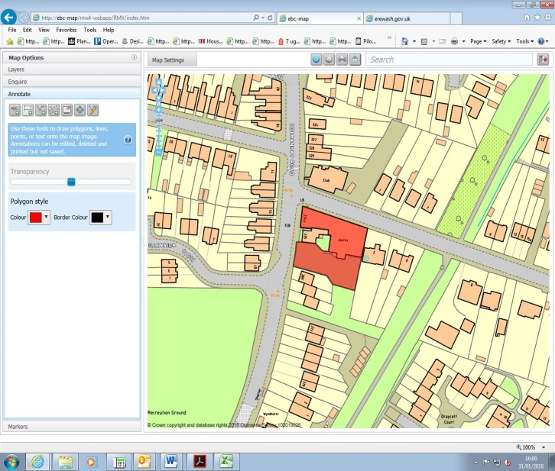

Site details:
Site reference (EELS) | EELS 063
Site name(s) | Works at junction of Cotmanhay Rd & Duke Street
Settlement | Ilkeston
Description | Works premise running along Duke Street, with trade store fronting onto Cotmanhay Rd.
Occupiers | Trade Carpets and Oatenvale Ltd.
Current use classes present | A1 and B1(c)
Size (ha) | 0.1ha
Building age(s) | Original buildings during 1920’s with later additions and reconfiguration.
Building quality | Poor to average.
Site assessment:
Prox. to strategic road network | Site 3.4km to A610 3
Local prominence | Frontage onto Cotmanhay Rd. & Duke St., two localised roads within north Ilkeston. 2
Public transport | Several bus routes serve Cotmanhay Rd, linking the site to Ilkeston town centre and further afield 10
Relationship to workforce | Site within Ilkeston settlement 10
Planning policy considerations | Location within largely residential area 9
Environmental setting | Some unkempt grassed areas form part of Cotmanhay Rd. frontage, but low quality elsewhere around site 5
Flexibility of premises | Site tightly bound on three sides, although area of car parking to south of premises could be utilised. Age and quality of building makes its re-use unlikely 3
Demand/Commercial desirability | Site home to two separate businesses occupying all space at the premises 8
Final score & status | (Out of 73) 50

Site commentary:
Site description:
This is a split employment site, with two businesses trading from what at the Cotmanhay Rd. frontage appears to be two separate buildings, but which adjoin towards their rear. Trade Carpets are based within what appears to be a former residential property, noticeable by its pebble-dashed exterior, yellow-painted sills and signage and a letterbox set into the corner of the building. This quickly steps down to a single-storey former works building that enjoys a long elevation stretching along Duke St. which has been substantially altered over recent decades to incorporate two roller-shutter loading bays, although the deteriorating quality of all windows is evident. Just beyond the building is 2 Duke St, a residential property. Positioned aside Trade Carpets on the Cotmanhay Rd. frontage is a single property (no. 335) which appears to have been sub-divided into an upstairs and downstairs flat. To the rear of this is the southern section of the works mentioned above. This building, occupied by Oatenvale Ltd, providers of bespoke bathrooms, kitchens and bathrooms, is accessed from Cotmanhay Rd, and a reasonably large area of car parking and service yard is evident. The brick building, set into sloping land which is lowest at its eastern-most end, is average in quality of appearance with it having a rather striking white finish creating contrast with neighbouring buildings. The premises appear to be divided partly between a showroom and workshop space. Some basic grassed landscaping surrounds the off-street area of car parking with another residential property (no. 369) further beyond.

Planning policy:
With the site set within what is largely a residential area of Ilkeston, the only conflict between the site’s use and planning policies involves the relationship between the use of buildings and neighbouring residential properties. Most noticeably, residents of the flats at 335A and B Cotmanhay Road may have their level of amenity impacted by works occurring at Oatenvale. Whilst the site visit did not give any indication of unreasonable levels of noise, it is expected that some manufacturing processes could result in disturbance for those in the site’s immediate vicinity.

Site flexibility:
This is a fairly constrained site in the sense that with roads immediately north and west, and residential properties to the east, little scope for physical expansion exists. These are low-quality, but localised premises that if redeveloped would likely be explored for residential development to better accord with surrounding uses. An area of off-street car parking exists in the south of the site, but if this was lost to accommodate further structures then local roads would have to absorb parking/loading/unloading pressures from visitors, staff and trade deliveries.

Demand and commercial desirability:
Both premises are currently occupied for use. It is expected that with both Trade Carpets and Oatenvale Ltd having been present for several years, both premises will likely have configurations adapted for their operations.

Final conclusion:
These premises, average in quality and with minimal historic or visual interest, represent good examples of works which continue to exist within ever-stronger residential surroundings. Such locations continue to make contributions to the local economy, although it is likely that should one or both of the current businesses leave the site, it would hasten the loss of it to residential development.

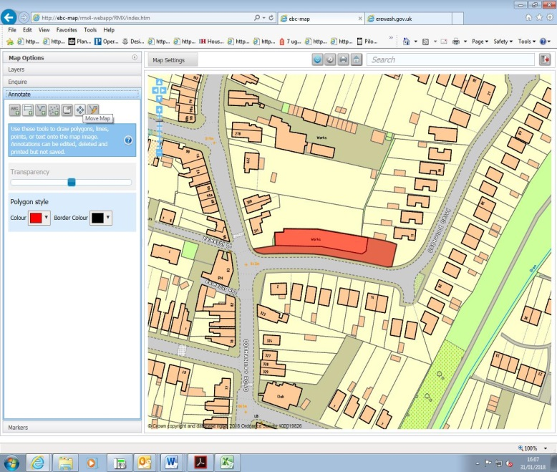

Site details:
Site reference (EELS) | EELS 064
Site name(s) | Works at Grenville Drive
Settlement | Ilkeston
Description | Former lace factory premises at Orchard Works with two-storey office accommodation at western end
Occupiers | Derventio Housing Trust
Current use classes present | D1 (unauthorised use), lawfully B1(c).
Size (ha) | 0.1ha
Building age(s) | Original part of building dates to circa. 1900, with two additions to lengthen factory between 1914-21 and sometime during the 1930’s.
Building quality | Average
Site assessment:
Prox. to strategic road network | Site 3.4km to A610 3
Local prominence | Fronts onto Grenville Drive, which is accessed off Cotmanhay Road 2
Public transport | Routes 2, 14, Ilkeston Flyer & the Y3 all regularly serve Cotmanhay Road a few metres from the site 10
Relationship to workforce | Site within Ilkeston settlement 10
Planning policy considerations | Surrounding residential development and unauthorised current use 8
Environmental setting | Limited setting, although yard and car parking located at eastern end of the premises 6
Flexibility of premises | Limited space surrounding the premises to physically expand internal operations 4
Demand/Commercial desirability | Building currently occupied by Derventio Housing Trust and being operated as a non-residential rehabilitation centre 8
Final score & status | (Out of 73) 52

Site commentary:
Site description:
Originally a single-storey Lace Factory upon its construction back at the beginning of the c20th, this Works premise now sits within a predominantly residential suburb of Ilkeston near to the busy Cotmanhay Road. A long rectangular brick factory which is noticeably higher at its western than eastern end, shares its longest frontage with Grenville Drive with the premises sitting behind palisade fencing. A number of windows exist on the building’s southern exterior, with a recently inserted floor-to-roof loading bay positioned towards the western end of the façade which is currently inaccessible due to the security fencing separating the employment site’s curtilage from the public highway. At its western-most end near to the junction with Cotmanhay Road, a two-storey building constructed in a residential style annexes the factory. This has served as the administrative area of the premises when the site was occupied by its previous tenants (Frank Beardsley & Co. Ltd). To the right of the building (when viewed from Grenville Drive) is a small area of off-street parking for a handful of vehicles. This is lined by palisade fencing, with another small section of private parking situated beyond.

Planning policy:
The premises are located within a residential area of Ilkeston, and as such, the existing lawful use of the site (B1(c)) could cause low-level amenity issues to nearby residences on the southern side of Grenville Drive, particularly from trade deliveries accessing the premises along the road. However, with the factory long pre-dating the homes opposite, it is expected that minimal disturbance is generated by the nature of works within the building. The Borough Council are aware that the premises are currently being used in an unauthorised manner, and hope that the situation can be resolved in due course.

Site flexibility:
With the site’s long and thin shape stretching along Grenville Drive, it is not believed that the building could be substantially altered to intensify industrial operations or even replaced altogether with a new building given the increasingly residential surroundings in this part of Ilkeston.

Demand and commercial desirability:
Currently a single occupant of the building (Derventio Housing Trust), although this is subject to Borough Council Enforcement action due to a failure to obtain the necessary permission to change the building’s use.

Final conclusion:
The former factory, now being currently utilised as a rehabilitation centre, is in reasonably sound condition structurally with a recent work evident to relocate the main trade access point into the premises. This was undertaken by the premises previous occupants, and now appears to be surplus to requirements owing to the present use of the building. With a current unlawful use taking place, the future of the site is unknown raising doubts as to whether it will remain in a general employment use for the foreseeable future.

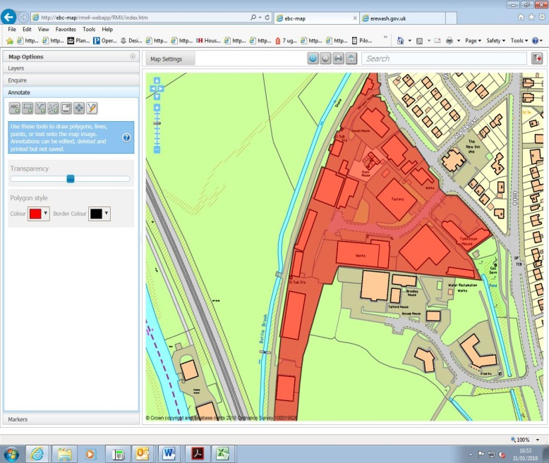

Site details:
Site reference (EELS) | EELS 065
Site name(s) | Duffield Road Industrial Estate
Settlement | Little Eaton
Description | The site is located off the A38, south of Little Eaton
Occupiers | Various
Current use classes present | Multiple uses including B1a. B1c, B2 and B8
Size (ha) | 3.4ha
Building age(s) | The site was developed following the 1970’s
Building quality | Good
Site assessment:
Prox. to strategic road network | Site 1.1km to A38. 7
Local prominence | Site is adjacent and visible from the B6179. 3
Public transport | Bus stops positioned close to the site’s boundary. 10
Relationship to workforce | Located within Little Eaton settlement. 10
Planning policy considerations | Situated adjacent to residential properties, contains a Grade II Listed Building and is in Flood Zone 3. 7
Environmental setting | The site is mainly hard concrete surfacing, including various car parks and loading bays, with minor areas of grass that break up the sites units and shrubbery and trees on the site’s boundary. 6
Flexibility of premises | The site contains a handful of areas where there is potential to create additional units. 8
Demand/Commercial desirability | Only one unit was recorded as vacant during the site visit. 8
Final score & status | (Out of 73) 59

Site commentary:
Site description:
The employment site was constructed on a former sewage and water works, after the 1970’s. The site is accessible via Duffield Road. There is wide vehicular access to the main entrance of the site, enabling convenient and easy entrance for larger vehicles, such as HGV’s to manoeuvre the site. On the opposite side of Duffield Road, is Little Eaton village, with residential properties visible from the employment site. Businesses located on the estate include M W Polymers, Mercia Image Print and Design and East Midlands Demolition Limited. Buildings are typically constructed of brick and metal cladding, with regular occurrence of pull up garage doors for vehicular access to the units. Newer buildings on the estate include the Tomlinson Group building, immediately in the entrance to the site. Car parking facilities are readily available with some street parking also existing. The site is easily accessible from main access roads including the B6179, A38 and nearby A52. The site is located within walking distance from Little Eaton village and has a convenient bus stop in close proximity, enabling easy access for both a local workforce and national commercial trade. The site’s appearance is clean and tidy and there was minimal noise pollution evident during the site visit.

Planning policy:
The site provides a good quality employment site with the provision of jobs for the local economy. It is however within close proximity of residential properties, with the commercial traffic thought to impact slightly on residential amenity. A Grade II Listed Clock House (late-c18th) lays centrally positioned within the Industrial Estate, with the surrounding industrial premises impacting upon the setting of a listed heritage asset. Finally, EELS 065 is situated within Flood Zone 3a, influenced by the nearby River Derwent and therefore of relevance should further development interest occur here.

Site flexibility:
The site has available space to create additional units. There is a large vacant area, on the south of the site, situated next to East Midlands Demolition Limited, which has potential to house an additional employment unit. However, its current occupation is unclear, with possible uses including a loading bay and a storage depot. There is potential to add to existing units, similar to the development of the joint units on site. Total Hire and Sale added an additional block to their unit to create an adjoining component, to create space for Tomlinson Vehicle Services. The site’s location within Flood Zone 3a would add complexity to any newly-proposed employment unit(s).

Demand and commercial desirability:
The site has a high occupation rate and the identified vacant unit received interest from various parties, which appears to have already secured a new occupier for future use.

Final conclusion:
Overall the site visit demonstrates that this is a popular location for employment opportunities and business operations with its proximity to the A38 and further links to the strategic road network though to be a strong commercial asset. It is therefore a reasonably well-kept and commercially appealing site, reflected by its high occupancy rate and contributing a sizeable number of jobs within one of Erewash’s rural settlements.

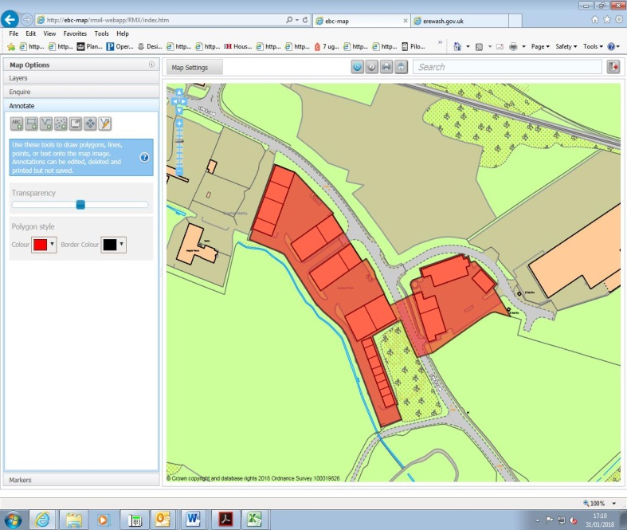

Site details:
Site reference (EELS) | EELS 066
Site name(s) | Langham Park and facing business units
Settlement | Stanton-by-Dale
Description | Modern collection of business units at the south-eastern end of the wider Stanton site
Occupiers | Various occupants
Current use classes present | Mainly B2, but also B1(a), B1(b) & B1(c) uses
Size (ha) | 2.1ha
Building age(s) | Modern
Building quality | Excellent
Site assessment:
Prox. to strategic road network | Site 3.8km to J25 (M1/A52) 2
Local prominence | Site visible from M1 just south-east of the site 5
Public transport | Site greater than 1km away from nearest bus service 0
Relationship to workforce | Site part of Ilkeston settlement 10
Planning policy considerations | Group TPO designation adjoining site between Golf Club Road and Lows Lane 9
Environmental setting | Limited soft landscaping on-site, but green surrounds – particularly to west, south-west 6
Flexibility of premises | Modern units so may be adaptable internally. Little space for further additions on site given need for parking/service areas 6
Demand/Commercial desirability | No units vacant at time of site visit. Recent vacancies only lasting limited time before new occupants 8
Final score & status | (Out of 73) 46

Site commentary:
Site description:
This is a cluster of business units situated on both sides of Lows Lane, accommodating a diverse range of occupiers and operations. Constructed during the early-c21st, the units are good examples of modern, mainly smaller premises, able to accommodate small and medium enterprises, being one of a limited number of sites developed in the Borough over the last couple of decades. The site displays three evident sections with the first, located furthest north on-site incorporating four rows of industrial premises arranged with gable-end facing towards Lows Lane. A number of loading doors are visible on the exterior of each row of units, as are limited windows suggesting the presence of small areas of ancillary office floorspace inside. Each row also benefits from a spacious forecourt area, containing provision for car parking. The main vehicular access is taken off Lows Lane, with an internal service road leading to the back of the development where roads then subsequently pass between each row of units to access parking and loading areas. It is this rear access road which links to the second section of EELS 066, a row of much smaller business units which face westwards onto a narrow area of car parking at the front of these properties. Behind these, positioned between the units and Lows Lane are a group of trees covered by TPOs. The access road servicing this row of premises ends before Golf Club Road. On the opposite (east) side of Lows Lane, and accessed off West Way, is the final section of the site; three blocks of industrial premises arranged around a communal courtyard area providing for staff and visitor parking. Similarly to stock on the opposite side of Lows Lane, loading doors can be found on the frontages of the large units which face inwards into the communal courtyard.

Planning policy:
Few planning policies are of relevance to this particular site. An adjoining Group TPO designation on the west side of Lows Lane form part of the site’s setting, although the units which neighbour have no active frontage to the small wooded area.

Site flexibility:
With the stock on this site relatively new in age, it is expected that the interiors will allow some level of adaptation to accommodate a diverse range of business-orientated operations without too much disruption. The layout of the estate on both sides of Lows Lane makes acceptable provision for parking and service areas, so it is thought the addition of further units on the site are unlikely due to limitations on space. In the coming years however, some unit occupants may wish to make small-scale alterations to their premises to facilitate growth needs.

Demand and commercial desirability:
All units are currently occupied demonstrating the success of this industrial estate. Isolated units have become available over the course of the development’s life, but have generally been taken relatively quickly minimising the time any single unit has remained vacant.

Final conclusion:
It is unsurprising that business premises within the wider Stanton redevelopment site have proved commercially popular in accommodating a number of local enterprises. With the introduction of modern industrial facilities generally scarce around Erewash, such units and premises are thought likely to continue to remain popular over the coming years, particularly throughout the redevelopment of the neighbouring Stanton Regeneration Site.

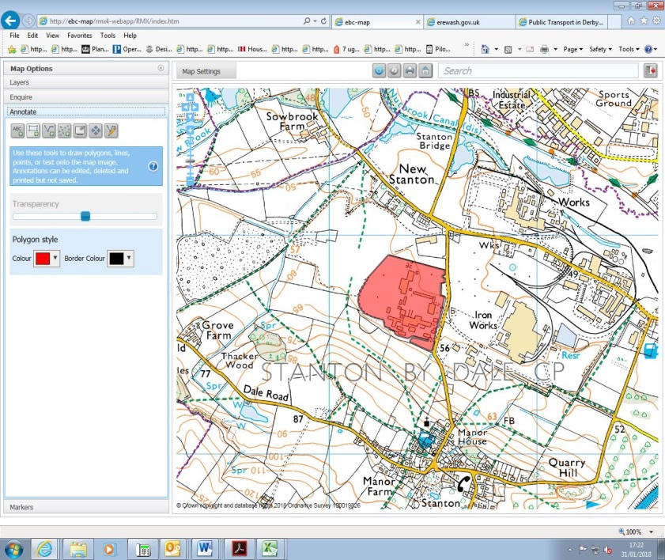

Site details:
Site reference (EELS) | EELS 067
Site name(s) | Stanton Bonna Concrete Plant and Works
Settlement | Stanton-by-Dale
Description | Large area of Concrete Works with spacious area of open storage on-site for made products
Occupiers | Stanton Bonna Pipelines
Current use classes present | B1a, B2 and B8
Size (ha) | 12.1ha
Building age(s) | Original buildings date from the 1960’s with a number of more recent additions and modifications
Building quality | Mixed
Site assessment:
Prox. to strategic road network | Site 5.2km to A52 0
Local prominence | Site fronts Littlewell Lane, a country lane which links Stanton-by-Dale with Lows Lane 2
Public transport | The local 14 bus service routes along Littlewell Lane 10
Relationship to workforce | Site part of Ilkeston settlement 10
Planning policy considerations | Possible noise disturbance from nature of on-site operations 9
Environmental setting | Grassed area to front of administrative buildings and often-dense areas of trees surrounding parts of the site to screen use from neighbouring land. Little on-site greenery or landscaping however 7
Flexibility of premises | Sizeable spaces evident across the site in which additional buildings could be accommodated 8
Demand/Commercial desirability | Single occupier (Stanton Bonna) who have adapted the site to meet current operational needs 8
Final score & status | (Out of 73) 54

Site commentary:
Site description:
The Stanton Bonna facility covers a sizeable area of land immediately west of the former Stanton Ironworks site. The majority of buildings are broadly positioned within the eastern part of the facility, with the western half fulfilling an open storage role in storing the many concrete-based products manufactured on-site. A number of buildings of various sizes, uses and differing appearance have been constructed here since manufacturing began at this location during the 1950’s and 60’s. As expected with a major company, additions to the campus have been made regularly over the last several decades to keep up with changing processes, increasing demands for products and to better utilise Stanton Bonna’s sizeable estate. The company’s administrative buildings are found in the south-eastern corner of the site, close to where the main vehicular access is taken from Littlewell Lane (Gate A), although another site entry point (Gate C) is situated in the far north-eastern corner and is shared with access to the neighbouring Elliott Skip Hire business. A number of buildings on site are visible from this road despite it being generally at a lower level, with the Large Diameter Products Moulding Shop building rising up behind the company’s main offices. Further north along Littlewell Lane, newer large-scale industrial buildings with sheet-metal cladding finish are clearly visible over the grass embankment running alongside the road, and further north again, a break in surrounding screen of trees allows for views of buildings served by a conveyer belt. On the opposite (western) side of the site, a vast area of open storage is evident containing stocks of concrete products (largely pipes or variants of pipe working) of varying sizes arranged in a block grid formation to allow vehicular access around them to pick-up and redeposit. Surrounding the site on its southern side are sloping arable fields, helping to provide a reasonable buffer between the site and the edge of Stanton-by-Dale village, around 400m south of the Bonna facility and situated on higher ground.

Planning policy:
The site sits within a wider industrial setting west, north and east, with the wider (now former) Stanton Ironworks site sweeping around most sides of Stanton Bonna. With the absence of residential properties close by to the facilities, a severe lack of residential amenity is avoided, although residents at the Grade II listed properties at Twelve Houses may be within the sound shadow of the industrialised operations carrying at the site when residents are outside of their homes. Whilst not an issue currently, careful consideration will need to be given to how future residents of a redeveloped Stanton site will not have their residential amenities adversely impacted due to the close proximity between the current industrial operations and where homes are scheduled to be constructed just west of Littlewell Lane.

Site flexibility:
With Stanton Bonna covering such a large expanse of land, it is thought that ample space exists in which to construct or extend addition facilities at the site. Indeed, the company have been granted several planning permissions for the construction of new facilities at this location. Recent permissions granted in late-2017 secured consent for a new Batching Plant and Slab Machine & Wet Cast Shop, both of which haven’t yet commenced, but demonstrate the site’s ability to support new operational facilities.

Demand and commercial desirability:
With only a single occupant of the site, the facility is configured exclusively for the operational use of Stanton Bonna.

Final conclusion:
A well-known business and sector leader, Stanton Bonna and its facility make a notable contribution to the Borough’s economy and recent investment made by the company in the development of new facilities demonstrate their long-term commitment to Erewash.

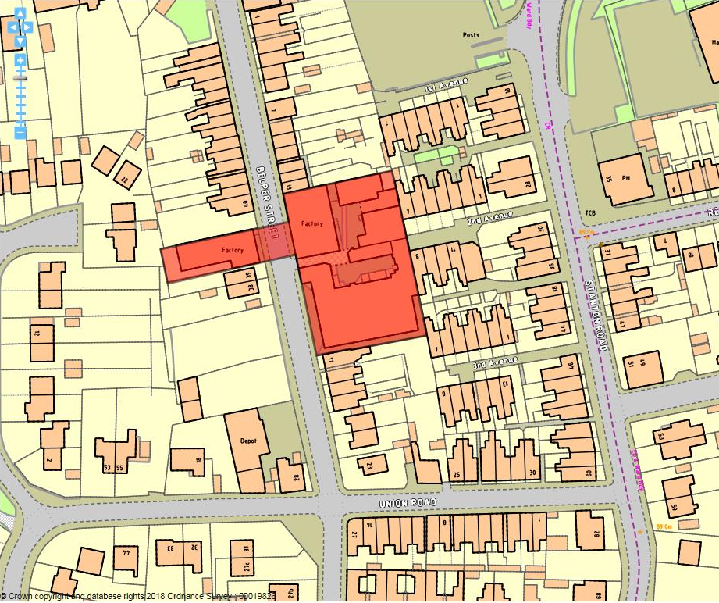

Site details:
Site reference (EELS) | EELS 068
Site name(s) | Factories east and west of Belper Street
Settlement | Ilkeston
Description | Former Mill premises located on opposite sides of Belper Street which extend to three-storeys in height. On western side, West Side Factory – on east Belper Street works.
Occupiers | In Belper St. works – Cluny Lace Company, in West Side Factory – White Space Living (furniture), two photography studios and two vacant units.
Current use classes present | Mixed
Size (ha) | 0.23ha
Building age(s) | Both main Mill premises constructed between 1870 & 1880, although later additions made between 1880 and the turn of c20th.
Building quality | Average
Site assessment:
Prox. to strategic road network | Site 5.2km away from A610 0
Local prominence | Site fronts Belper Street, a narrow and unclassified highway in largely residential area 2
Public transport | Short walk to bus services which route along A6096 Stanton Road 10
Relationship to workforce | Site within Ilkeston 10
Planning policy considerations | Adjacent residential properties, restrictive vehicular access and buildings on Local Interest List 7
Environmental setting | Set within densely urbanised surroundings with no landscaping evident to soften site, although quality of buildings helps provide visual interest 6
Flexibility of premises | Internal space within West Side Factory has been reconfigured in recent years, but little expansion space 5
Demand/Commercial desirability | Two units appeared vacant within West Side Factory 6
Final score & status | (Out of 73) 46

Site commentary:
Site description:
The site consists of two facing factory buildings constructed towards the end of the 19th century, is set within a largely residential surrounding with terraced housing extending mainly northwards, but also slightly southwards of the industrial buildings. Terraced housing is also present immediately east of the Cluny Lace Company with several rows of properties running between Stanton Road and the Cluny premises allowing for occasional views through to the premises. The buildings on the eastern side of Belper Street covered a larger footprint, and while the three-storey Mill at the road frontage is the most visually dominant aspect of the site, newer smaller-scale and less elaborate additions to the south and rear of the original building provide a sizeable amount of industrial floorspace. Opposite this is a smaller Mill factory premise, now internally renovated to provide several smaller spaces which have flexible uses. The building, which due to the sloping topography with higher level at the roadside falling away to the west, sees two distinct parts; a frontage section consisting of four storeys (with partial view of basement level), and a rear wing which sits on an east-west orientation projecting back to adjoin the curtilages of properties on Stanley Close. At its rear, a small single-level workshop of little merit has been added with access taken along the building’s northern elevation. South of the building a sizeable area of off-street surface car parking for the usage of staff and visitors to the premises on both sides of Belper Street can be found.

Planning policy:
The factory premises are long-established, co-existing with surrounding residential properties for more than a century. However, Belper St is a narrow highway with car parking permitted on both of its sides narrowing the width for vehicles. Whilst an area for loading/unloading is provided outside the Cluny Factory Premises, trade vehicles accessing the site have to journey along a less than ideal part of the localised road network creating some highway safety issues. Related to this, the Site Description above also describes the close proximity of properties to the employment premises here. This is of lesser relevance for the West Side Factory building given the loss of industrial uses inside it, but the nature of work in the Cluny premises could create low-level noise disturbance for surrounding residences. Lastly, both facing premises are on the Borough’s Local Interest List reflecting their heritage importance which poses challenges in the maintenance of these buildings moving into the future.

Site flexibility:
The Cluny premises on the east side of Belper St appear to have fully utilised their available footprint and now adjoin a number of adjacent residential properties suggesting that further physical growth is unrealistic. The West Side Factory has seen subdivision and recent modernisation to provide office and studio space, demonstrating that the building has been able to adapt to meet changing needs, whilst also helping to maintain the building’s longevity. Similarly to the facing premises, further outward expansion would not be possible.

Demand and commercial desirability:
Cluny Lace Manufacturing has been on-site since the building’s construction, and have adapted premises for their own operational requirements. Space in the West Side Factory is currently available with two units being commercially marketed.

Final conclusion:
A small and visually interesting zone of employment, one side remains rooted in its industrial history as the manufacturing of lace continues, with the Cluny business helping continue Ilkeston’s link to the area’s lacemaking heritage. Premises west of Belper St provide smaller spaces for non-industrial uses, and show that careful internal modernisation of a heritage building can provide useful areas for small-scale business enterprises.

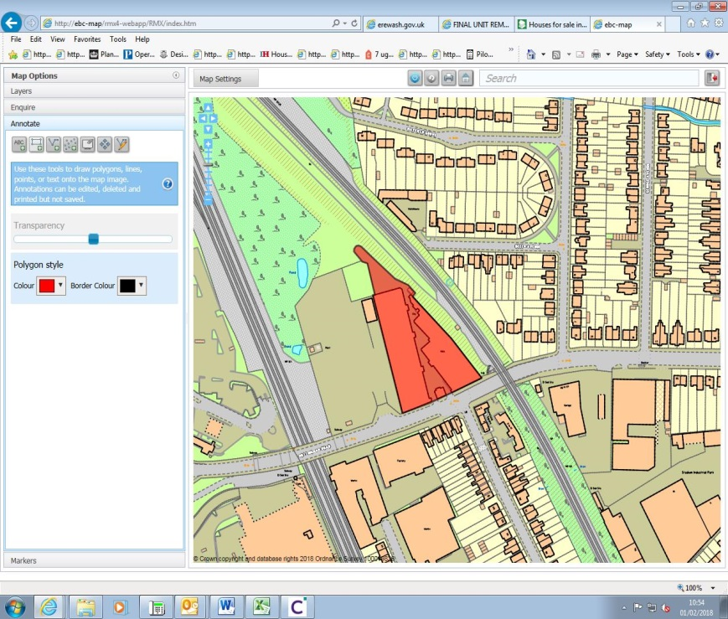

Site details:
Site reference (EELS) | EELS 069
Site name(s) | Phoenix Mills, Nottingham Road
Settlement | Long Eaton
Description | Pair of Mill premises situated around 350m east of Long Eaton town centre
Occupiers | Aburnet Ltd, Royce Chemicals Ltd, Long Eaton Carpet Centre, Roger Smeeton Memorials, Floor Trade Long Eaton, Long Eaton Building Plastics & Fast Fix Auto Centre
Current use classes present | B2, A1 & Sui Generis
Size (ha) | 0.6ha
Building age(s) | Mills constructed around the turn of c20th
Building quality | Average
Site assessment:
Prox. to strategic road network | Site 3.2km to A52 3
Local prominence | Site accessed from A6005 Nottingham Road 4
Public transport | Several bus services route along Nottingham Road 10
Relationship to workforce | Site part of Long Eaton settlement 10
Planning policy considerations | Adjoins local wildlife site (ER208: Nottingham Road Carr and difficult vehicular access/egress arrangements 8
Environmental setting | Significantly developed site with no evident landscaping to soften environment 5
Flexibility of premises | Some recent alterations to frontage of east Mill, although given age and condition of Mill premises, unlikely to offer scope for wholesale reconfiguration or extension given constrained site 3
Demand/Commercial desirability | All space within the Mills at the time of site survey appeared occupied 8
Final score & status | (Out of 73) 51

Site commentary:
Site description:
A pair of early-c20th Mill premises arranged in unconventional orientation with both inverted to leave a central triangular courtyard which units on each side face out into. Positioned between each Mill building at the site’s frontage sits an elegant former Boiler House now occupied by a business use. Two points of vehicular access serve the site, with narrow passages flanking both sides of the former Boiler House. These meet to its rear at the southern end of the shared yard space. The access points sit opposite the junction between Nottingham Road and Conway Road, creating a busy section of highway. Both Mill premises are typical examples of stock of their age, being single-storey in height with saw-tooth roof pitches running back from the southern frontage. A small area of hardstanding provides parking and storage space to the rear of the buildings. Railway dominates the site’s immediate surrounds, particularly to its east, with the high-level line sitting atop a steep, densely tree-lined embankment which elevates the line to a noticeably higher level than the industrial buildings sit at street level. Immediately west of the site is a newly-constructed facility accommodating three containerised units for the storage of electricity to supplement power available to the national grid. South, beyond Nottingham Road, is a residential area along Conway Road.

Planning policy:
Of greatest relevance here are highway conditions surrounding the premises. The limited width of site entry points and inability for HGVs to turn within the site itself poses issues of highway safety when parked HGVs embark upon loading/unloading. This greatly narrows the width of the highway, and given the junction arrangements here which see Conway Road and a small service road accessing nos. 20-34 Nottingham Road, a narrowing is not conducive with maintaining highway safety for road users and pedestrians. Additionally, the site also adjoins Nottingham Road Carr, a local wildlife site, which is located immediately north of the Mill buildings. The nature of operations in premises on-site does not afford the neighbouring sensitive area of biodiversity with a strong setting.

Site flexibility:
Some alterations have been visible at the site over recent years. This is most evident on the east Mill which saw its frontage demolished, recessed back further into the site and then replaced with modern and rectangular southern elevation to include several bays incorporating entrance and vehicular loading doors.

Demand and commercial desirability:
The premises here appear to be in reasonably high demand with minimal vacant space currently available.

Final conclusion:
Phoenix Mills have provided industrial floorspace within Long Eaton for a considerable period of time. The buildings have been adapted internally over time to create a number of smaller units in which local companies have manufactured and traded from. With vehicular access arrangements compromised due to limitations on width and turning space, businesses with requirements for high frequencies of HGV movements would be unsuitable. HS2’s passage through Long Eaton may offer buildings such as these a long-term future, either continuing in their current use or in pursuing alternative uses – but access will likely remain problematic for the employment site.

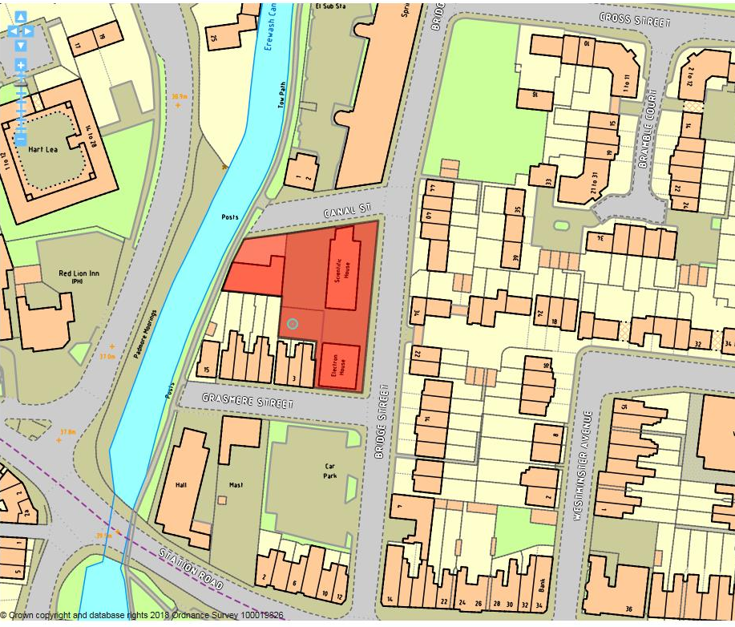

Site details:
Site reference (EELS) | EELS 070
Site name(s) | Electron House and Scientific House
Settlement | Sandiacre
Description | A pair of flat-roofed buildings constructed for office use adjacent to a single-storey workshop located alongside the Erewash Canal
Occupiers | Xynomix and R Woodward Decorators Ltd.
Current use classes present | B1(b)
Size (ha) | 0.15ha
Building age(s) | Workshop constructed in 1960’s & office buildings during the 1980’s
Building quality | Average
Site assessment:
Prox. to strategic road network | Site 1.8km to J25 (M1/A52) 6
Local prominence | Buildings situated on side road to the B5010 Station Road 2
Public transport | B5010 served by a number of frequent bus services 10
Relationship to workforce | Site part of Sandiacre settlement 10
Planning policy considerations | Site partially within Conservation Area, within the setting of a Listed Building and directly adjacent to a local wildlife site 7
Environmental setting | Site comprises office block buildings, car parking and a yard area off Canal St. Very limited environmental qualities on-site, but more attractive surrounds 6
Flexibility of premises | Two-storey extension to Electron House granted PP in 2013 but not yet implemented 5
Demand/Commercial desirability | All premises occupied – Xynomix acquired Electron House in 2013 to facilitate future growth of company 8
Final score & status | (Out of 73) 54

Site commentary:
Site description:
The site exists just beyond the designated Local Centre of Sandiacre, containing a pair of broadly matching two-storey office blocks, both with flat roofs. Located between these and the Erewash Canal, a painting and decorating business is based out of a single-storey premise which takes its vehicular access from Canal Street. The pair of office block buildings, named Electron and Scientific House, are unimaginatively-designed brick premises typical of the 1970-80’s era, constructed on the site of terraced housing which once lined this stretch of Bridge Street. Electron House, slightly the smaller of the two buildings, appears to have been subject to recent modernisation with new windows and signage. Scientific House, slightly recessed from Bridge St allowing for off-street parking at the building’s frontage, is noticeable for an annex at the northern-end of its frontage where security shutters protect what is likely to be the building’s access at ground floor level giving the impression of its only partial occupancy. An area of secured parking beyond palisade fencing and security gates can be found to the rear of the property. Immediately beyond this to the west of Scientific House are the small premises of R Woodward Decorators Ltd which again, are of little design significance. The building and its forecourt are well enclosed, with a small office area extending from its frontage and a workshop closest to the neighbouring Canal.

Planning policy:
The bland building styles within the extent of the employment site are somewhat at odds with the general historic character evident within the Sandiacre Canalside Conservation Area (SCCA). The small decorator’s workshop at the end of Canal Street sits inside in the SCCA, enjoying significant prominence right alongside the Erewash Canal when viewed from both sides of the waterway. Whilst Electronic and Scientific Houses are outside the SCCA, the curtilage adjoins the designated area, contributing an average setting to this part of it. Immediately north of EELS 070 is the Grade II Listed Springfield Mill, an imposing building highly visible around this part of the Borough. Once again, the visual appearance of the employment premises and their use of space (surrounding car parking) detract from the setting of such a prominent local landmark. The employment site also adjoins the Erewash Canal, a designated Local Wildlife Site (ER215). Again, the adjacent trade yard which backs directly on to the Canal’s towpath on its eastern side is slightly incongruous with the environmental sensitivity such designations hold.

Site flexibility:
The two Houses display some flexibility to adapt and modify their existing premises. ERE/0912/0013 granted permission for a two-storey side extension to Electron House, although this remains unimplemented and has now likely expired. With a generous amount of surrounding off-street car parking, it is thought some space could be utilised to extend further space to the two buildings along Bridge Street.

Demand and commercial desirability:
All premises within the site’s boundaries are currently occupied, although Scientific House looked under-occupied at the time of visit. The decorator’s yard is a small enclosure and appears to have been configured to suit the needs of the current occupant.

Final conclusion:
Whilst all premises are currently occupied with active businesses, their location in a part of Sandiacre which has increasingly become residential may at some point in the future mean land attracts attention to deliver further housing units close to the Local Centre of Sandiacre.

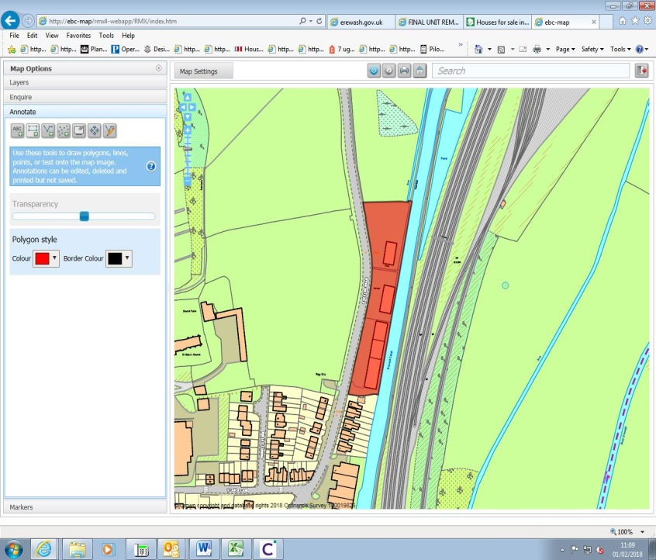

Site details:
Site reference (EELS) | EELS 071
Site name(s) | Ilkeston Road Industrial Estate
Settlement | Sandiacre
Description | Small, linear industrial estate which adjoins Erewash Canal and located at northern end of Sandiacre
Occupiers | JTD Autos, Kitchen Fit Sandiacre, Beeston Beltings and Auto Body Tec
Current use classes present | B2
Size (ha) | 0.5ha
Building age(s) | Late-c20th
Building quality | Good
Site assessment:
Prox. to strategic road network | Site 2.4km to J25 (M1/A52) 5
Local prominence | Site fronts Ilkeston Rd; a busy but unclassified road 2
Public transport | 14 and i4 bus routes pass close by along Church St 10
Relationship to workforce | Site part of Sandiacre settlement 10
Planning policy considerations | Confirmed route of HS2 passes through site, adjoins local wildlife site (ER215), part of setting for Sandiacre Cloudside Conservation Area (SCCA) and adjacent residential properties 6
Environmental setting | Very little soft landscaping on-site – nearly exclusively hardstanding for car parking & servicing – pleasant surroundings consist of Erewash Canal & SCCA 5
Flexibility of premises | Units thought to be adaptable internally – however, no additional space to extend on-site or build standalone premises due to congested arrangement of buildings. Confirmed HS2 route negates site investment 2
Demand/Commercial desirability | All units occupied at time of site visit 8
Final score & status | (Out of 73) 48

Site commentary:
Site description:
A relatively modern row of industrial premises which, beyond a small area of poor-quality forecourt providing limited areas of staff/visitor car parking, display frontages that incorporating two-storey office accommodation as ancillary space to the main general industrial uses located in workshop space set further back in each unit. Units are functional in general appearance, largely exposing brick construction with corrugated metal exteriors higher up the buildings at first-floor level. Each of the four units (a row of three units, with a separate premise positioned slightly north) is rectangular in design, appearing to have flat-pitch roofing. Little demarcation between public and private space beyond the highway exists in front of the row of three industrial units, all of which have their own vehicular access points off Ilkeston Road, but the northern-most unit is set within a secured space beyond palisade metal fencing. All units back onto the western bank of the Erewash Canal (no interaction between the premises and the Canal side is possible), whilst the Erewash Valley railway line (several tracks wide at this location) is situated immediately beyond.

Planning policy:
The published route of the eastern leg of the HS2 line is scheduled to run right up to the north of this employment site, with the entirety of it falling inside the Safeguarding Zone published by HS2 to demonstrate likely land-take on either side of the lines. This obviously presents a great risk to continued industrial uses occurring on EELS 071, but other matters of note is the site’s proximity to the Erewash Canal, a designated local wildlife site (ER215). Despite the lack of interaction between the units and the Canal, the sensitive habitats in and surrounding the Canal, its presence does not necessarily afford the watercourse a particularly compatible setting. The land directly opposite the units to the west of Ilkeston Road is the edge of the SCCA, and similarly to the previous ecological issue, the same principle of the employment site providing a weak visual setting to the CA is to detriment of an adjacent area of special historic character. Established residential properties extend south of the employment site, and the neighbouring industrial activities from the units may serve to create low-level disturbance for households, particularly when outside of their property.

Site flexibility:
The confirmed alignment of HS2 north of Sandiacre casts significant doubts over the site’s ability to continue to accommodate its present industrial uses. It is unlikely that material alterations to the site would be financial viability if the HS2 route requires land here to facilitate its construction. This renders the site largely inflexible for any future alterations.

Demand and commercial desirability:
All units are currently occupied, although the site’s position within the published HS2 Safeguarding Zone will likely result in industry at this location ceasing within the next several years.

Final conclusion:
Whilst the industrial units here are examples of reasonably good industrial space which local businesses utilise and contribute positively to the local economy, the long-term HS2 project, if delivered as per the current Government’s published route, would inevitably cause the loss of this employment site.

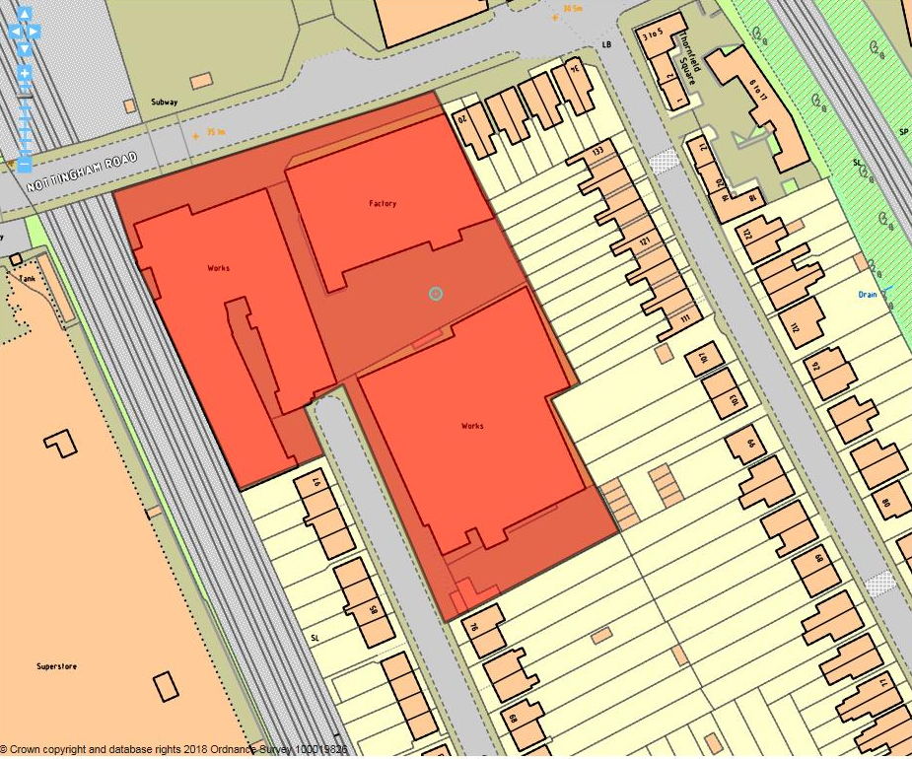

Site details:
Site reference (EEL) | EELS 072
Site name(s) | Works off Bonsall Street
Settlement | Long Eaton
Description | Pair of Edwardian-era mill factories and mid-20th century factory
Occupiers | Steed Upholsterers & TecQuipment
Current use classes present | Principally B2 with ancillary offices (B1a) and showroom (A1)
Size (ha) | 0.86 ha
Building age(s) | Mix of early and mid-20th century manufacturing premises
Building quality | Steeds – dated, TecQuipment - average
Site assessment:
Proximity to M1, A52 or A38 | 3.5 km to A52 3
Local prominence | Adjacent to A6005 4
Public transport | Nearest stop at The Green, Long Eaton 10
Relationship to workforce | Within Long Eaton urban area 10
Planning policy considerations | Access to site through residential streets (Bonsall St, Albion Rd & Conway Rd. HS2 impacts. 9
Environmental setting | No landscaping, setting mainly car parking 5
Flexibility of premises | Little scope for expansion, but serve use 6
Demand/Commercial desirability | All units on-site occupied 8
Final score & status | (Out of 73) 55

Site commentary:
Site description:
Three employment buildings are present on-site. The two northern-most premises are a pair of Edwardian-era mill-style factory buildings (originally Lace Mills) with some remaining interesting architectural detail, both now occupied by Steeds Upholsteries. One building serves as a showroom and offices, whilst the other houses active upholstery manufacturing. The conditions of both are dated, but no different to what might otherwise be expected given the activities taking place. A third, separate building is situated on the western side of Bonsall Street (TecQuipment). This is rather functional in appearance and two-storey at its frontage with administrative offices sited at first-floor level and manufacturing space to the rear. Two notable pockets of parking exist between buildings serving both businesses. The site is positioned within an urbanised part of Long Eaton, with a short walk (250m) to the edge of the Town Centre westwards along Nottingham Road (A6005). With the site being situated just off a main arterial road, its facilities are well served by public transport, allowing excellent levels of accessibility for staff and visitors.

Planning policy:
The site forms part of Long Eaton’s main built-up area. No specific planning policies from the Erewash Local Plan stipulate any alternative land-use to the current. However, HS2 plans show the construction of a new line passing directly through the industrial building adjoining the current line raising uncertainty towards part of the site’s long term employment use. While some of the operations at the premises can generate noise, other aspects around the site (active railway, noise of traffic along Nottingham Rd) help put this into context.

Site flexibility:
The site’s urban setting contributes to being tightly constrained and enclosed by surrounding land uses. This most notably includes the Erewash Valley railway line, residential properties and the A6005 Nottingham Road. Whilst some car parking exists on-site, its retention is necessary given the role this plays in accommodating staff and visitors vehicles away from parking on adjacent residential streets and is thought impractical to lose to accommodate new premises or additions to existing buildings. The future construction of HS2 will blight the site, adding uncertainty to how part of it will continue to function as a location for employment.

Demand and commercial desirability:
Steeds and TecEquipment have been present for a sizeable period, with all buildings currently occupied. With the north-western part of the site required for HS2’s new line, it is likely that future market interest in Steeds premises will be significantly affected and reduced. TecQuipment appears to not be affected directly by the HS2 route, but its nearby presence to future construction may cause operational difficulties for the company.

Final conclusion:
Site is home to established local businesses, and whilst the premises are not conducive to further expansion, they make a notable contribution to the local economy and are configured in a manner suitable to the operations which occur. HS2’s construction places part of the site at risk from demolition, but until this time the factories are likely to provide valuable local employment space.

