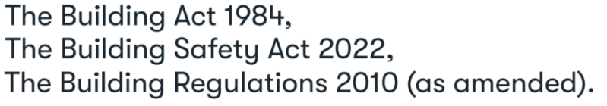

[buildingcontrol@erewash.gov.uk](mailto:buildingcontrol@erewash.gov.uk)

1 **Location of site to which the building work relates**

Address (incl postcode)

# 2 Applicant details

Title First Name Last Name

Company

Address (incl postcode)

Telephone Mobile

Email



**Building Regulation**

**Building Notice Form**

**R**

**1**

**3**

# 3 Agent details (where different from the applicant)

Title First Name Last Name

Company

Address (incl postcode)

Telephone Mobile

Email

# 4 Proposed works

**5 Date of Commencement**

1 of 2

## 6 Intended use of the building

**7 Person responsible for payment of fees**

Title First Name Last Name

Company

Address (incl postcode)

Telephone Mobile

Email

## Declaration

This application is deposited in relation to the building work etc., as described above. It is submitted in accordance with [Regulation 12(2)(a)](https://www.legislation.gov.uk/uksi/2010/2214/regulation/12) and is accompanied by the appropriate charge.



**Building Regulation Building Notice Form**

**R**

**1**

**3**

I / we apply for Building Notice Acceptance as described on this form and as detailed on any supplementary documents.

Signature

On behalf of

insert applicants name where the declaration is made by an agent

Date

The use of a building notice to inform the local authority of building work etc., is restricted to certain building types. Additional information will also be required to accompany your building notice depending upon the work proposed. Further information can be found in the attached notes and checklist. This form cannot be used for building control approval applications for higher-risk building work or stage of higherrisk building work or for work to existing higher-risk buildings. Applications for building work to higher-risk buildings can be made [here](https://www.gov.uk/guidance/manage-a-building-control-application-for-a-higher-risk-building?utm_medium=email&utm_campaign=govuk-notifications-topic&utm_source=c6323063-0050-4c04-b498-92296e154abd&utm_content=immediately). Form created in October 2023.

2 of 2