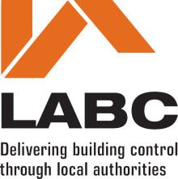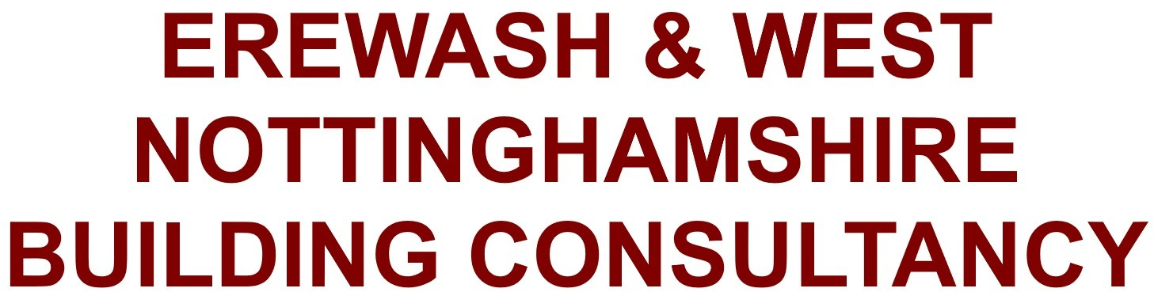**Building Regularisation Certificate Application Form (England)**

The Building Act 1984,

The Building Safety Act 2022,The Building Regulations 2010 (as amended).



**R18**

**RESOURCES DIRECTORATE**

Town Hall, Ilkeston Derbyshire, DE7 5RP

[buildingcontrol@erewash.gov.uk](mailto:buildingcontrol@erewash.gov.uk)

[**buildingcontrol@erewash.gov.uk**](mailto:buildingcontrol@erewash.gov.uk)

1. **Location of site to which the building work relates**

Address (incl postcode)

1. **Applicant details**

Title First Name Last Name Address (incl postcode)

Telephone Mobile

**Building Regularisation Certificate Application**

Email

1. **Description of the Unauthorised works**
2. **Date of Commencement**
3. **Person responsible for payment of fees**

Title First Name Last Name Address (incl postcode)

Telephone Mobile

Email

1. **Declaration**

This application is made in relation to the building work etc., as described above. It is submitted in accordance with [Regulation 18](https://www.legislation.gov.uk/uksi/2010/2214/regulation/18) and is accompanied by the appropriate charge.

I / we apply for a Regularisation Certification as described on this form and as detailed on any supplementary documents.

Signature On behalf of

insert applicants name where the declaration is made by an agent Date

This form cannot be used for building regularisation certificate applications for higher-risk building work or stage of higher-risk building work or for work to existing higher-risk buildings. Applications for building work to higher- risk buildings can be made [here](https://www.gov.uk/guidance/manage-a-building-control-application-for-a-higher-risk-building?utm_medium=email&utm_campaign=govuk-notifications-topic&utm_source=c6323063-0050-4c04-b498-92296e154abd&utm_content=immediately). Form created in October 2023.