**Notice of Intended Demolition**

PLEASE COMPLETE THIS FORM AND RETURN IT TO THE ADDRESS SHOWN ON PART B,

6 WEEKS PRIOR TO THE PROPOSED START DATE.

**Section 80 Demolition Notice**

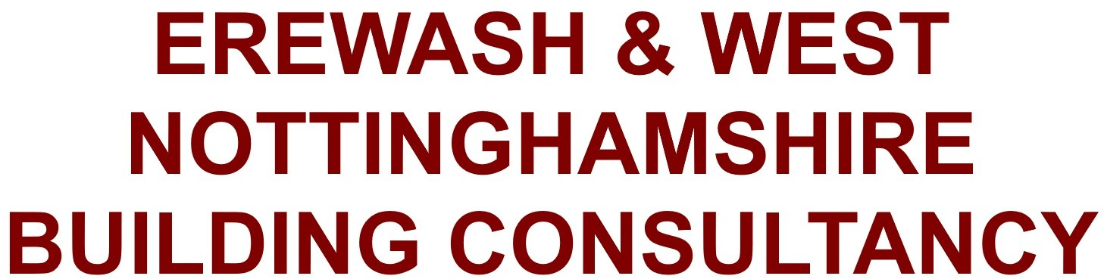

**RESOURCES DIRECTORATE**

Town Hall, Ilkeston Derbyshire, DE7 5RP

[buildingcontrol@erewash.gov.uk](mailto:buildingcontrol@erewash.gov.uk)

# Part A - SECTION 80 NOTICE

1. **Location of building to be demolished**

Address (incl postcode)

1. **Building owners details**

Title First Name

Company

Address (incl postcode)

Last Name

Telephone Mobile

Email

1. **Contractor's details**

Title First Name Last Name

Company

Address (incl postcode)

Telephone Mobile

Email

1. **Name of Person Serving Notice**

Title First Name Last Name

I confirm that *I/we *am/are the *owner/agent of the building to be demolished (1) and

*am/are authorised to accept formal notices in connection with the demolition of the premises.

 

B86.V6.PB.072020



**S80**



Cert No 16180

1. **Other Information:**
2. Has an asbestos survey been carried out. **Yes/No\***
3. Is asbestos present in the building. **Yes/No\***
4. Is the building in a planning conservation area. **Yes/No\***
5. Is the site being redeveloped. **Yes/No\***
6. Has Planning permission (where required) been granted **Yes/No\***
7. Are existing drainage runs being re-used **Yes/No\***

**Section 80 Demolition Notice**

1. Does the building contain any harmful chemicals **Yes/No\***
2. Is the building defined as ‘special’ (1) premises by the HSE and Fire Authority **Yes/No\***
3. The building is **\*** terraced / semi-detached / detached **Yes/No\***
4. Does the building have any special construction details ie. post tensioned beams

## Yes/No*

**\*** Delete as appropriate

**1** Petrol [station, che](https://www.legislation.gov.uk/uksi/2005/1541/contents)micals factory etc

If Yes to section 5,x please give details:

I confirm that I have served a Section 80 Notice to the occupier(s)/owner(s) of adjacent properties; the gas company; the electricity company and the water company (see [Section 80(3) of the Building Act 1984](https://www.legislation.gov.uk/ukpga/1984/55/section/80/enacted)).

**6**

Please list addresses of adjacent properties that you have served a section 80 Notice upon.

Address (incl name/ number, postcode)

Address (incl name/ number, postcode)

**7** I understand my legal duties associated with the proposed work under the Health and Safety Legislation, in particular; The Construction (Design and Management)

Regulations 1994; The Construction (Health, Safety and Welfare) Regulations 1996; Environmental Protection Act section 34; and Regulations dealing with the removal and disposal of asbestos.

**Name Signature**

**Date:**

 

B86.V6.PB.072020



**S80**



Cert No 16180

## A fee of £304.00 is applicable

Please provide details of the person who will be responsible for the fee

Title First Name Last Name

Company

Address (incl postcode)

**Section 80 Demolition Notice**

Should you wish to discuss your proposals further please contact Building Control on 0115 907 2233.

## I need to advise you that any personal information the council collects to provide our services, we may have to share this with other service providers or departments within the council to provide the service or if we are required to do so by law. You can find more details in the full privacy notice on our website at [www.erewash.gov.uk/privacy](http://www.erewash.gov.uk/privacy)

 

B86.V6.PB.072020



Cert No 16180 IS09001



**S80**

3 of 5

# Part B - NOTIFICATION OF COMMENCEMENT OF WORK

When a start date for demolition works is known please fill in this form and return to:- Building Control,

Town Hall, Long Eaton,

Derbyshire. NG10 1HU

**Section 80 Demolition Notice**

Email: [buildingcontrol@erewash.gov.uk](mailto:buildingcontrol@erewash.gov.uk)

I hereby certify that the demolition works at the address shown below are due to commence and that all the conditions as detailed on the [Section 81 Notice](https://www.legislation.gov.uk/ukpga/1984/55/section/81)

shall be complied with.

Building Address (incl postcode)

Start Date

**Signed**

**Print Name**

**Date**

 

B86.V6.PB.072020



**S80**



Cert No 16180 IS09001

# Part C - NOTIFICATION OF COMPLETION OF WORKS

When demolition is complete please fill in this form and return to-:

Building Control, Town Hall,

Long Eaton, Derbyshire. NG10 1HU

**Section 80 Demolition Notice**

Email: [buildingcontrol@erewash.gov.uk](mailto:buildingcontrol@erewash.gov.uk)

I hereby certify that the building at the address shown below has been demolished and that all the conditions as detailed on the [Section 81 Notice](https://www.legislation.gov.uk/ukpga/1984/55/section/81) have been complied with.

Building Address (incl postcode)

Start Date

**Signed**

**Print Name**

**Date**

 

B86.V6.PB.072020



**S80**



Cert No 16180 IS09001